GRADE I
ENGLISH
DAILY PRACTICE PAPER
[DPP]
2019-2020

MID TERM
S.NO | DATE | CONTENT | REMARKS | TEACHER  SIGNATURE
1 |  | Concept Based Worksheet
2 |  | Concept Based Worksheet
3 |  | Application Based Worksheet
4 |  | Concept Based Worksheet
5 |  | Application Based Worksheet
6 |  | Concept Based Worksheet
7 |  | Visual based worksheet
8 |  | Visual based worksheet
9 |  | Noun finder
10 |  | Application Based Worksheet
11 |  | Application Based Worksheet
12 |  | Visual based worksheet
13 |  | Pen paper test
14 |  | Visual stimulus based
15 |  | Learning based worksheet
16 |  | Check point

UNIT-3-ONE LITTLE KITTEN
CONCEPT BASED WORKSHEET
Objective: To identify the following words:
Q1. Complete the following words:
1.b___ g 2.s___als
3.bra___ e 4.t___ils
5.f___t 6.s___d
7. ki__ ___ en 8.b__ ___
9.r___t 10. e ___ ls

Q2. Now read and spell out the words loud:
Kitten | cats | fishes | seagulls | eels | fleas | smell | whale
Kitten | cats | fishes | seagulls | eels | fleas | smell | whale
Kitten | cats | fishes | seagulls | eels | fleas | smell | whale
Kitten | cats | fishes | seagulls | eels | fleas | smell | whale

DATE TEACHER’S SIGN

CONCEPT BASED WORKSHEET
Objective: To improve the vocabulary
1. Based on your reading of the poem “One Little Kitten”, choose the correct answer.
- There are two_____________(big/small) cats.
- There are _________________(four/five) big rats.
- There are six _____________ (sad/happy) seals.
- The bees are ________________ (brave/nervous).
- Fifteen donkeys have fifteen ______________ (tails/eyes).

2. Match the opposites:
- Happy - big
- Brave - slim
- Silly - Nervous
- Fat - smart
- Small - sad

3.Read the words:

a | e | i | o | U
bat | bed | fin | cot | Cup
cat | hen | hit | box | Cub
hat | jet | lid | dot | Nut
mat | let | pin | hot | Jug
rat | pen | lip | not | Sun

DATE TEACHER’S SIGN

APPLICATION BASED WORKSHEET
Objective: To improve their vocabulary
1.Rearrange the letters in correct order to make a word:
1.neh ____________
2.oht ____________
3.ebe ____________
4.aft ____________
5.gib ____________
2. Name two fruits which are red in colour and two vegetables which are green in colour, two fruits yellow in colour.
red fruits: cherry, ____________, ____________
green vegetables: beans, ____________, ____________
Yellow fruits ____________, ____________
3. Count and write the number of animals:
1.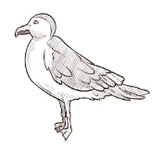
2.
3.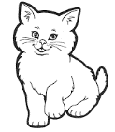
4.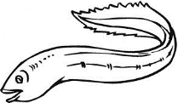

DATE TEACHER’S SIGN

CONCEPT BASED WORKSHEET
Objective: To improve their reading skill
1. Complete the following words:
1.f ___ s ___ 2.l___z___r__
3.t a ___ l 4.d ___ n k ___ y
5.W ___ a l ___ 6.b___e
7.r___d 8.p___a___t
9.y___l___ow 10.c___i___k

2. Solve the word puzzle:
The colour of
a] ___________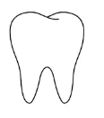 b] ___________
c] ___________ 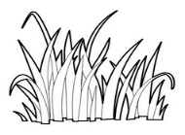 d] ___________
e] ___________

DATE TEACHER’S SIGN

UNIT-3- LALU AND PEELU
APPLICATION BASED WORKSHEET
Objective: Able to speak short sentences.
There was a hen. She had two chicks. Lalu and Peelu. Lalu was red. He loved red things. Peelu was yellow. He loved yellow things. One day Lalu saw something on a plant. It was red. He ate it up. Oh, no! It was a red chilli. It was very hot.
Answer these questions:
- Name the chicks in the story.

- Who liked red things?

- Who liked yellow things?

- What did Lalu eat one day?

- How was the red chilli?

DATE TEACHER’S SIGN

CONCEPT BASED WORKSHEET
Objective: To improve the thinking skills
1. Singular and plural
Eg.Cat-cats

1. rat ___________________ 2.bee ___________________
3.lizard ___________________ 4.donkey ___________________
5.eel ___________________ 6.alligator ___________________
7.tail ___________________ 8.elephant ___________________
9.flea ___________________ 10. seal ___________________

2. Match the naming words with correct describing words
1.bird - a) cloudy
2.elephant - b) naughty
3. sky - c) little
4. sugar - d) big
5. boy - e) sweet

DATE TEACHER’S SIGN

DATE TEACHER’S SIGN

VISUAL BASED WORKSHEET
Objective: To improve his/her thinking skills
1. Match the pictures with the correct names.
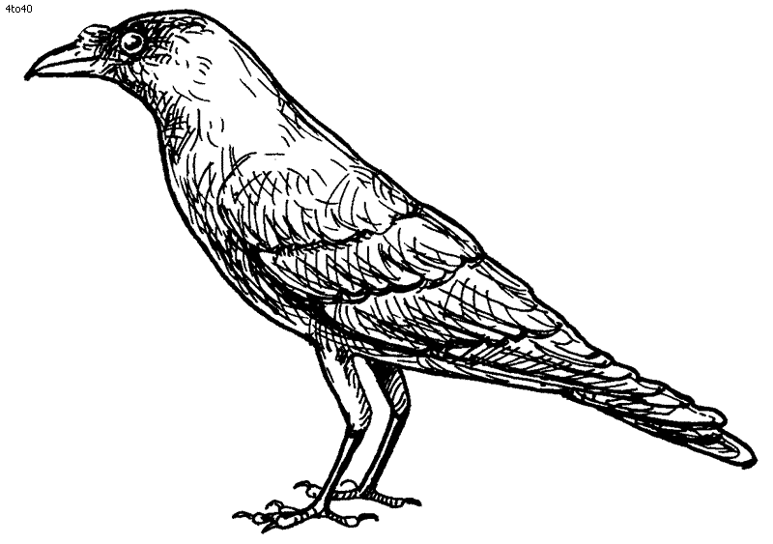 - peacock
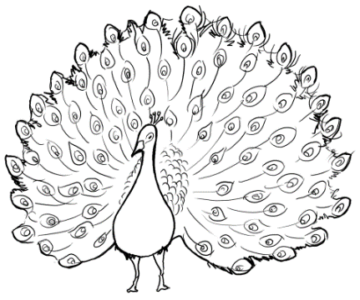 - eagle

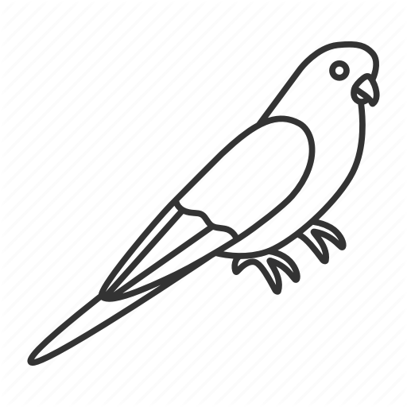 - crow
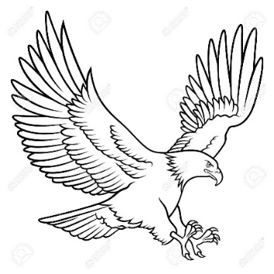 - parrot

DATE TEACHER’S SIGN

VISUAL BASED WORKSHEET
OBJECTIVE: To improve thinking skills
1.Write the names in correct place
[Fox Fish Sparrow Bird Snail Snake]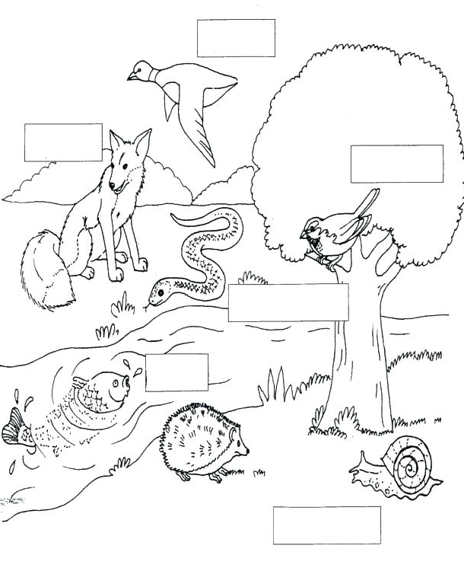
DATE TEACHER’S SIGN

NOUN FINDER
Objective: To know about noun.
Nouns are naming words . Nouns are names of people, places,animals and things.

Examples:
People : Anitha,Raju,Seela,Gopi
Place : school,temple,hospital
Animals: cat,dog,elephant
Things : table,chair,pen

1.Read the sentences and circle the noun
- Sheema and Sheela are dancing.
- Raj is in Kerala.
- The book is on the table.
- The car is red.
- The monkey is on tree.

2.Match the fruits and vegetables to the trees they grow on.
.
Banana - | Coconut Tree
Coconut - | Apple Tree
Apple - | Banana Tree
Grapes - | Mango Tree
Mango - | Grapevine

DATE TEACHER’S SIGN

APPLICATION BASED WORKSHEET
Objective: To improve the thinking skills
1.Circle the noun in the box below
Noun is a person, a place or a thing

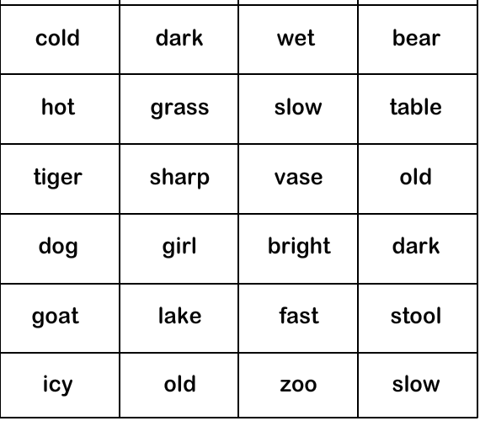

DATE TEACHER’S SIGN

APPLICATION BASED WORKSHEET

Objective: To improve their vocabulary.
1. Circle the vowels in the given words:
- Ball 6. Elephant 11. Fish

- Apple 7. Water 12. Tom

- Cat 8. Height 13. Naughty

- knife 9. Under 14. Umbrella

- Tomato 10. Knot 15. Ocean

2 Match the animals with sound they make:
1.Mice - a) bleat
2.Sheep - b) croak
3.Bird - c) neigh
4.Frogs - d) squeak
5.Horses - e) chirp

DATE TEACHER’S SIGN

VISUAL BASED WORKSHEET
objective: To improve the grammar skill
1.Choose the noun from the box and find them in the correct column:
Pen school brother lion park cat ok Rani Pencil hospital Raju dog tiger table temple Anu

PERSONS:  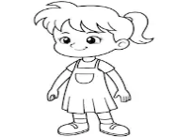  1._____________ 2._____________  3._____________ 4._____________ | PLACES:  1._____________ 2._____________  3._____________ 4._____________
ANIMALS:  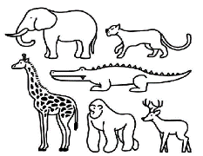  1._____________ 2._____________  3._____________ 4._____________ | THINGS:  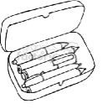  1._____________ 2._____________  3._____________ 4._____________

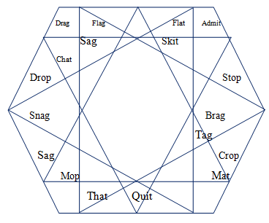
DATE TEACHER’S SIGN

PEN PAPER TEST
Objective: Learn the noun
Noun is a name, place, things, animals
1.Fill in the correct noun
- The museum is closed on Sunday ______________

- The car was parked in front of the house ______________

- She was trying to catch the ball ______________

- I could not see the boy in the crowd ______________

- Chips are my favourite snacks ______________

- I checked out two books from library ______________

- My teacher is very nice to the class ______________

- We watched the last leaf fall ______________

- He left his bag at the school ______________

10.The doctor gave me a sucker ______________

DATE TEACHER’S SIGN

VISUAL STIMULUS BASED WORKSHEET
Objective: To improve the reading vocabulary
Finish the word:
1.Write the correct digraph to complete the word
Blends bank: th, ch, wh, sh, ph

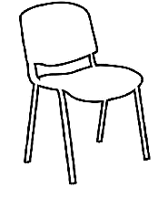_________ air 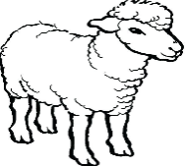______ eep
_______ umb _______ oto
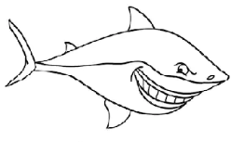 _______ ark 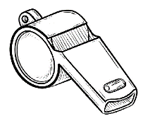 _______ istle
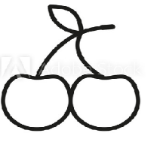______ eery _______ orn
______ eel ________ one

DATE TEACHER’S SIGN

LEARNING BASED WORKSHEET
Objective: Learning sentence formation
This is, these are

1.Read out these sentences given below:
This is a boy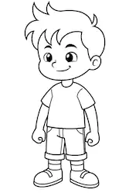 TheY are boys 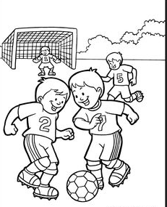
This is a pencil 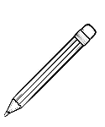 These are pencils 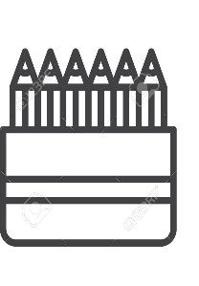
This is a bird 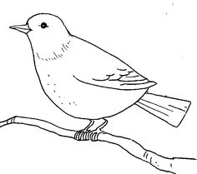 These are birds 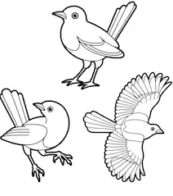

This is a chair 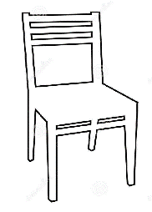 These are chairs 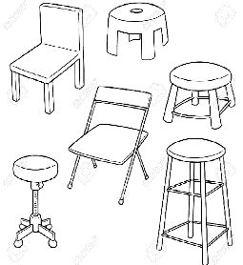

DATE TEACHER’S SIGN

CHECK POINT
Objective: To improve their grammar skill
1. Fill in the appropriate word (this or these)
1.____________ is an apple . 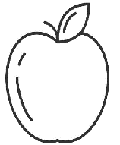
2. ____________ are books.
3._____________ is a comb.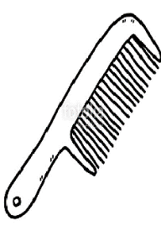
4._____________ are bags.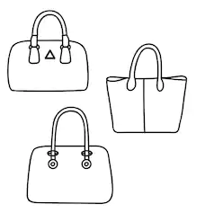
5.______________ is a duck.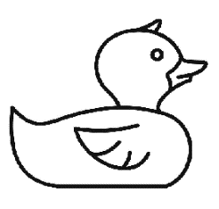

DATE TEACHER’S SIGN

