GRADE I
MATHS
DAILY PRACTICE PAPER
2019-2020

PRE-MID TERM
S.NO | DATE | CONTENT | REMARKS | TEACHER  SIGNATURE
1 |  | Concept Based Worksheet
2 |  | Concept Based Worksheet
3 |  | Application Based Worksheet
4 |  | Concept Based Worksheet
5 |  | Figure Based Worksheet
6 |  | Paper Pencil Test
7 |  | Think and Write
8 |  | Think and Write
9 |  | Concept Based Worksheet
10 |  | Create and Relate
11 |  | Application Based Worksheet
12 |  | Pen Paper Test

CONCEPT BASED WORKSHEET
Objective: To know about what is Inside and outside.To know how to apply.
1.Color the bird that is outside the cage.
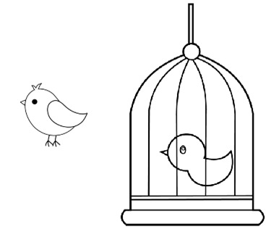
2.Color the flowers that are inside the vase.
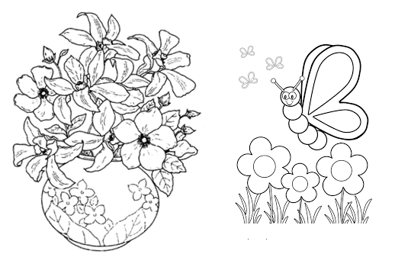
3.Color the dog that is outside the kennel.
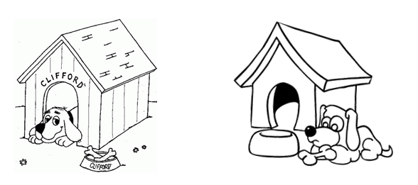
4.Draw the book, inside the bag.

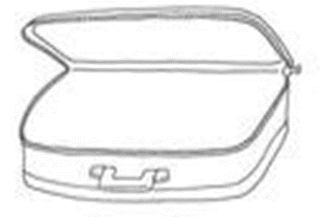
DATE: TEACHER’S SIGN:
CONCEPT BASED WORKSHEET
Objective:To identify the superlatives.
1.Circle the smaller ones among the following pictures.
a. b.
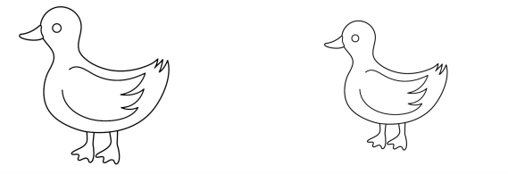
2.Color the bigger ones among the following pictures.
a.
b.
3.Tick the biggest apple.

4.Tick the smallest balloon.
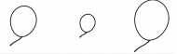

DATE: TEACHER’S SIGN:
APPLICATION BASED WORKSHEET
By this they can find the differences in distances and they will identify.
- Color the tree farther from the house.
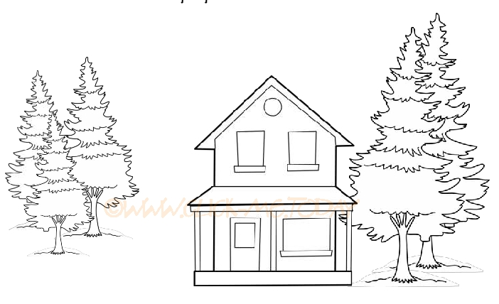

- Draw a bird nearer to tree.

- Circle the animal nearest to the tree.
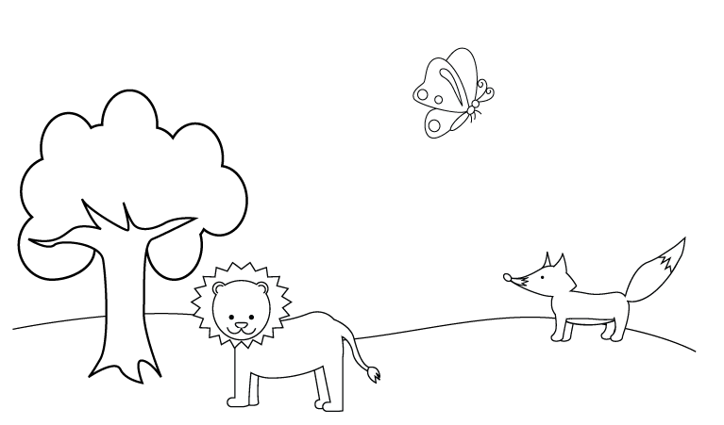
- Tick the tree farthest from the animal.

DATE: TEACHER’S SIGN:
CONCEPT BASED WORKSHEET
Objective:To identify the preposition (Position) of the objects.
1.Tick the hen at the bottom of the house.
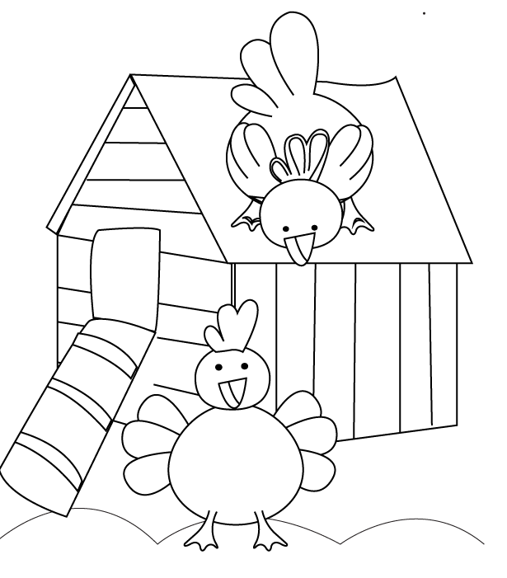
2.Circle the bird at the top of the object.
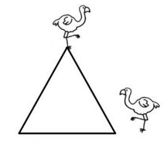
3. (i) Draw 2 birds above the boat.
(ii) Draw 2 ducks on the water.
(iii). Draw 3 fish below the boat.
.
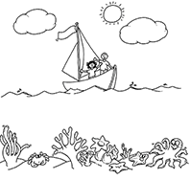

DATE: TEACHER’S SIGN:
PICTURE BASED WORKSHEET
Objective:They will understand and get knowledge in shapes.
- Match the same shapes
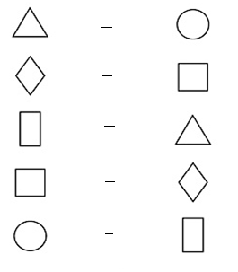
- Circle the object that will slide.
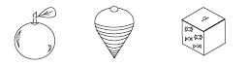

- Tick the object that will roll.
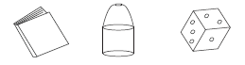

4.Draw the object that slide and another object that roll.

DATE: TEACHER’S SIGN:
PAPER PENCIL TEST
1.Trace the numbers.
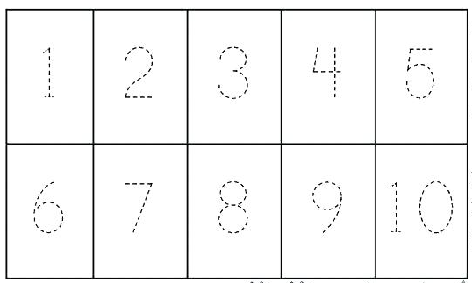
- Do the following.
a. Circle the number 3’s.
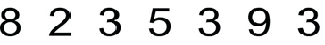

b. Circle the number 7’s.
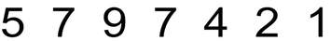

c. Circle the number 2’s.

d. Circle the number 9’s.
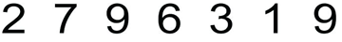

e. Circle the number 1’s.
f.Circle the number 3’s

DATE: TEACHER’S SIGN:
THINK AND WRITE
By this they can develop their Numerical ability
1.Write the missing numbers.
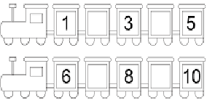
2.Count and write.
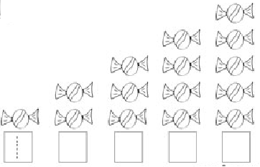
3.Match the following.
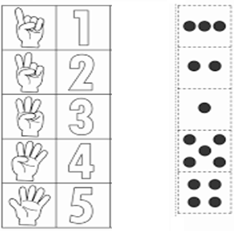
DATE: TEACHER’S SIGN:

THINK AND WRITE
Based in Numericali ability.
1.Count and colour the correct number box.
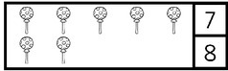
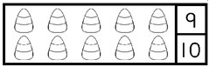
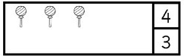
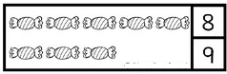
2.Write the numbers.
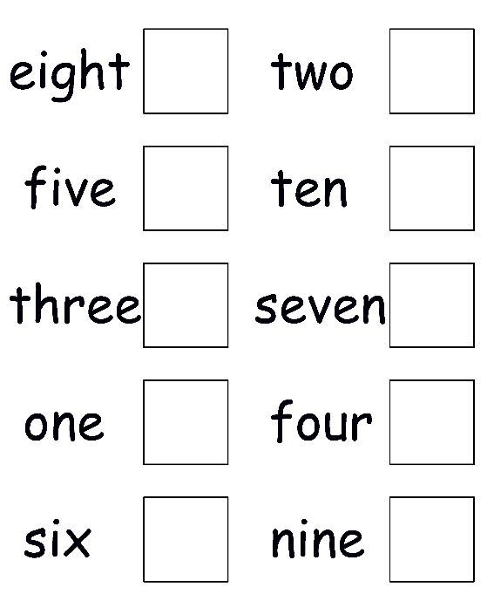
DATE: TEACHER’S SIGN:
CONCEPT BASED WORKSHEET
Objective: Identifying the numbers.
1.Match the following.
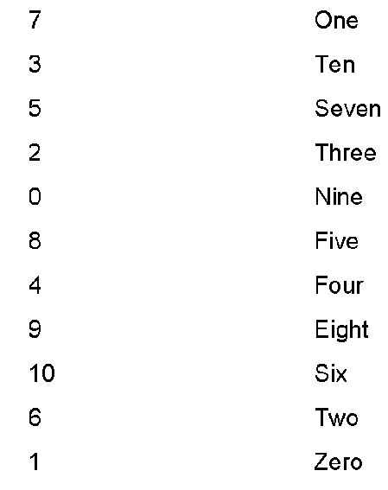
2.Write the number names.
4 = _______________________________________________
8 = _______________________________________________
1 = _______________________________________________
- = _______________________________________________
0 = _______________________________________________
3.Write the numbers.
Two = _______________________________________________
Five = _______________________________________________
Seven = _______________________________________________
Nine = _______________________________________________
Eight = _______________________________________________
DATE: TEACHER’S SIGN:
CREATE AND RELATE
Objective:To develop logical thinking with the help of numeric pictorial representation.
- Join in order.
a.
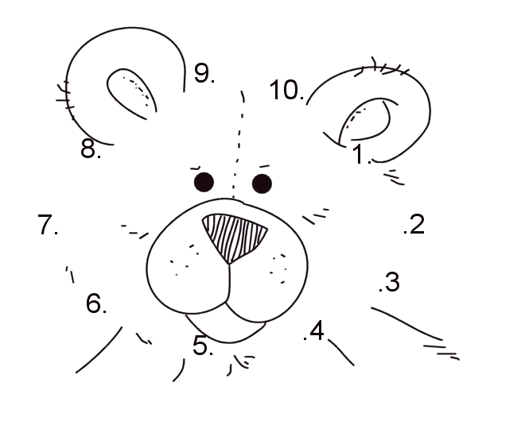
b.
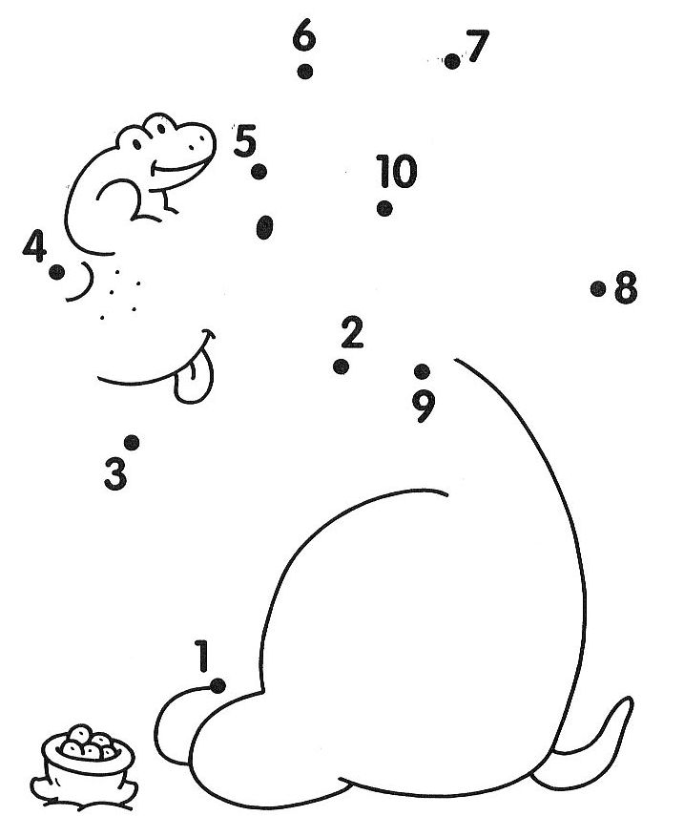

DATE: TEACHER’S SIGN:
APPLICATION BASED WORKSHEET
Objective:To apply the numerics
1.Count and Match.
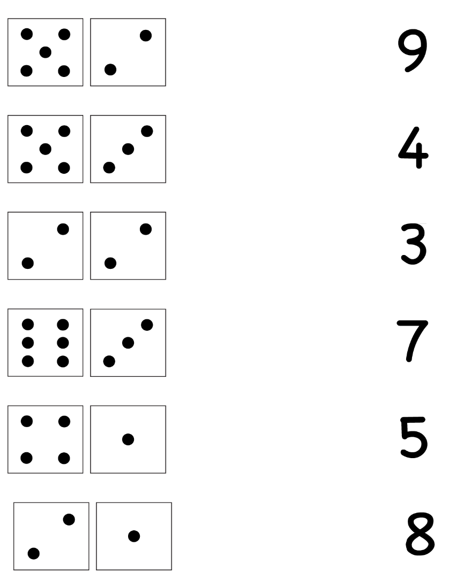
2.Write Before and After number.
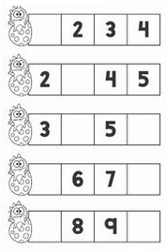
DATE: TEACHER’S SIGN:
PEN PAPER TEST
- Write the numbers 101 to 150.
101
150
DATE: TEACHER’S SIGN:

