GRADE I
MATHEMATICS
DAILY PRACTICE PAPER
[DPP]
2019-2020

POST MID TERM
TIME
APPLICATION BASED WORKSHEET
Objectives: To improve their thinking skill.
1. Write the given time in the box.
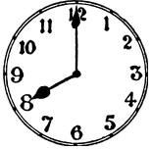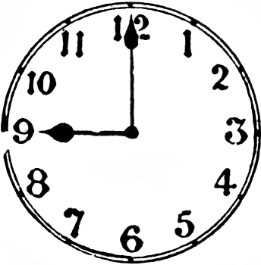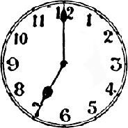

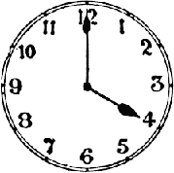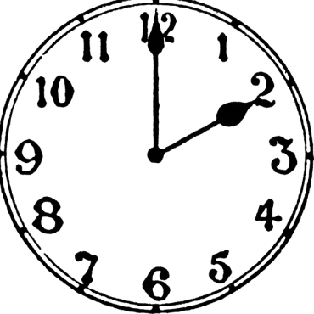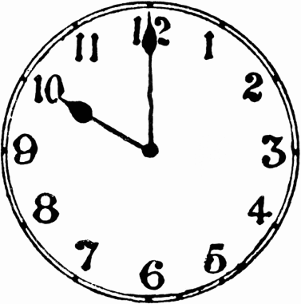

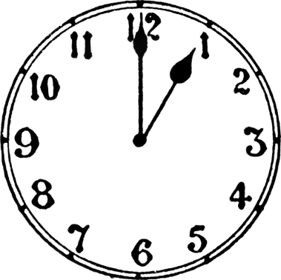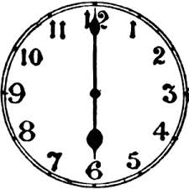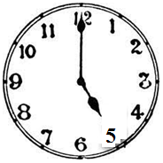

DATE TEACHER’S SIGN

CONCEPT BASED WORKSHEET
Objective: To develop logical thinking with the help of numeric.
- Draw the hour hand and minute hand in the clock.
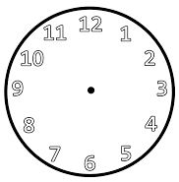
9:00 PM
12:00 AM
6:00 AM

2:00PM
8:00AM
4:00 AM

4:00PM
7:00PM
1:00 PM

DATE TEACHER’S SIGN

CONCEPT BASED WORKSHEET.
Objective: To develop logical thinking with the help of numeric.
1. Write the correct time.
[ Evening, Night, Morning, Afternoon ]

DATE TEACHER’S SIGN

PEN PAPER TEST
Objective: To check their numerical ability.
1. Think and write the correct time.
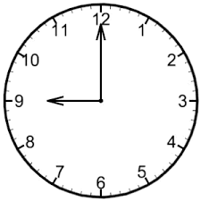

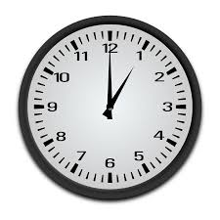

DATE TEACHER’S SIGN

MEASUREMENT
APPLICATION BASED WORKSHEET
Objective: To identify the longer and shorter, longest and shortest.
1. Colour the longer object in each of the following pictures.
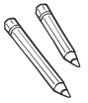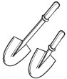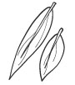

2. Tick the shorter object in each of the following picture.
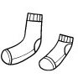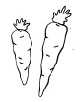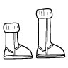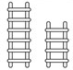

3. Tick the longest object.
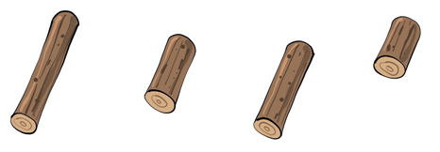

4. Colour the shortest object.
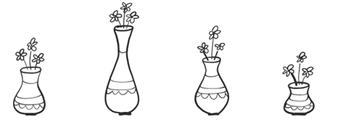

DATE TEACHER’S SIGN

APPLICATION BASED WORKSHEET
Objective: To think and identify taller and shorter, tallest and shortest.
1. Tick the Taller in each object.
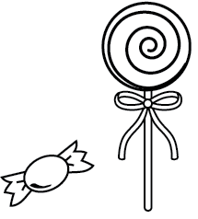

2. Colour the shorter in each object.
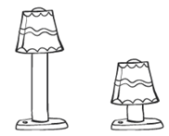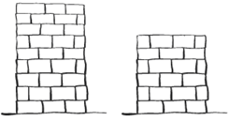

3. Use the words Longest and Shortest.

3
2
1

a) Glass 2 is the ______________
b) Glass 3 is the ______________

DATE TEACHER’S SIGN

THINK AND WRITE
Objective: To develop their thinking skills.
1. Circle the thinner object in the following.
2. Tick the thicker object in the following.
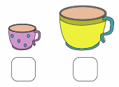
3.Colour the thickest object in the following.

4. Arrange the objects from thickest to thinnest by numbering them from 1 to
use 3 ! for the thickest and 3 for the thinnest.

DATE TEACHER’S SIGN

APPLICATION BASED WORKSHEET
Objective: To think and identify lighter and heavier, lightest and heaviest.
1. Circle the lighter.

2. Tick the Heavier.

3. Colour the Lightest.

4. Circle the Heaviest.
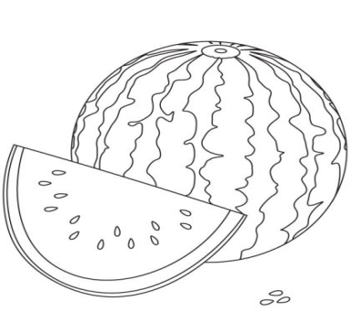

DATE TEACHER’S SIGN

CHECK POINT
Objective:To check their numerical ability.
1.Fill in the blanks.
a) Theis ____ spans long.

b) The is ____ spans long.

c) The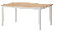 is ____ spans long.

d) The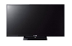 is ____ feet long.

e) The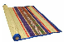is ____ spans long.

f) The is ____ feet long.

g) The 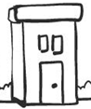is ___ feet long.

h) The 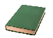is ___ spans long.

i) The is ___ spans long.

j) The is ___ feet long.

DATE TEACHER’S SIGN

NUMBERS FROM TWENTY-ONE TO FIFTY
NUMERICAL ABILITY
Objective: To develop their numerical ability.
1. Fill in the numbers that are missing in the table.
 | 2 |  |  |  |  | 7
11 |  |  |  | 15
 |  |  |  |  |  |  |  |  | 30
 |  | 33
41
 |  |  |  |  |  | 57
 |  |  | 64
71

 |  |  |  |  |  |  | 88
 |  | 93

DATE TEACHER’S SIGN

APPLICATION BASED WORKSHEET
Objective: To identify the place values.
1.Count and write.
Tens | Ones
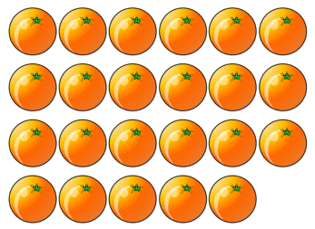

Tens | Ones
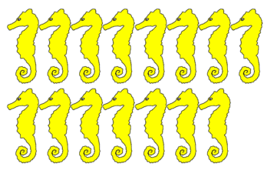

Tens | Ones
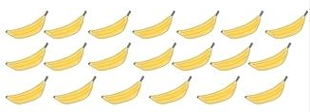

Tens | Ones
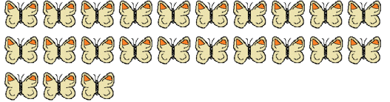

Tens | Ones
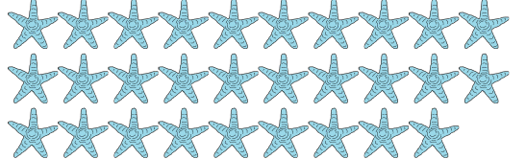
DATE TEACHER’S SIGN

NUMERICAL ABILITY
Objective: To check their numerical ability.
1. Match the following.
33

48

50

24

29

2. Fill in the blanks.
a) Three tens are __________.
b) Five tens and eight ones are ________.
c) Two tens and six ones are ________.
d) Four tens and one ones are ________.
e) Three tens and five ones are ________.
f) Five tens and five ones are ________.
g) Two tens and zero ones are _________.
h) Four tens and nine ones are _________.
i) One ten and two ones are _________.

DATE TEACHER’S SIGN

PEN PAPER TEST
Objective: To develop logical thinking with the help of numeric.
1. Draw the missing tens or ones or both for each of the following.
a) |  |  | 14
b) |  |  | 50
c) |  |  | 28
d) |  |  | 42
e) |  |  | 39
f) |  |  | 21
g) |  |  | 37

DATE TEACHER’S SIGN

DATA HANDLING
CONCEPT BASED WORKSHEET
Objective: To count and write using shapes.
1.Count the geometrical shapes and write the numbers in the table.
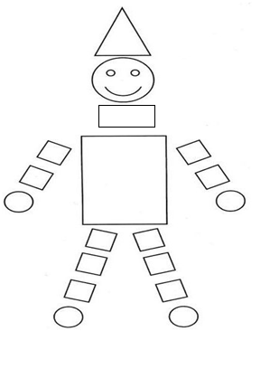
a)
b)
c)
d)

DATE TEACHER’S SIGN

CHECK POINT
Objective: To check their counting skills.
1. Count the geometrical shapes and match them with their respective number in the table.

a) |  | 4
b) |  | 6
c) |  | 2
d) |  | 5
e) |  | 3
DATE TEACHER’S SIGN

PEN PAPER TEST
Objective: To apply the concept.
1. Write the numbers 101 to 200.

DATE TEACHER’S SIGN

