

**GRADE II**

**ENGLISH**

**DAILY PRACTICE PAPER**

**2019-2020**

**PRE-MID TERM**

|  |  |  |  |  |
| --- | --- | --- | --- | --- |
| **S.NO** | **DATE** | **CONTENT** | **REMARKS** | **TEACHER**  **SIGNATURE** |
| **1** |  |  |  |  |
| **2** |  |  |  |  |
| **3** |  |  |  |  |
| **4** |  |  |  |  |
| **5** |  |  |  |  |
| **6** |  |  |  |  |
| **7** |  |  |  |  |
| **8** |  |  |  |  |
| **9** |  |  |  |  |
| **10** |  |  |  |  |
| **11** |  |  |  |  |
| **12** |  |  |  |  |

**PAPER PENCIL TEST**

**Objective:** To improve vocabulary skill

**I .Match the Following:**

1.Angry - 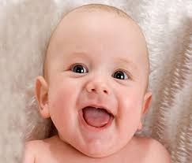

2.Shy - 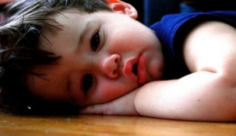

3. Happy - 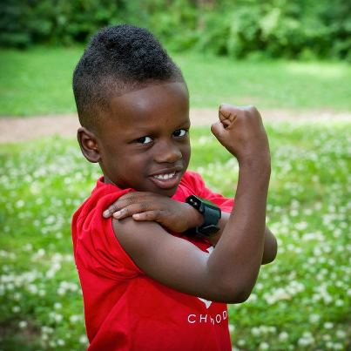

4.Sad - 

5.Fear - 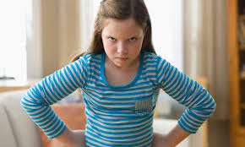

6.Brave - 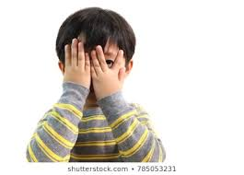

**DATE: TEACHER’S SIGN:**

**HEARING AND LISTENING**

**Objective :** To identify the similar sounds and the words.

**WorkSheet - 2**

**I . Fill the rhyming Words.**

1. Will - _________ 4.Full - _________
2. Mom - _________ 5.Look - _________
3. Sad - _________

**II. Write five words using the letters given in this word “Teacher”.**

1. __________ 4.__________
2. __________ 5.__________
3. __________

**III. Choose the correct word from the box and fill in the blanks.**

|  |
| --- |
| **Swimming, Cooking , Reading , Jumping, Eats** |

1. Ramya is _______ the book.
2. A Bear ______ a big meal.
3. My mom is ______ my favorite dinner.
4. The frog is ___________.
5. Krish is ______ in the pool.

**DATE: TEACHER’S SIGN:**

**APPLICATION BASED**

**Objective:** To build the vocabulary.

**I. Rearrange the jumbled letters.**

O

R

W

N

E

D

L

S

P

A

1. ------ ---- --------------------------------------

O

C

S

H

O

2. ------ ---- --------------------------------------

S

R

A

T

E

3. ------ ---- --------------------------------------

U

Y

P

P

4. ------ ---- --------------------------------------

N

I

R

D

W

G

5. ------ ---- -------------------------------------

**II. Tick the correct answer:**

1. Help your classmates. 
2. Run in the corridor. 
3. Hit other children. 
4. Study properly. 
5. Share your things. 

**III .Match the opposites:**

1. Good - Last
2. Full - Night
3. Like - Bad
4. First - Empty
5. Day - Dislike

**DATE: TEACHER’S SIGN:**

**COMIC STRIP**

**Objective:** To learn the priorities of the daily routines.

1. **Draw line in sequence our daily activities.**

Go to school

Back to home

Studying

Playing

Doing homework

Go to bed

Wakeup

Take a bath

Have breakfast

Pray to God

Brush your teeth

**DATE: TEACHER’S SIGN:**

**APPLICATION BASED**

**Objective:** Recollect the things that used daily, with vocabulary.

**I. Find the words and circle it.(Any Five Words).**

|  |  |  |  |  |  |  |  |
| --- | --- | --- | --- | --- | --- | --- | --- |
| P | B | O | O | K | A | C | N |
| E | E | U | K | G | J | E | O |
| Q | G | N | S | T | K | R | K |
| A | H | K | C | J | R | A | L |
| T | S | L | H | I | U | S | O |
| B | A | G | O | Y | L | E | U |
| S | W | D | O | G | E | R | G |
| R | C | O | L | H | R | S | F |

**II.Answer the question.**

1 . What is your name?

Ans :___________________________________________________.

2. Write your School name?

Ans :___________________________________________________.

**DATE: TEACHER’S SIGN:**

**CONCEPT BASED**

**Objective:** To connect picture with word and form new compound words.

1. **Identify the picture and write the Compoundwords.**

1.

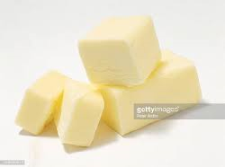 + Fly = ___________________

2. + Fish = ___________________

3. + Ball = ___________________

4. 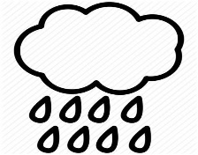+ Bow = ____________________

5. + Fly = _____________________

6. 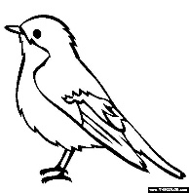+ House = ____________________

7.  + Hopper = ____________________

8.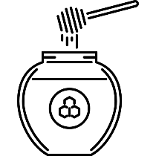+ Bee = _____________________

**DATE: TEACHER’S SIGN:**

**APPLICATION BASED**

**Objective:**To improve creative and designing skill.

I.Draw a favourite animal or bird and label its parts.

|  |
| --- |
| I like it because __________________________________________. |

**II. Identify the words.**

1. MORF - _________ 6. TUB - _________
2. OFR - _________ 7.FTEAR - _________
3. LLIT - _________ 8.NAER - __________

4. NI - _________ 9. THIW - __________

1. DERNU - __________ 10. TUO - __________

**DATE: TEACHER’S SIGN:**

**VISUAL IDENTIFICATION**

**Objective:** To improve relative thinking and imagination skill.

1. **Find the hidden animals and write their names.**

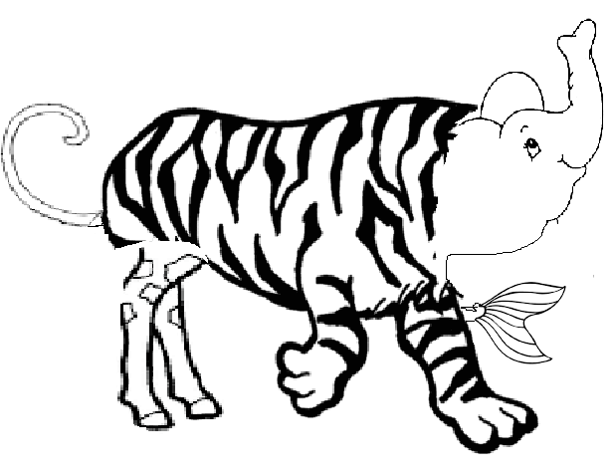

1 . ______________­­­­­__ 2. ________________

3. _________________ 4.________________

5._________________

**DATE: TEACHER’S SIGN:**

**RETRACT THE FACT**

**Objective:** To improve the Linguistic skill.

1. **Write the sentence correctly using punctuation.**
2. he is very very Happy

_____________________________________________

1. this is Fun HE says

____________________________________________________

1. take this Magic wand , She says

_____________________________________________________

1. the zebra has stripes

_____________________________________________________

1. the little monkey wants to be big and strong

_____________________________________________________

**II . Missing letter**

1. S__ R__ NG 6.W__ __ D
2. W__ S__ 7.M__ __ K__Y
3. MO __ S__ER 8.GI__ R__ FF _
4. Z__ E B__ __ 9.F L __ __ k
5. T__ U__K 10.R __ V __ R

**DATE: TEACHER’S SIGN:**

**NOUN FINDER**

**Objective:** To enrich the knowledge about subject in the sentence .

**A. Write the nouns below into the correct column.**

boy car fireman home store book dog

zoo waiter ruler baby town paper lion

|  |  |  |  |
| --- | --- | --- | --- |
| **Person** | **Place** | **Thing** | **Animal** |
|  |  |  |  |
|  |  |  |  |
|  |  |  |  |
|  |  |  |  |

**B. Underline the following nouns in the sentences:**

1. The plane landed safely at the airport.

2. The girl dropped the glass on the table.

3. My cat likes to play with string and yarn.

4. I saw my teacher at the store.

5. Is that child waiting to get on the bus?

6. There was a huge spider crawling across the floor.

7. A monkey jumped down and grabbed the banana.

8. The book must be returned to the library soon.

9. The driver is driving the bus.

10. The boy saw the wolf.

* A noun names a person/place/animal/bird/thing. A noun may also refer to an activity or a quality.
* **Example:** Robert, Boy, Sidney, School, Pussy, Cat, Peacock, Fowl, Spoon, Tennis, Sorrow.

**C. Choose the correct nouns to fill in the blanks. Color the correct box with green color.**

1) Mom cuts an apple with a _____.

spoon knife fork

2) Grandpa puts the _____ in the mailbox.

paper e-mail letter

3) It is fun to fly a ____.

kite bird kitten

4) Christian go to ______________ on Sunday.

temple mosque church

5) The house was built with _______________.

bricks leaves plastics

6) Tiger lives in _________________.

home den desert

7) Cat likes _____________.

cake milk dosa

8) Most kids love _________________.

spinach fruits chocolates

9) A _________ lives in a beehive.

ant butterfly bee

10) ______________ lives in a kennel.

elephant rabbit dog

**WORD USAGE**

**Objective:** To enrich the grammar knowledge.

**A. How will you describe the words in each row? Choose from the box.**

**fruits games birds vehicles cutlery animals**

1. car, bus, aeroplane, cycle ______________

2. spoon, fork, knife, tongs _______________

3. apple, mango, cherry, banana ______________

4. hockey, cricket, football ________________

5. cat, rat, dog, cow, goat _________________

**B. Match the correct common noun with its correct proper noun:**

|  |  |
| --- | --- |
| 1. boy | Mahatma Gandhi |
| 2. woman | Sri Lanka |
| 3. mountain | Rahul |
| 4. city | The Gateway of India |
| 5. leader | Sharda |
| 6. river | Delhi |
| 7. building | Godavari |
| 8. country | Mount Everest |
| 9. girl | Peacock |
| 10. bird | Rani |

**C. Underline the common nouns in the following sentences.**

1. The monkey is eating a banana.

2. The cat is sleeping under the table.

3. The girls are on their way to the school.

4. I am working in the garden.

5. We must eat plenty of fruits and vegetables.

6. The dog is chasing the cat.

7. There are some mangoes in the basket.

8. The duck was swimming in the pond.

9. The lion is in the cage.

10. India is my country.

**D. Proper nouns – Write the names of your classmates and teacher to answer these questions. Begin each name with a capital letter.**

1. What is your name? _____________________________

2. Who sits next to you? _____________________________

3. Who likes to read books? _____________________________

4. Who is your best friend? _____________________________

5. Who is your Class teacher? _____________________________

6. Which is your favorite subject? _____________________________

7. Where do you play in school? _____________________________

8. Where does the teacher writes in your class? _____________________________

9. Who is very naughty in your class? _____________________________

10. What you want to become in future? _____________________________

**DATE: TEACHER’S SIGN:**

**CREATIVE BASED WORKSHEET**

**Objective: Free-hand Drawing**

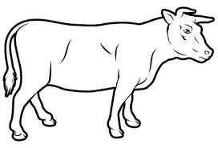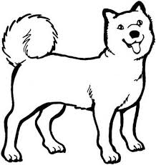

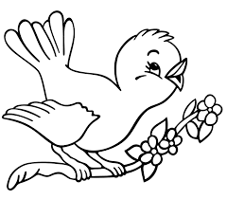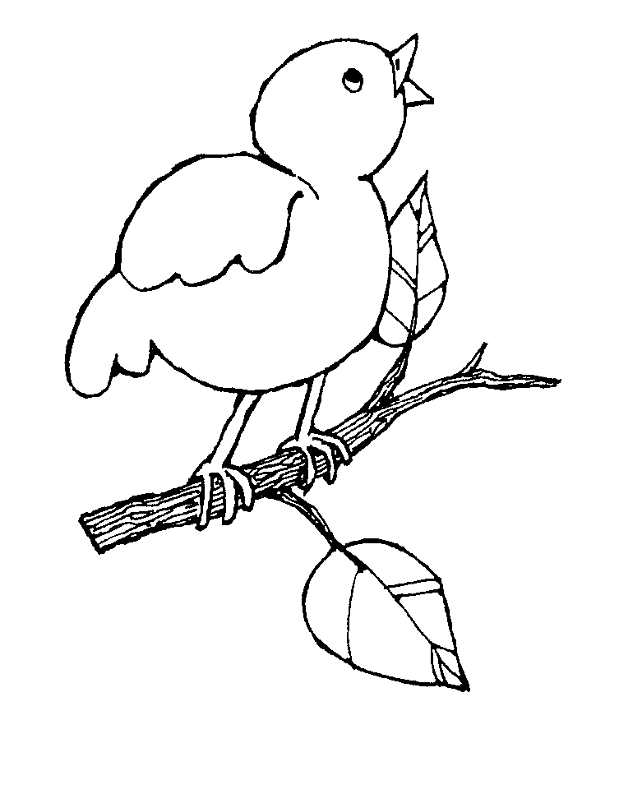

**DATE: TEACHER’S SIGN:**