GRADE II
MATHEMATICS
DAILY PRACTICE PAPER
[DPP]
2019-2020

MID TERM
S.NO | DATE | CONTENT | REMARKS | TEACHER  SIGNATURE
1 |  | Concept Based Worksheet.
2 |  | Critical Thinking
3 |  | Numerical Ability
4 |  | Mathematical Ability
5 |  | Application  Based
6 |  | Numerical Ability
7 |  | Concept Based Worksheet.
8 |  | Logical Thinking Enhancing
9 |  | Pen Paper Test
10 |  | Concept Based Worksheet.
11 |  | Free Hand Drawing
12 |  | Application Based
13 |  | Riddles
14 |  | Concept Based Worksheet
15 |  | Measuring units

3. HOW MUCH CAN YOU CARRY?
CONCEPT BASED WORKSHEET
Objective: To know the concept of heavy and light.
Fill in the blanks with heavier or lighter:

1)Apples are __________ than chips.
2)The bears are __________ than an elephants.
3) I am __________than my mother.
4)Hens are __________ than a goat.
5)Dog is __________ than a fish.
6)2 Apples are __________ than a 2 bananas.
7)A toddler is __________ than a boy.
8)A car is __________ than a bicycle.
9)A empty water bottle is__________ than a lunch box.
10)A Desktop is __________ than Laptop.

DATE TEACHER’S SIGN

CONCEPT BASED WORKSHEET
ADDITION
Objective: To develop their Numerical ability.

T | O
1 | 0
+ | 9  +
T | O
2 | 3
1 | 2

T | O
0 | 5
7 | 6

T | O
3  + | 2  +
1 | 9

T | O
6 | 9
2 | 2

T | O
 | +
5  + | 3
2 | 8

H | T | O
1 | 8 | 3
 | 7 | 5

H | T | O
3 | 2 | 1
 | 6 | 5
+
+
DATE TEACHER’S SIGN

CRITICAL THINKING
Objective: To think and solve the word problem.
Addition:
Read the story and answer the questions:
Once there lived a woman, she had some cattles like 10 hens,5 goats and 3calves.10 hens each hens weights 2kg, 5 goats in that 2 goats weight is 5kg,3 goats weights 15 kg and 3 calfs which weights 45 kg each.
Questions:
1.What is the total weight of goats ? --------KG
2.Which cattle is heavier Calf or Hen? -------------
3.What is the total weight of 2 calves? --------KG
4.If we add 5 hens of same weight what may be the total weight of hens? ----------KG
5.What will be the weight of 2 hens and 3 calves? -----------KG
6.What will be the weights of hen if she sold 3 hens from those 10, whether weights become heavier or lighter? ------------------
7.The women can able to lift 45Kg ,if possible which cattle category she can lift? ---------
8. How many cattles are there in total? -----------
9.What is the total weight of hens? ------------
10.What is actual weight difference between the goat and calves?
----------KG

DATE TEACHER’S SIGN

4.COUNTING IN 10’S:
NUMERICAL ABILITY
Objective: To know the numbers.
Write 10 th table in clouds:
10X10=
10X3=

10X2=
10X7=

10X6=
10X5=

10X9=
10X4=

10X1=
10X8=

DATE TEACHER’S SIGN

MATHEMATICAL ABILITY
Objective: To know skip count.
Counting numbers in 10’s:
1.
10 |  | 30 | 40 |  | 60
2.
2 |  | 22 | 32 |  | 52
3.
6 | 16 |  |  | 46
4.
110 |  | 130 |  |  | 160
5.
84 |  |  | 114 |  | 134
6.
67 |  |  | 97
7.
212 |  |  | 242 |  | 262
8.
780 |  | 800 |  | 820
9.
81 |  |  | 111 |  | 131
10.
128 |  | 148

DATE TEACHER’S SIGN

APPLICATION BASED WORKSHEET

Objective: Story based sums
1.Tim has four bins of cars.Each bin have 10 cars.How many cars does he have?
Sol:
Total no of bins : _____.
No of cars in each bin : _____.
Total no of cars : _____.

2.My pet dog likes to eat bones. Every day he likes to eat five bones.In four days how many bones will he eat?
Sol:
No of bones in each day : _____.
Total no of days : _____.
Total no of bones in 4 days : _____.

3.On Wednesday you saw 13 robbins on one tree and 7 robbins on another tree.How many robbins in altogether?
Sol:
No of robbins on one tree : _____.
No of robbins on another tree : _____.
Total no of robbins : _____.

4.Today is May 3rd . Your birthday is on 23rdMay.How many more days until your birthday?
Sol:
Today’s date : _____.
Your birthday falls on : _____.
Remaining days : _____.

5.Matt and his brother went out Matt saw 6 hamster ,his brother saw 24 hamsters.How many clouds they saw altogether?
Sol:
No of hamsters seen by Matt : _____.
No of hamsters seen by his brother : _____.
Total no of hamsters : _____.

DATE TEACHER’S SIGN

NUMERICAL ABILITY

Objective: To think and write
Counting in 10’s with the help of airthematic operations:

MENTAL MATH
35 | Now add 100.
47 | Now subract 20.
58 | Now (+) 60.
89 | Now add 90
96 | Now(–) 60.
54 | Now sum 110.
78 | Now (–) 50.
120 | Now subract 80.
91 | Now deduct 30.
32 | Now sum 70.

DATE TEACHER’S SIGN

DATE TEACHER’S SIGN

5.PATTERNS
CONCEPT BASED WORKSHEET
Objective: To think and answer logically.
What comes next?

DATE TEACHER’S SIGN

LOGICAL THINKING ENHANCING
Objective: To know and fill the sequence.
Read and write the correct sequence:
35 | 45 | 55 | 65 | 75
8 | 16 | 24 | 32 | 40
1A | 2B | 3C | 4D | 5D
Zz | Yy | Xx | Ww | Vv
6 | 9 | 12 | 15 | 18
1*2 | 2*4 | 3*6 | 4*8 | 5*10
100 | 90 | 80 | 70 | 60
eE | gG | iI | kK | mM
1.5 | 2 | 2.5 | 3 | 3.5
93 | 97 | 101 | 105 | 109

DATE TEACHER’S SIGN

PEN PAPER TEST
Objective: To apply the concept.
Determine which choice the best describe the rule pattern is using:
- Which choice is using the same addition rule as the pattern shown?
2, 12, 22, 32, 42
- 7, 17, 27, 37,47
- 5, 15, 35, 45, 25
- 43, 53, 65, 78, 3
- 89, 7, 90, 5, 76

- Which choice is using the same subtraction rule as the pattern shown?
4, 14, 24, 34,44
a)9, 19, 28, 38, 48
b) 6, 13, 24, 34, 42
c) 37, 47, 57, 67,77
d) 57, 50, 43, 35, 22

- Which choice is using the same skip count rule as the pattern shown?
8, 10, 12, 14, 16
- 45, 41, 34, 30, 22
- 88, 92, 96, 100, 104
- 9, 15, 21, 27, 33
- 7, 9, 11, 13, 15

- Start at 15 and add 3 at each time: ____, ____, ____,____,____.

- Start at 128 and deduct 8 for each time:____, ____, ____,____,____.

DATE TEACHER’S SIGN

6. FOOTPRINTS
CONCEPT BASED WORKSHEET
Objective: To understand what are the shapes.
Match the following:
1. |  | Cuboid
2. |  | Star
3. |  | Cone
4. |  | Cube
5. |  | Circle
6. |  | Rectangle
7. |  | Oval
8. | 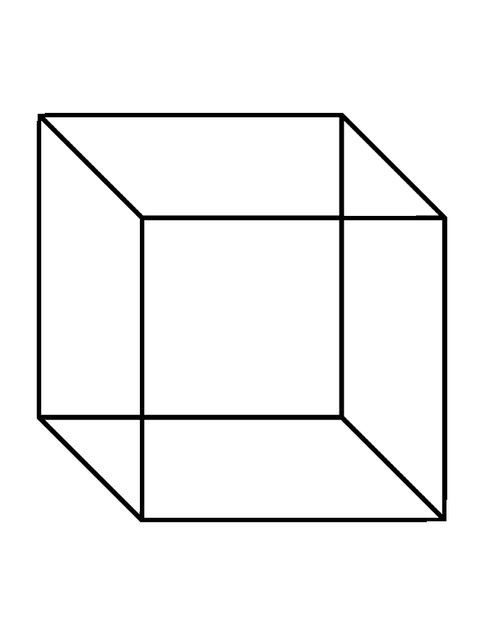 | Diamond
9. |  | Triangle
10. |  | Square

DATE TEACHER’S SIGN

FREE HAND DRAWING
Objective: To draw a picture using shapes.
Draw a picture using the shapes given below and colour the pictures by using the instruction given below :

- Red - Green - Blue

- Orange - - Yellow - - Pink

DATE TEACHER’S SIGN

APPLICATION BASED WORKSHEET
Objective: To apply the concept based on numerical ability.
My shape Robot

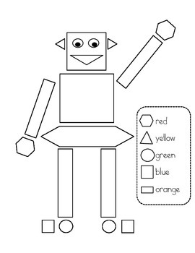

1)My robot has _________ circles.
2)My robot has _________ rectangles.
3)My robot has _________ squares.
4)My robot has _________ triangles.
5)My robot has _________ hexagons.

DATE TEACHER’S SIGN

RIDDLES
Objective: To think logically.
Word problem:
1.I have 4 sides all the same size and I have 4 corners.Who I am?____________.
2.I am thinking of an odd number,it is greater than 6 and less than 9.
What I am thinking? ____________.
3.In a tree there was 7 birds A loud noise scared some birds,now there was only 3 birds in the tree.How many birds scared of loud noise?____________.
4.Today is Monday my birthday has 5 many more days. When is my birthday on?____________.
5.You have to share your 12 candy with your friend,How many will each get?____________.
6.Sam has 9 balloons,3 are red 4 are blue and 2 are yellow.How many balloons are there in red and yellow colour?____________.
7.Can you solve;
+ = 15

_ = 5

X = ____

DATE TEACHER’S SIGN

7.JUGS AND MUGS
CONCEPT BASED WORKSHEET

Objective: To know the estimating concept.
Circle the objects that holds more than the other in each pair.

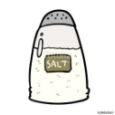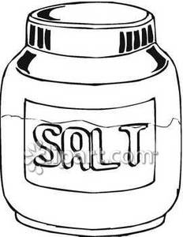
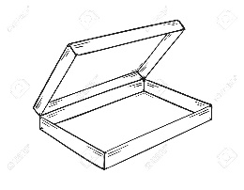 | 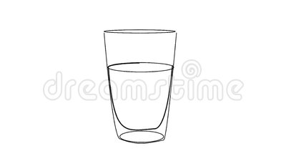
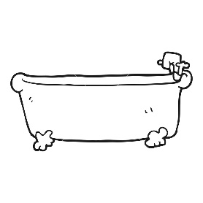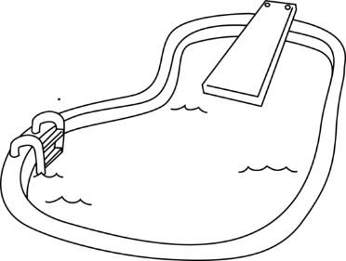

DATE TEACHER’S SIGN

MEASURING UNIT

Objective :To know the measuring volume.

Estimate the each object can hold. Then find the actual amount that the container can hold.

Item | Estimate | Actual
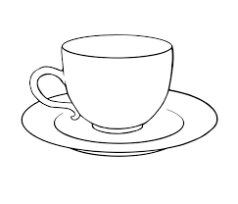 | ________ spoons. | ________ spoons.
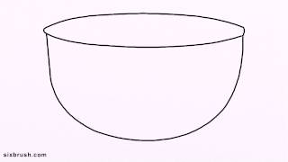 | ________ glasses. | ________ glasses.
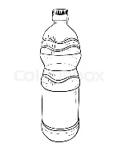 | ________ glasses. | ________ glasses.
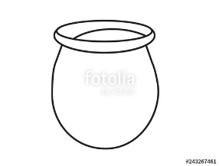 | ______ waterbottles . | ______ waterbottles .
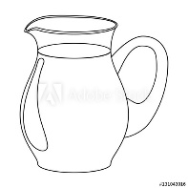 | ________ glasses. | ________ glasses.
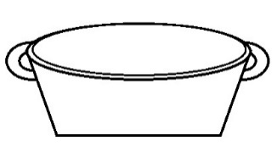 | ________ pots. | ________ pots.
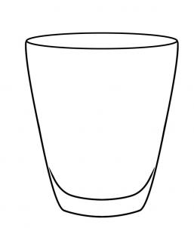 | ________ spoons. | ________ spoons.
DATE TEACHER’S SIGN

LEARNING THE UNITS.
Objective: To know the units for the liquids.
Read and write the answers:
1000ml = 1 l.
ml = milli litre
l = litre
Convert l (litre) into ml (millilitre) and viceversa:
1)5 l = _______ ml.
2) 7 l = _______ ml.
3)9 l = _______ ml.
4)2 l = _______ ml.
5)11 l = _______ ml.
6)6 l = _______ ml.
7)4 l = _______ ml.
8)2.5 l = _______ ml.
9)8 l = _______ ml.
10)12 l = _______ ml.
11)9.2 l = _______ ml.
12)7.1 l = _______ ml.
13)6.3 l = _______ ml.
14)1 l = _______ ml.
15)3 l = _______ ml.

DATE TEACHER’S SIGN

PEN PAPER TEST
Objective: To apply the concept.
Solve the following word problems:

1)Seena filled 9 pots with water. She fills 100ml on each pots. How much water she filled in all the pots? _____________.

2)There are 3 empty bottles in a bench. Each bottle can hold 1l of juice.How much juice is required to fill all the bottles? _____________.

3) Solve: 630 ml + 370 ml = _________l.

4) A cow can give 8l of milk a day. How much milk can cow give in 3 days? _____________.

5)The volume of 1 cane of slice is 500 ml . What is the volume of 5 cane? _____________.

6) Magil ask Abi to fill a glass with 10ml of water . How much glass can he fills with 50ml of water?_____________.

7)Vedha had 7l of lime juice in that vedha and his friend Karthi drank 3l of juice. How much juice is remaining with Vedha?_____________.

DATE TEACHER’S SIGN

