GRADE III
ENGLISH
DAILY PRACTICE PAPER
[DPP]
2019-2020

PRE-MID TERM
S.NO | DATE | CONTENT | REMARKS | TEACHER  SIGNATURE
1
2
3
4
5
6
7
8
9
10
11
12

UNIT 1
POEM: GOOD MORNING
Spot the correct Rhyming words
Objectives: Able to find the correct rhyming words.

Rhyming Words

Using the given clues, find the rhyming word.

Chick cat Shark Baboon duck goose

1. buck _________________________
2. lark _________________________
3. raccoon _________________________
4. moose _________________________
5. tick _________________________
6. bat _________________________

DATE: TEACHER’S SIGN:
NOUN FINDER

Objectives: Able to find the noun

[Nouns are words that name people, places, and things (including ideas and feelings) ]
Read each sentence and draw a box around each noun.
- Her pencil was broken.
- The boy jumped in the pool.
- The cat ran across the yard
- The lizard slithered across the rock.
- The computer played the movie.
- Her juice spilled on the table
- His dog barked all night.
- The coat fell on the floor.
- She finished her apple juice.
- The horse galloped around the corral.

DATE: TEACHER’S SIGN:

PICTURE COMPREHENSION
Objectives: Able to see the picture and write a few sentences about it.
Write 5 sentences to describe the picture and give a suitable title.
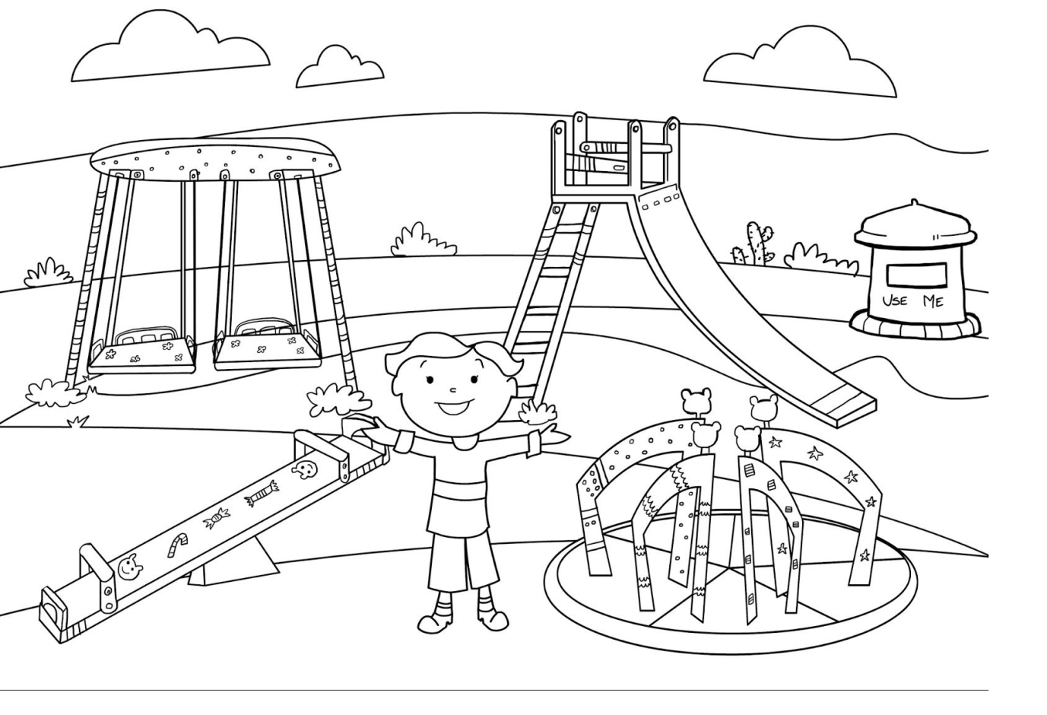

DATE: TEACHER’S SIGN:
PROSE: THE MAGIC GARDEN
Identifying Subject
Objectives: Able to understand and find the subject from the given sentences.

Read the sentences and underline the subject:
1. The police officer pulled over the red car.
2. My little brother loves this song.
3. Four children played in the sandbox.
4. The opera singer finished on a high note.
5. The football player spiked the ball.
6. The blue bicycle sped down the long hill.
7. Cindy, Vicky and Tammy went to the spa together.
8. That giant oak tree is really old.
9. The little girl skinned her knee.
10. Isabelle danced beautifully!

DATE: TEACHER’S SIGN:
IDENTIFYING SUBJECT AND PREDICATE
Objectives: Able to understand and find the subject and predicate from the given sentences.
Circle the subject and underline the predicate in the given sentences:
1. The police officer pulled over the red car.
2. My little brother loves this song.
3. Four children played in the sandbox.
4. The opera singer finished on a high note.
5. The football player spiked the ball.
6. The blue bicycle sped down the long hill.
7. Cindy, Vicky and Tammy went to the spa together.
8. That giant oak tree is really old.
9. The little girl skinned her knee.
10. Isabelle danced beautifully!

DATE: TEACHER’S SIGN:
PARAGRAPH COMPREHENSION
Objectives: Able to read the passage and answer the following questions.
Read the given passage and answer the questions below:
THE PUPPY AND THE KITTEN
My family just adopted a puppy and a kitten from the animal shelter. They were so young, they did not even have names yet. We had to think of good names for them.
The puppy likes to jump up. The kitten likes to curl up in our laps. “What do you want to name them?” asked Mom.
My sister said, “Pounce for the puppy and Cuddles for the kitten.” We all thought those names were perfect.
Answer the Questions:
- What animals did the family adopt?

- What does the kitten like to do?

- What is the puppy’s name going to be?

- Name the pet animal which you would like to have.

DATE: TEACHER’S SIGN:
UNIT 2
POEM: BIRD TALK
PAPER PENCIL TEST
Objectives: Able to understand and answer the questions about the poem.
Patterns in Poems
1.My brother gave me a red yo‐yo
I flick my wrist and watch it go.

Towards my feet and towards my hips,
Down and then back up it zips!
2.
I wish I had a toy boat
To take down to the lake

I’d cast it off and it would float
And leave a little wake!

Answer the following questions:

- How many stanzas are in each poem?
__________________________________

- How many rhyming pairs are there in the given poem?

_________________________________

- Write down the rhyming scheme for the given poem

_________________________________

DATE: TEACHER’S SIGN:
NOUN FINDER
Objectives: Able to find the collective noun

Fill in the blank in each sentence with the correct collective noun from the word bank.
Box colony crowd gaggle
Gang herd pack pad

1. My aunt gave me a ________________ of crayons.
2. The ________________ of cows crossed the country road.
3. A ________________ of ants lived under the log.
4. The farmer kept a ________________ of geese in the barnyard.
5. My little brother got lost in the ________________ of people.
6. The ________________ of dogs chased the kitten under a car.
7. The police are looking for a ________________ of thieves.
8. My mother wrote the list on a ________________ of paper.

DATE: TEACHER’S SIGN:

POEM COMPREHENSION
Objectives: Able to read the stanza and answer the following questions.
Read the given passage and answer the following questions:
AT THE ZOO

First I saw the white bear, then I saw the black; Then I saw the camel with a hump upon his back; Then I saw the grey wolf, with mutton in his maw; Then I saw the wombat waddle in the straw; Then I saw the elephant a-waving of his trunk;
Then I saw the monkeys—mercy, how unpleasantly they smelt!

Answer the Questions:
- What colors were the two bears?

- What did the camel have upon his back?

- What did the wombat do in the straw?

- Which is the last animal that was seen?

DATE: TEACHER’S SIGN:
PROSE: NINA AND THE BABY SPARROWS
Tell Me More
Objectives: Able to identify the correct opposite word by matching.

DATE: TEACHER’S SIGN:

PICTURE STRIP
Objectives: Able to identify the correct sound of the animals and birds.
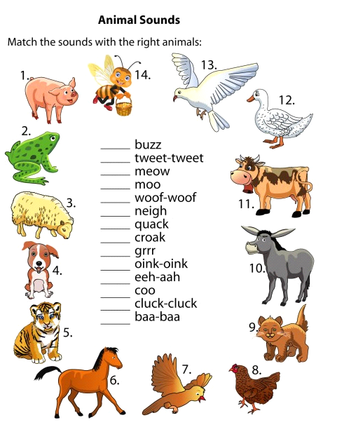

DATE: TEACHER’S SIGN:

TELL ME MORE
Objectives: Able to find the suitable meaning from the box.
Synonyms
Stone, Below foolish, Close, Hard, answer, sniff, gift

For each word, find a word in the box that means the same, or almost the same, and write it on the line.

1. difficult ________________
2. smell ________________
3. rock ________________
4. shut ________________
5. present ________________
6. under ________________
7. funny ________________
8. reply ________________

Fill in the Blank

DATE: TEACHER’S SIGN:

PARAGRAPH COMPREHENSION
Objectives: Able to read the stanza and answer the following questions.
Read the given passage and answer the given questions:

THE THUNDERSTORM

The kids were outside playing catch. They heard a rumble in the sky.

They didn’t want to stop playing, but they knew it wasn’t safe to be out in a storm. Also, they did not want to get wet.
They decided to go inside and play a board game. They loved listening to the thunder as they played their game.
The kids went outside again after the storm had passed. They saw a rainbow!

Answer the Questions:
- What were the kids playing outside?

- What did they hear?

- Where did they go?

- What did they play inside?

DATE: TEACHER’S SIGN:

