GRADE III
ENGLISH
DAILY PRACTICE PAPER
[DPP]
2019-2020

POST MID TERM
UNIT V
POEM: THE BALLOON MAN
APPLICATION BASED WORKSHEET
Objective: To arrange the letters to make a meaningful word.
Unjumble the letters to form words.

- NUSNY – 6.IWND –
- GIHH – 7.EISHN –
- GNIRTS – 8.RETTYP –
- EENRG - 9.DSTAN –
- MALLS – 10.PPLEUR –

PAPER PENCIL TEST
Objective: To make sentences for the given words.
Make sentences by using the following words.
- Balloon - __________________________________________
- Market - ___________________________________________
- Wind - _____________________________________________
- High - _____________________________________________
- Lunch - ____________________________________________
DATE TEACHER’S SIGN

PICTURE DESCRIPTION
Objective: To see and write few sentences about the picture.
Write five sentences to describe the picture and give a suitable title.
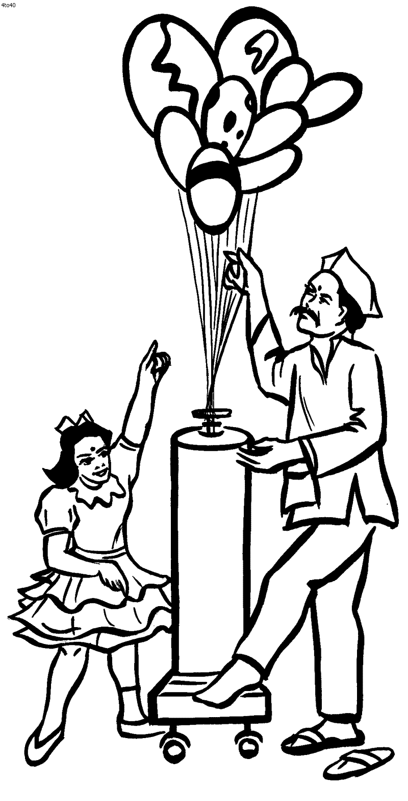
Title: ____________________________________________
- _______________________________________________
- _______________________________________________
- ________________________________________________
- _______________________________________________
- ________________________________________________

DATE TEACHER’S SIGN

PROSE: THE YELLOW BUTTERFLY
PAPER PENCIL TEST
Objective: Able to write two words.
Make two words from the given word.
- Anyone – _________ __________
- Everyday – _________ __________
- Sometime – _________ ___________
- Dragonfly – __________ ___________
- Moonlight – __________ ___________
- Newspaper – ___________ ___________
- Outpatient – ___________ ___________
- Grasshopper – ___________ ___________
- Photocopy – ___________ ___________
- Cowboy – ___________ ____________
- Birthday – ___________ ____________
- Friendship – ___________ ____________
DATE TEACHER’S SIGN

APPLICATION BASED WORKSHEET
Objective: To find the meanings.
Find the meanings of the following words, by using dictionary
- Escape –
- Flutter –
- Chase –
- Twist –
- Sail –
- Catch –
- Middle –
- Float –
Draw and color a beautiful butterfly.

DATE TEACHER’S SIGN

PARAGRAPH COMPREHENSION
Objective: To read the passage and answer the following questions.
THE ANT AND THE DOVE
Read the given story and answer the following questions.
There was an Ant who was very thirsty, and she went down to the brook to drink, but the current carried her away down the stream. A Dove pulled a leaf from the bush nearby and dropped it into the water. The Ant, climbing upon the leaf, floated down the stream and she landed safely. Not long after, a man who was out in the woods tried to catch the Dove and just as the man was about to catch the Dove the Ant bit him on his heel. So, the Dove flew away safely.

Answer the following questions:

- Was the Ant thirsty?
b) Yes b) No
2. Why did she go down to the brook?
a) To drink b) To swim
3. What did Dove do?
a) Pulled a leaf b) Pushed a leaf
4. Where did the Ant bite a man?
a) On his Heel b) On his Nose
5. What is the title of the story?
_____________________________________

DATE TEACHER’S SIGN

UNIT VI
POEM: TRAINS
APPLICATION BASED WORKSHEET
Objective: To write the related rhyming pairs for the given word.
Write the pair of rhyming words for the words given below.
- Plains – 6.Mail –
- On – 7.Dusk –
- Cars – 8.River –
- In – 9.Loads –
- Carry – 10.Bring –
Draw and color your favorite means of transport.

DATE TEACHER’S SIGN

POEM COMPREHENSION
Objective: To read the stanza and find the answer.
Read the given stanza and answer the following questions.
SPOT CAN TROT

Spot is a horse.
Spot can run.
Spot can run fast.
Spot can trot.
Spot can trot fast.
Spot wins a lot.
He is a hot shot!

Answer the following questions.
- Spot is a _______.
- Dog b) Horse
- Spot can trot _________.
- Away b) Fast
- Spot wins _________.
- A pot b) A lot
- What is the name of the horse?
- Spot b) Foot
- What is the title of the poem?
- Spot can Trot b) Spot run Fast

DATE TEACHER’S SIGN

ROSE: THE STORY OF THE ROAD
PENCIL PAPER TEST
Objective: To write the correct plural form of the noun.

Write the plural of the words given in the bracket.
- Both the _____________(girl) enjoy fishing.
- How many_____________(horse) can fit in the stable?
- _______________(Cherry) are on sale at the grocery store.
- How many ________________(brush) do you need for art class?
- There are two ______________(fox) in the cave.
- I have two _____________ (brother).
- She has many ____________(fruit).
- In our garden, my father planted many __________(tree).
- Dhanush has two ______________(box) of crackers.
- I have many ______________(friend).

DATE TEACHER’S SIGN

APPLICATION BASED WORKSHEET
Objective: Able to write the correct verb.
Fill in the blanks with the correct verb from the bracket.
- The crayons __________ (is / are) on the floor.
- Tara ____________ (draws / draw) a painting every day.
- Madhu _____________ (pick / picks) flowers from the garden.
- The flowers_____________ (is / are) in a vase.
- Liya and Riya ____________ (plays / play) together.
- I ____________ (like / likes) music.
- Water ____________ (flows / flow) in the river.
- He _____________ (sleep / sleeps) at 10 PM.
- They ____________ (are / is) going to shopping.
- We ____________ (works / work) in a hospital.

DATE TEACHER’S SIGN

DATE TEACHER’S SIGN

PARAGRAPH COMPREHENSION
Objective: Able to read the given passage and answer the following questions.
PICKING APPLES
Read the passage and answer the following questions.
Jonas is going to apple picking with his sister Maria. They are going to the apple orchard near their house. They need to pick twelve apples. Their mom is going to use the apples to make a big apple pie. At the orchard Jonas picked nine apples and Maria picked three. They had a great day together. Now they can’t wait to enjoy their pie.

Answer the following questions:

- Where is Jonas going?
- To school b) To the apple orchard
- Who is he going with?
- Mother b) Maria
- How many apples do they need?
- Ten b) Twelve
- What will their mother do with the apples?
- Make a pie b) Make apple juice
- How many apples were picked by Maria?
- Three b) Thirteen

DATE TEACHER’S SIGN

UNIT VII POEM: PUPPY AND I
APPLICATION BASED WORKSHEET
Objective: To apply his/her knowledge.
Write down the past tense of the verbs given below.
- Move - ____________ Push - ___________
- Care - ___________ Walk - __________
- Go - ___________ Bake - ___________
- Come - __________ Use - ____________
- Meet - __________ Wait - __________
Give the opposite words by adding ‘-in’ or ‘-im’ or ‘un’.
- Happy x ___________ Safe x ____________
- Pure x ___________ Patient x ____________
- Polite x ___________ Seen x ____________
- possible x ___________ Complete x ___________
- Proper x __________ Mortal x ___________

DATE TEACHER’S SIGN

POEM COMPREHENSION
Objective: To read the stanza and find answer.
Read the given stanza and answer the following questions.
JAKE BAKES
Jake likes to bake.
He will make yummy cake.
“Can I help you bake?” asks Maya.
“Sure”, says Jake. “You can help me
Bake the cake.”
Jake takes out the bowls.
Maya takes out the sugar and flour.
Together, they bake the cake.
After the cake cools, Maya puts on some icing.
Jake shakes sprinkles on top of the cake.
“Look!” says Jake. “We baked a great cake!”
Answer the following questions:
- Jake likes to _________.
- Bake b) Make things
- Jake takes out _________.
- Plates b) Bowls
- Who helps Jake?
- Maya b) Father
- Maya puts on __________.
- Some icing b) Candles
- The cake was made by ________.
- Jake and Maya b) Maya and Father
DATE TEACHER’S SIGN

PROSE: LITTLE TIGER, BIG TIGER
APPLICATION BASED WORKSHEET
Objective: To know about prepositions.
Fill in the blanks with correct prepositions.
- The cat is ____________ (on / in) the table.
- The river flows ____________ (over / under) the bridge.
- We do not work ____________ (during / at) holidays.
- The stars’ shine ______________ (over / by) the night.
- The house is ______________ (in / on) fire.
- He sat _____________ (on / with) the chair.
- She lost her ring ______________ (on / at) the beach.
- The sun is _______________ (above / below) the clouds.
- I got a gift ____________ (from / to) my friend.
- She drew a picture _____________ (with / on) crayons.

DATE TEACHER’S SIGN

TELL ME MORE
Objective: To identify the correct animals with their young ones.
Match the animals with their young ones.
Animals Young one
- Frog – Caterpillar
- Butterfly – Tadpole
- Buffalo – Chick
- Hen – Calf
- Owl – Joey
- Kangaroo – Owlet
- Rabbit – fawn
- Deer – Kit
- Donkey – Infant
- Monkey – Foal

DATE TEACHER’S SIGN

PICTURE COMPREHENSION
Objective: Able to describe the picture.
Write five sentences to describe the picture and give a suitable title.
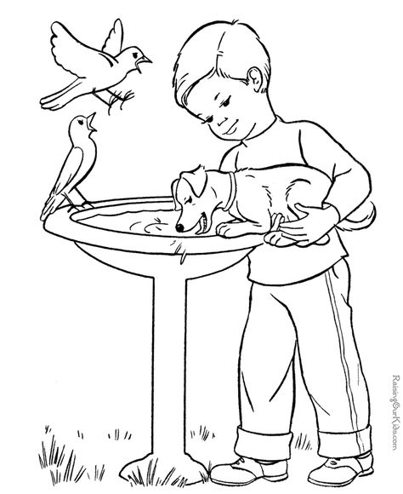
TITLE: __________________________________________
- ___________________________________________________
- ___________________________________________________
- ___________________________________________________
- ___________________________________________________
- ___________________________________________________

DATE TEACHER’S SIGN

CONJUCTION
Objective: Able to write the linking words:
I.Fill in the blanks with appropriate linking words:
[and or but so]
1.Mohan went to the supermarket _________________ bought some fruits.
2.My father is not in home now _________________ I cannot go out.
3.I went to Hari’s house _________________ he wasn’t there.
4.We must leave now _______________ we will miss the plane.
5.What would you like to drink? Tea ________________ coffee?

II.Use ‘Some’ or ‘any’ to complete the sentences:
1.There is ______________________ milk in the fridge.
2.She bought ____________________ flowers for her mother.
3.May I have _______________ water, please?
4.I haven’t got ___________________ money.
5.Are there ____________________ toffees left.

DATE TEACHER’S SIGN

PARAGRAPH COMPREHENSION
Objective: Able to read the given passage and answer the following questions.
Read the following passage. Answer the following questions in one word or one sentence.
Father: Salim, why are you wearing sherwani to school today?
Salim : We are doing a play on Chacha Nehru,today. Today is 14th November and we are going to stage a play on Chacha Nehru. Nehru was fond of children. So, we celebrate this day as Children’s day. We call him as Chacha.
Ahmed: I am going to play the role of Gandhi. Gandhi was called ‘Bapu’. The father of Nation.
Questions:
- Who is going to play the role of Nehru? __________________________________________________________________
ii) Who is going to play the role of Gandhi? ___________________________________________________________________
iii) Who is wearing Sherwani? ___________________________________________________________________
iv) Who are going to stage a play? ___________________________________________________________________
v) Where they are playing a stage? ___________________________________________________________________
vi) Whose birthday is going to be celebrated? ___________________________________________________________________
vii) On which day we celebrate Chacha’s birthday? ___________________________________________________________________
viii) Who is known as Chacha?
___________________________________________________________________
ix) Who was fond of children? ___________________________________________________________________
x) Who is known as father of Nation?
__________________________________________________________________
DATE TEACHER’S SIGN

DATE TEACHER’S SIGN

