GRADE III
EVS
DAILY PRACTICE PAPER
[DPP]
2019-2020

PRE-MID TERM
S.NO | DATE | CONTENT | REMARKS | TEACHER  SIGNATURE
1
2
3
4
5
6
7
8
9
10
11
12

CHAPTER:1
POONAM’S DAY OUT
CHECK YOUR PRIOR KNOWLEDGE

Objective: Able to understand about the animals.

I. Give an Example for
(a) a beautiful bird with blue green long feather: ___________
(b) an animal which gives us wool: ___________
(c) an animal which gives us milk: ___________
(d) an animal with four legs: ___________
(e) an animal with no legs: ___________

Objective: Able to understand the sound of animals.
II. Tick the correct answers:
(a) A bird : croaks/chirps
(b) A cat : moos/mews
(C) A dog : neighs/ barks
(d) A frog : croaks/chirps
(e) A lion : roars/bray
DATE: TEACHER’S SIGN:
CONCEPT BASED WORKSHEET
Objective: Able to differentiate living places of animals.
I. Arrange the following animals according to the place where they live:

CROW , LION, TIGER, FISH, PARROT, CROCODILE, OCTOPUS, BEES, SPARROW, ZEBRA, DOG, TORTOISE.
LAND | WATER | TREE

Objective: Able to understand different habitat of animals.

II. Answer the following questions:
(a) Name two animals that eat grass: ___________ ___________
(b) Name two animals that eat flesh: ___________ ___________
(c) Name two animals that live in water: ___________ ___________
(d) Name two animals that have wings: ___________ ___________
(e) Name two animals that can hop: ___________ ___________
DATE: TEACHER’S SIGN:
DIAGRAM BASED WORKSHEET
Objective: Able to know the name of the animals.
I.Identify the following animals. Write their name and colour the pictures:
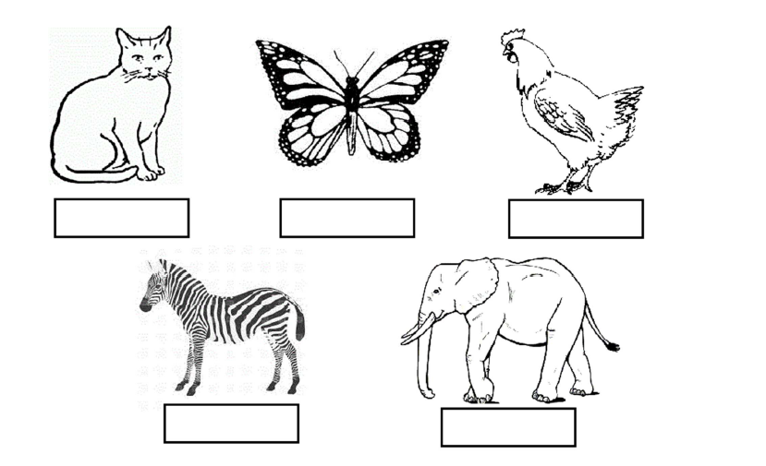

Objective: Able to find the names of animals.
II.Find out the names from the given grid:
Monkey Frog Owl Snail Spider
S | P | I | D | E | R | S
Q | W | E | R | T | Y | U
M | F | A | S | Z | X | C
O | R | S | N | A | I | L
N | O | A | S | D | F | G
K | G | Q | O | R | T | Y
E | A | U | W | I | O | P
Y | D | F | I | H | J | K
DATE: TEACHER’S SIGN:

APPLICATION BASED WORKSHEET
Objective: Able to identify the movement of animals.
I.How does these animals move?

[run, hop, crawl, fly, swim]
- Sparrow - ______________________
- snake - ______________________
(c) A frog - ______________________
(d) A fish - ______________________
(e) A horse - ______________________

II. Where will you find these animals?

[river or sea or pond, Park or garden, forest and zoo, tree, near our house]

- Grasshopper, wasp, butterfly, ladybird - __________________________________
- Cow, buffalo, goat, sheep - __________________________________
- Lion, elephant, zebra, wolf - __________________________________
- Fish, tadpoles, Water-snake - __________________________________
- Squirrel, Monkey, crow, sparrow - __________________________________

DATE: TEACHER’S SIGN:

CHAPTER:2
THE PLANT FAIRY
DIAGRAM BASED WORKSHEET
Objectives: Able to identify the parts of a plant.
I. Name the parts of the plant:
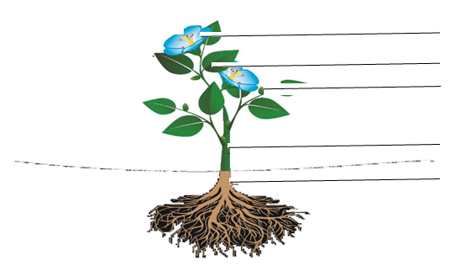
Objective: Able to draw the patterns of flowers or leaves.
II.Draw, name and colour four objects that have patterns of flowers or leaves on them:

DATE: TEACHER’S SIGN:
CHECK YOUR KNOWLEDGE

Objective: Able to write the different types of plants
I. Name the following;
a) Two big trees ___________ ___________
b) Two plants whose flowers you like ___________ ___________
c) Two plants whose leaves are eaten: ___________ ___________
d) Two plants whose roots are eaten: ___________ ___________
e) Two plants with soft stem: ___________ ___________
Objectives: Able to understand the uses of plants
II. Name any two trees or plants which give us:
- Medicine: ___________ ___________
- Perfume: ___________ ___________
- Fruit: ___________ ___________
- Vegetable: ___________ ___________
- Oil: ___________ ___________

DATE: TEACHER’S SIGN:

CHAPTER 3
WATER O’ WATER!
QUICK CHECK
Objective: Able to write about water
I. Write two sources of water:

- ___________ b) ____________
2. Name the three forms of water:
a)___________ b) ___________ c)___________
3. Name two rivers:
a) ___________ b) ___________
4.Write two uses of water:
a) ___________ b) ___________
Objective: Able to draw the sources of drinking water.
II. Draw, name and colour two sources of drinking water:

DATE: TEACHER’S SIGN:

ACTIVITY BASED WORKSHEET
Objective: Able to demonstrate the activities with the help of water.
I. Name five activities which you cannot do without water:
a) _______________________________________________________

b) ________________________________________________________

c) ________________________________________________________

d) ________________________________________________________

e) ________________________________________________________
Objective: Able to demonstrate the activities which can be done without water.
II. Write five activities which you can do without water:

a) _______________________________________________________

b) ________________________________________________________

c) ________________________________________________________

d) ________________________________________________________

e) ________________________________________________________
DATE: TEACHER’S SIGN:

TEST YOURSELVES
Objective: Able to know the different forms of water.
I. Fill in the blanks:
a) ________ is the solid form of water.
b) ________ is the gaseous form of water.
c) ________ is a huge source of salty water.
d)________ is the purest form of water.
e)Always ________ your hands before eating food.
DIAGRAM BASED WORKSHEET
Objective: Able to draw the containers.
II. Draw name any two containers which you use for storing water:
a)________________ | b)_________________

DATE: TEACHER’S SIGN:

CHAPTER 4
OUR FIRST SCHOOL
EXPERIMENT BASED WORKSHEET
Objective: Able to know the family members and their relationship
I. Name five members of your family and their relationship with you:
Name of the family member | Relationship with you
1.
2.
3.
4.
5.

ANALYSE AND EVALUATE
Objective: Able to identify the family relations.
II. Match the following relationship:
Father - Wife
Husband - Aunt
Grandfather - Sister
Uncle - Grandmother
Brother - Mother

DATE: TEACHER’S SIGN:
DIAGRAM BASED WORKSHEET
Objective: Able to draw the family members and their names.
I. Draw a family tree and write the names of your family members:

QUIZ BASED WORKSHEET
Objective: Able to identify the family relations.
I. How do you address these relations.
a) Father’s father: ______________

b) Father’s sister: ______________

c) Mother’s mother: ______________

d) Mother’s brother: ______________

e) Mother’s sister: ______________

DATE: TEACHER’S SIGN:

CHAPTER 5
THE CHHOTU’S HOUSE
PICTURE MYSTERY
Objective: Able to draw the house.
I. Draw the picture of your room and colour it:
DATE: TEACHER’S SIGN:
CHECK YOUR KNOWLEDGE
Objective: Able to know the different houses name.
I. Name the types of houses:
____________ ____________ ____________

____________ ____________ ____________

Objective: Able to write the decorating things of house.
II. Name the things with which you decorate your house:

____________ ____________ ____________

____________ ____________ ____________

Objective: Able to identify the rooms of house.
III. Name the rooms t of this house :
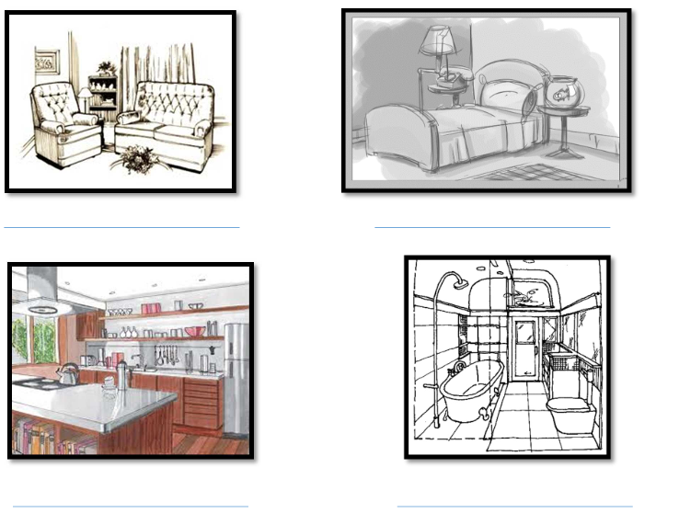
REASON BASED WORKSHEET
Objective: Able to find the odd one out.
I. Encircle the odd one out:
a) Bathroom-
Bucket Tub Bed soap
b) Bedroom-
Bed Almirah Bucket Dressing table
c) Drawing Room-
Sofa Table Television Sink
d) Kitchen
Gas Stove Shower Utensils Fridge
Objective: Able to draw the animals:
II. Name, draw and colour the picture of two animals that enter your house un-invited:
a)________________ | b)_________________
DATE: TEACHER’S SIGN:

