GRADE III
MATHS
DAILY PRACTICE PAPER
[DPP]
2019-2020

PRE-MID TERM
S.NO | DATE | CONTENT | REMARKS | TEACHER  SIGNATURE
1
2
3
4
5
6
7
8
9
10
11
12

1. WHERE TO LOOK FROM ? FIND THE VIEW
Objective: To understand the different types of viewing the object
- Underline the correct view to look at these things:

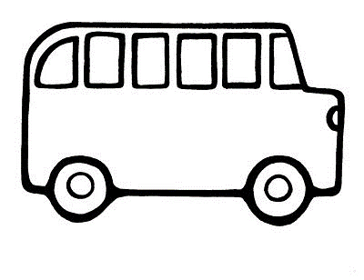
Top/Side/Front Top/Side/Front
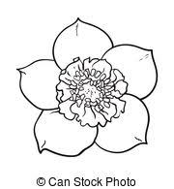

Top/Side/Front Top/Side/Front

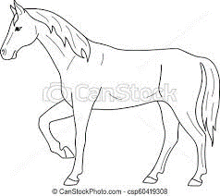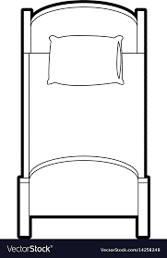
Top/Side/Front Top/Side/Front
DATE: TEACHER’S SIGN:
DOT PATTERN
Objective: To continue the pattern using dots
- Continue each pattern

II. Complete these figures to form the basic shapes.

DATE: TEACHER’S SIGN:
THINK AND WRITE
Objective : To find the difference between symmetry and non symmetrical objects.
Is the dotted line drawn on the figure a line of symmetry? Write Yes / No.

DATE: TEACHER’S SIGN:

DIVIDE ME
Objective: To find mirror halves
1. Draw the Line of Symmetry for the following:

A M U W

E B C D
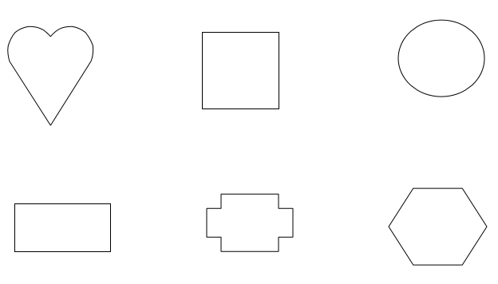
DATE: TEACHER’S SIGN:
2.FUN WITH NUMBERS
Objective:Recognize and sequence the numbers.
1. Fill in the missing numerals

300 |  |  |  |  | 305
768 |  |  |  |  | 773
943 |  |  |  |  | 948
Objective: To Understand the number names.
2. Write the number names for the following

a) 199 ________________________________________________
b) 213 ________________________________________________
c) 341 ________________________________________________
d) 605 ________________________________________________

Objective : Understand the concept of skip count.
3. Counting by 2’s write the numbers starting from:

202 |  |  |  | 210
454 |  |  |  | 462
798
646

4. Counting by 5’s write the numbers starting from:
500
455
315
960
DATE: TEACHER’S SIGN:
ARRANGE ME

Objective: Rearrange the numbers in ascending and descending order
1. Arrange the following numbers in ascending order
576 953
469 154
452 464
432 489

2. Arrange the following numbers in descending order

852 844
832 865
674 574
945 376

3. How many triangles can you find in this figure? ___________________

DATE: TEACHER’S SIGN:
FIND AND COLOUR

Objective : To understand the concept of place value.
1. Who am I ?
1) My Ones digit is four.

My Tens digit is 3 more than my Ones digit.
I am the number ___________________.

2) My Ones digit is five.

My Tens digit is 2 more than my Ones digit.
My Hundreds digit is 1 less than my Ones digit.
I am the number ___________________ .

3) My Ones digit is zero.

My Tens digit is 7 more than my Ones digit.
My Hundreds digit is 6 more than my Ones digit.
I am the number _____________________.

2. Colour the Numbers as directed.

18 | 9 | 132
6 | 65 | 875
43 | 568 | 7

1 digit numbers GREEN.
2 digit numbers YELLOW.
3 digit numbers RED.

DATE: TEACHER’S SIGN:

EXPANDING WORKSHEET
Objective: To understand the expanded form.
1. Write the Expanded form of the following Numbers.

1. 732 = 700 + 30 + 2.
2. 123 = __________________________________
3. 390 = __________________________________
4. 589 = __________________________________
5. 666 = __________________________________
6. 909 = __________________________________
7. 576 = __________________________________
8. 345 = __________________________________
9. 809 = __________________________________
10. 200 = __________________________________
11. 851 = __________________________________
12. 454 = __________________________________
13. 333 = __________________________________
14. 666 = __________________________________
15. 760 = __________________________________
DATE: TEACHER’S SIGN:
SMART CHARTS
MAKE A TALLY
Objective: Able to write the tally of numbers
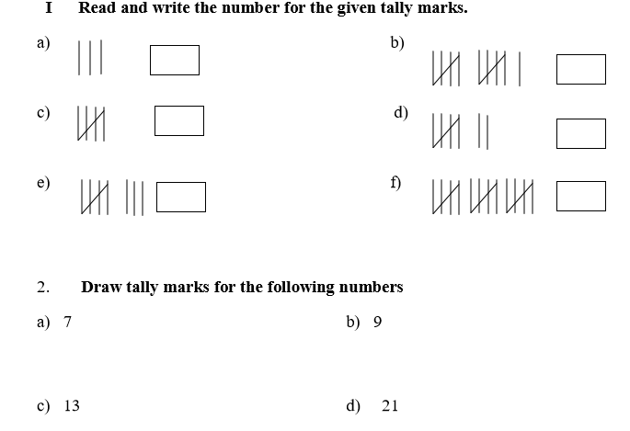

e) 19 f) 25

g) 5 h) 11

DATE: TEACHER’S SIGN:
ABILITY TO COMPUTE
Objective: To understand the pictograph
- Read the table given below about the hobbies of students of class III .Represent the data pictorially using smilies (☺ = 1 student)
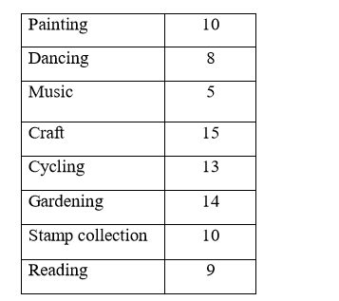
(a) Which is the most popular hobby?
__________________________________________________________________

(b) Which is the least popular hobby? __________________________________________________________________

(c) How many more children like craft than music? __________________________________________________________________

(d) How many students like gardening? __________________________________________________________________
(e) What is the difference between the number of students who prefer reading and those who prefer music? ___________________________________________________________________
DATE: TEACHER’S SIGN:
RELATE AND DRAW
Objective: To draw the bar graph
The table given below shows the number of absentees in class III in a week. Represent the same in the form of a bar chart: (1 cm = 1 student)
DAYS | NUMBER OF STUDENTS ABSENT
MON | 4
TUE | 3
WED | 8
THURS | 9
FRI | 5
SAT | 10

Mon Tue Wed Thurs Fri Sat

DATE: TEACHER’S SIGN:
STUDY THE CHART
Objective : Able to interpret the given data
Aman, Bhanu, Shreya, Tarun and Tanya measured the length of their pencils. They stuck their strips as shown.
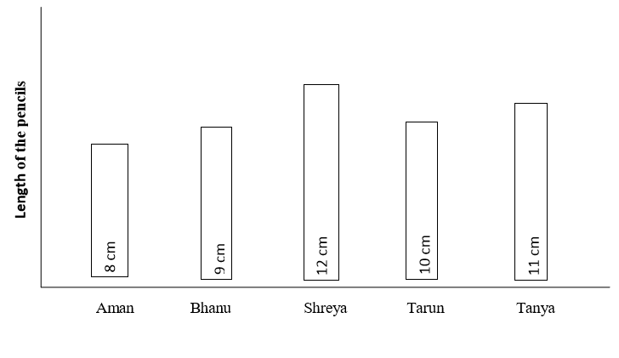
Study the above chart and answer the following questions
(a) The length of Aman’s pencil is ____________cms.
(b) The length of Shreys’s pencil is ____________cms.
(c) Length of Bhanu’s pencil is ______than Tanya’s pencil(more, less).
(d) The difference between the length of pencils of Tarun and Aman is ____cms
(e) Arrange the length of the given pencils in descending order
____________________________________________________________

DATE: TEACHER’S SIGN:

