GRADE IV
ENGLISH
DAILY PRACTICE PAPER
[DPP]
2019-2020

POST MID TERM
UNIT-5 - DON’T BE AFRAID OF THE DARK
NOUN FINDER
Objective: To identify the nouns.

Underline the nouns (naming words) in the below sentences.
1. I love red cars.
2. John and Mary went to the supermarket and bought eggs and cheese.
3. We had pizza for dinner.
4. We get medicine from plants.
5. Give me a cup of tea.
6. I have a pet dog.
7. Camel is the ship of the desert.
8. I left my pencil in school.
9. I decided to catch the bus because I was late.
10. London is very expensive to live in.

Pick out the names of the persons, places, birds, animals and things from the following sentences and put them in the box below. A name under each head is already given.
1. Parrots like nuts.
2. Cow gives us milk.
3. Tiger lives in jungles.
4. My native is Chennai.
5. The teacher is writing on the blackboard.
6. Rehaan is a naughty boy.
7. Manya studies in my school.
8. The tortoise defeated the hare.
9. The boys are playing in the garden.
10. This pen has no ink.

Persons | Places | Birds | Animals | Things
boy | Chennai | parrots | cow | milk

Colour the word which is not a noun in each group.

1. sun | see | sky | star | moon
2. tree | bird | fly | grass | leaf
3. board | chair | table | write | book
4. girls | sing | boys | school | music
5. park | players | play | football | cricket
6. goat | mouse | cow | dog | run

Look around in your classroom. Write ten nouns that you can see.
1. ------------------------- 2. -------------------------
3. ------------------------- 4. -------------------------
5. ------------------------- 6. -------------------------
7. ------------------------- 8. -------------------------
9. ------------------------- 10. -------------------------

Underline the nouns in the following story.
There were two best friends – an ant and a grasshopper. The grasshopper liked to relax the whole day and play his guitar. The ant, however, would work hard all day. He would collect food from all corners of the garden while the grasshopper relaxed, or played his guitar, or slept. The grasshopper would tell the ant to take a break every day, but the ant would refuse and continue his work. Soon, winter came. The days and nights became cold and very few creatures went out. The grasshopper couldn’t find any food and was hungry all the time. However, the ant had enough food for him to last through the winter without any worries at all.
DATE TEACHER’S SIGN

SHORT FORMS

Objective: To write the short forms of the given words.

Put ‘apostrophe’ to make the short forms of the following. One has been done for you as an
example :

did not didn’t cannot _________________
was not _________________ are not _________________
has not _________________ have not _________________
will not _________________ is not _________________
let us _________________ it is _________________
that is _________________ i am _________________
we are _________________ she is _________________
they have _________________ he will _________________
we have _________________ they are _________________

Match the words with their short forms.

1. I am - he’ll
2. we are - he’s
3. you are - they’re
4. he will - we’re
5. they will - I’m
6. they are - you’re
7. he is - they’ll
8. can not - I’ll
9. I will - can’t
10. I had - I’d

DATE TEACHER’S SIGN

HOMOPHONES

Objective: Understand the difference in spelling of words which are very closely spelt and apply them in proper context.

Example: Please try not to waste (waste, waist) paper.
1. Can I go to the party_____________ (to, too, two)?
2. This is my favourite_______________ (pare, pair, pear) of jeans.
3. I _____________(sent, scent, cent) a letter to my aunt in Vietnam.
4. The children got _________________(bored, board) during the lecture.
5. Mr. and Mrs. Rodriguez like to work in ___________(there, they’re, their) garden.
6. Alec is going to____________ (wear, ware) his work boots today.
7. Do you think it is going to____________ (rein, rain, reign) this afternoon?
8. I saw a restaurant just off the ______________(rode, road) about a mile back.
9. David’s brother is in a _____________(band, banned) which plays Russian music.
10. Juana wants her socks because her_______________ (tows, toes) are cold.
Circle the correct word.
Example: Petrol, coal and gas can all be used as…
fuel
l
fewel fhewe
1. You can dry yourself with this
towel towwel trowel
2. We are staying at a wonderful…
hotell hottel hotel
3. They are taking photographs of a…
camel camell camel
4. My favourite sandwich contains…
fallafel falafel falafel
5. I like to visit new places and to…
travell trevel travel

DATE TEACHER’S SIGN

PARAGRAPH COMPREHENSION
Objective: To read the given passage and to answer the questions accordingly.
The Earth
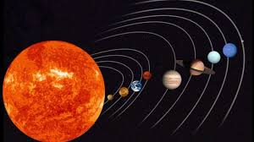

The sun is a huge star made of very hot gases. There are nine planets which revolve around the sun. These planets are Mercury, Venus, Earth, Mars, Jupiter, Saturn, Uranus, Neptune and Pluto. We live on Earth. The Earth is the only planet that has life upon it. The Earth moves on its orbit around the sun. It takes a time period of one whole year to make one complete round around it. This movement of the Earth causes day and night. Those parts of the Earth facing the sun have day time and the other parts have night time. The Earth has big masses of land which are called continents and big masses of water which are called oceans. Our homes are part of a city which in turn is a part of a country. Our country is part of the continent. Whether you live in North or South America, Asia, Europe, Africa, Australia or Antarctica, you are part of this Earth.

Answer the following questions.
1. What is the sun made of?
____________________________________________________________________________________________________
2. There are nine planets which are called
__________________________________________________________________________________________________
3. The Earth takes
____________________________________________________________________________________________________
4. The movement of the Earth causes
__________________________________________________________________________________________________
5. What are the big masses of land and water called?
_________________________________________________________________________________________________

DATE TEACHER’S SIGN

HELLEN KELLER
ADJECTIVES
Objective: To find the adjectives.
Underline the adjective in the following sentences.
1. The class was very noisy.
2. It is a warm afternoon.
3. The garden is beautiful.
4. The elephant is a huge animal.
5. I have two rabbits.
6. Rehaan is an intelligent child.
7. My uncle is very brave.
8. It is a rainy day.
9. I want two apples.
10. The child is happy.
Fill in the blanks with suitable adjectives from the box:-
cotton black seven red large four one eleven rainy oldman

1. An elephant is a ________________ animal.
2. There are ________________ days in a week.
3. During summer we wear ____________ clothes.
4. The tiger has ______________ stripes on its body.
5. Watermelon is green outside but _______________ inside.
6. A square has ____________ sides.
7. There are many stars but only _______________ moon in the sky.
8. There are ____________ players in a cricket team.
9. Mr Prakash is an ____________.
10. It is a ____________ day.

Match the adjectives with suitable nouns.
Adjectives Nouns
1. red lion
2. woolen grass
3. chubby apple
4. hot hair
5. blue tree
6. twelve tea
7. curly months
8. tall clothes
9. green sea
10. angry cheeks
DATE TEACHER’S SIGN

VERBS
Objective: To identify the verbs.
Circle the verb in each sentence.
1. We went to Gram’s house.
2. My pal Mack fed my cat.
3. He walked my dog, too.
4. We came back on the plane.
5. The plane landed at 6 P.M.
6. I thanked Mack
7. I am hungry.
8. The boy is crying.
9. We are celebrating Rekha’s birthday.
10. We have a new computer.

Fill in the blanks with the verbs.
1. Devesh ____________ the fish. (feed)
2. Father ______________ the dog. (walk)
3. Shh! The baby _______________ now. (sleep)
4. He ____________ his bike. (repair)
5. Amar ____________ the piano now. (play)

Adverbs
Circle the adverbs and underline the verbs that they describe:
Objective: To identify the verbs and adverbs.
1. We finally got our grades from the test.
2. John walked his dog to the park quickly.
3. The balloon rose quickly in the sky.
4. We danced merrily around the school yard.
5. Linda watched the ball game closely.
6. The player boldly ran from base to base.
7. My mom cares deeply about me.
8. I almost ate a rotten apple.
9. Tom plays football outside.
10. I already finished my homework.

Fill in the blanks with –ly forms of the words given.
1. The teacher explained the lesson ___________________. (clear)
2. They found the way to the bank _______________. (easy)
3. The children behaved ________________. (nice)
4. The boys played _________________. (noisy)
5. Our dog barks ______________. (loud)

Circle the adverbs and underline the adjectives. Skip the verbs and nouns!
baseball swiftly hungry yellow almost
today table sing happily warmly
bright rocket loudly teach madly
buffalo giant sister sandwich tightly
train dimly over towel fluffy
clearly rarely stringy yearly car
politely principal watch orange today
mountain fast openly outside sunny
tasty green island joyfully evenly

Choose the best answer:-

1. I ............................... go to bed at 10 o’clock.
a. once b. ever c. usually

2. I have …………………. been to the USA.
a. never b. ever c. one
3. I have been to Australia just …………………..
a. one b. once c. ones

4. I ………………….. take a bath before I go to bed.
a. once b. always c. ever

5. My grandparents live in Kerala. I visit them ................................
a. once b. often c. ever
6. She passed the exam .......................................
a. one b. ever c. easily
7. They walk .......................................to catch the train.
a. sometimes b. normally c. quickly
8. The dinner party went .......................................
a. correctly b. normally c. badly
9. John answered the question .......................................
a. usually b. ever c. correctly

10. We .......................................go to Paris in the springtime.

a. often b. badly c. easily

DATE TEACHER’S SIGN

PARAGRAPH COMPREHENSION
Objective: To read the passage and to answer the questions accordingly.
The Life Cycle of a plant
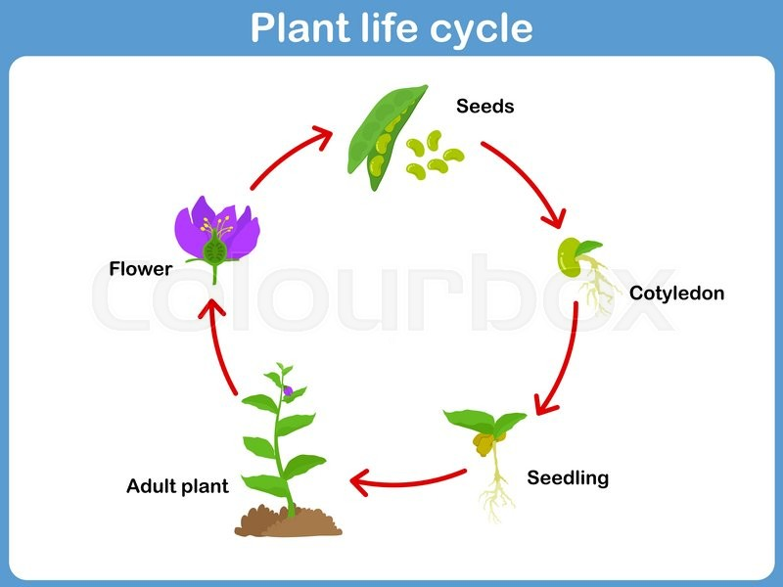

Read the explanation and answer the questions below:-

1. A plant begins its life as a seed. Small changes happen inside the seed.
2. A tiny root grows downwards, and a tiny stem grows upwards. This small plant is called seedling. It has a small stem with a few small leaves.
3. A seedling needs sunlight and water to grow. Slowly, the stem grows longer and new leaves appear. It becomes a full-grown plant.
4. Soon, flowers grow on the plant. Flowers help to make new seeds.

a. How does the life cycle of a plant begin?
________________________________________________________
b. What happens after small changes happen inside the
seed?
_____________________________________________________

______________________________________________________
c. What happens just before a seed becomes a full-grown
plant?
______________________________________________________

______________________________________________________
d. How does the life cycle of a plant begin again?
_______________________________________________________

_______________________________________________________

DATE TEACHER’S SIGN

UNIT – 6 THE DONKEY

Objective: To get familiar with animals.
Match these animals with their living places :
Animals | Living Places
- pig | - stable
- horse | - nest
- dog | - burrow
- bird | - hole
- rat | - sty
- rabbit | - kennel
I. Answer the following questions:

1. What is a baby frog called? ________________________
2. What is a baby goat called? ________________________
3. Name two animals that lay eggs. ________________________
4. What is a baby cat called? ________________________
5. Where does a cuckoo lay its eggs? ________________________

Match the following animals with their young ones:
1. Sheep  2. Horse  3. Elephant  4. Rabbit  5. Fish | (a) calf  (b) kit  (c) lamb  (d) fry  (e) colt

Write the names of the animals.
Example: This animal has two syllables. It lives in deserts and it has a hump. Camel
1. This animal has two syllables. It is black and orange. ________________
2. This animal has one syllable. It chases mice and rats. ________________
3. This animal has two syllables. It has a white tail and long ears. ________________
4. This animal has one syllable. It gives us wool and milk. It eats everything. ________________
5. This animal has one syllable. It is tiny and very busy. ________________
6 This animal has one syllable. This animal flies at night and eats fruit. _________________

DATE TEACHER’S SIGN

SINGULAR-PLURAL
Objective: To form the plural forms of words.
Rewrite the sentences with the plural form of the words underlined.
1. The man painted the walls.
___________________________________________________________________
2. The baby’s foot is very soft.
___________________________________________________________________
3. The story is about animals.
___________________________________________________________________
4. The puppet is beautiful.
___________________________________________________________________
5. The child is drawing pictures.
___________________________________________________________________
6. This shoe is polished.
___________________________________________________________________
7. I cleaned the shelf in my room.
___________________________________________________________________
8. The leaf has fallen from the tree.
___________________________________________________________________
9. The branch of this tree is very strong.
___________________________________________________________________
10. The match was cancelled due to rain.
_______________________________________________________________________

CREATIVE WRITING
Objective: To write few sentences on their own.
Write five to six sentences about ‘A Rainy Day”. Use the clues given below.
Weather cloudy use umbrellas, raincoats, warm clothes, room-heaters, eat
hot and spicy children paper boats.

__________________________________________________________________
__________________________________________________________________
__________________________________________________________________
__________________________________________________________________
__________________________________________________________________

__________________________________________________________________
DATE TEACHER’S SIGN

THE MILKMAN’S COW
ARTICLES
Objective: To use the articles a, an and the correctly.
Write a or an to complete each sentence.
1. We saw ____________ elephant at the zoo.
2. Sheela brought ____________ apple to her teacher.
3. Our family stayed in ____________ hotel on our vacation.
4. Yesterday I saw ____________ ant hill.
5. Texas is ____________ large state.
6. Please look that word up in ____________ Spanish dictionary.
7. John will put on ____________ old shirt before he begins to paint.
8. Jill will pull the toddler in ____________ wagon.
9. I use ____________ umbrella when it rains.
10. Mother placed the flowers in ____________ vase.
11. They need ____________ oven for their new house.
12. We landed on ____________ island.
13. Dad will put ____________ engine in the old car.
14. Sam will use ____________ axe to chop firewood.
15. Martin has ____________ blue and white tie.
16. Juile and Justin talked to ____________ teacher about their project.
17. She went to get ____________ open bottle of sunscreen.
18. Neal wrote ____________ article for the school paper.
19. They saw ____________ camel by the river.
20. We will wait no longer than ____________ hour.
DATE TEACHER’S SIGN

Complete the paragraph using ‘a’, ‘an’, ‘the’:
Objective: To be able to use the articles a, an and the correctly.
Once ________ farmer was going to ________ market riding his horse. ________ old man stopped him on ________ way and requested him to given him ________ ride. ________ man agreed But, when they reached ________ market, ________ old man refused to get down and started shouting at ________ farmer ________ saying it is his horse. ________ man who heard him came near them and told them to stand at ________ distance holding ________ apple and call ________ horse. ________ old man called, but the horse did not respond. when ________ Farmer called him instantly he came running. ________ man who came to settle their dispute told the farmer to take his horse and go.

Read the following sentences and complete the blanks using the following words :
is

- The weather ____________ beautiful today.
- All the children ____________ in the playground.
- Boys! You ____________ always late for class.
- ____________ you in the basketball team, too ?
- Nobody in my class ____________ interested in football.
are
- ____________ this computer more expensive than that one ?
- Sally ____________ my best friend.
- Mum and dad ____________ downstairs watching television.
- Poll and Henry ____________ in the computer room.
- The Eiffel tower ____________ the tallest monument in Paris.

DATE TEACHER’S SIGN

BASE FORM/PAST TENSE:
Objective: To know and understand the past tense of the given words.
Base form | Past tense
be | was/were
begin | began
break | broke
bring | brought
buy | bought
build | built
choose | chose
come | came
teach | taught
Stand | stood
Write | wrote
Base form | Past tense
do
drive
eat
feel
find
get
give
go
say
sit
sell
Base form | Past tense
have
keep
know
leave
lose
make
pay
run
speak
understand
win

Write the sentences in the simple past.

Example: Arjun and Maanya catch some fish. Arjun and Maanya caught some fish.

1. Maanya makes a fire with some dry wood. __________________________________________
2. Arjun lights the fire. __________________________________________
3. Maanya puts the fish on the hot wood. __________________________________________
4. The fish goes black. __________________________________________
5. Arjun takes the fish off the fire. __________________________________________

DATE TEACHER’S SIGN

PARAGRAPH COMPREHENSION
Objective: To observe the picture and answer the given questions.
Look at the picture given below:

Now, read the questions and write suitable answers:

1. Do you like the festival of Holi?

_______________________________________________________________
2. Do you know quite often dangerous chemicals are mixed in colours?

_______________________________________________________________
3. Do you know it is wrong to throw balloons filled with colour. If yes, why?

_______________________________________________________________
4. What kind of colours are considered safe?

_______________________________________________________________
5. Do you indulge in throwing colours at unsuspecting by-standers?

_______________________________________________________________

Give one word for the following :
- A place where aeroplanes are kept __________________
- A place where coins are made __________________
- A place where Hindus go to worship __________________
- A place where you buy stamps, envelopes, etc. __________________
- A place in your house where your vehicles are kept __________________
- A place where leather goods are made __________________
- A place where you stay when you are on a vacation __________________
- A place where scientific experiments are conducted __________________
DATE TEACHER’S SIGN

UNIT 7: HIAWATHA
Fun time
Make eight words from the word ‘CARPENTER’.
_______________, ______________,

_______________, ______________,

_______________, ______________,

_______________, ______________,

_______________, ______________,
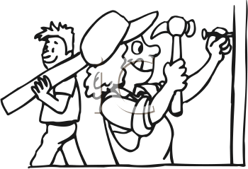
SPOT THE DIFFERENCES !!
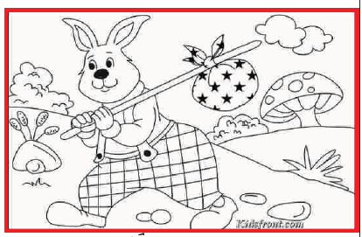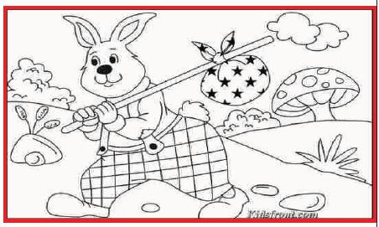

PICTURE READING
Objective: Make meaningful sentences by seeing the picture.
Frame any four questions related to the given picture:-
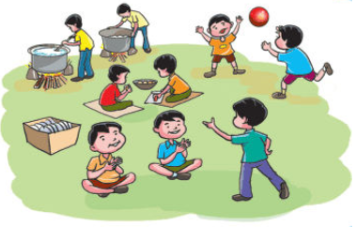
___________________________________________________________

___________________________________________________________

___________________________________________________________

___________________________________________________________

DATE TEACHER’S SIGN

THE SCHOLAR’S MOTHER TONGUE
PRONOUNS

Objective: To write the short forms of the given words.
A. Fill in the blank with "I" or "me."
- Mom drove _____ to school today.
- _____ really want that chocolate cake.
- Mom bought a snack for _____.
- _____went to the mall yesterday.
- You drive much better than _____.

B. Fill in the blank with "she" or "her."
- Harry wrote a love poem for _____.
- Martha is certain of _____ facts.
- Debbie had a headache, so _____ took medicine.
- _____ loves playing basketball.
- Ruth needed to take _____ dog to the vet.

C. Fill in the blank with "he" or "him."
- Randy's sister refused to give _____ the paper.
- When _____ fell out of the tree, he broke his arm.
- Did Sam tell you why _____ did not come to the party?
- Danny knows that Terry is better than _____.
- I told _____ about the celebration.

D. Fill in the blank with "we" or "us."
- She can not come with _____ today.
- After _____ eat, let's see a movie.
- Come in and tell _____ the news.
- I know where _____ can go.
- Dad came with _____ to buy school supplies.

E. Fill in the blank with "they" or "them."
- Everybody knows _____ spilled the beans.
- If the peaches are not ripe, we will not buy _____.
- Take your shoes and put _____ in the closet.
- _____ are the best friends.
- Will and Tom wish _____ could drive a car.

DATE TEACHER’S SIGN

POEM COM
PREHENSION
Objective: To read texts with comprehension, locate details and answer questions.
Read the following story and fill in the blanks with one word only:

Once there was a cut called Lucy and a rat named Raffy.
Taffy was a smart rat. Everty time lucy tried to catch him,
He would run back to his hole.
One day, Lucy thought of a plan. She took a dish full of milk.
and kept it in front of the hole where Taffy lived.
When Taffy peeped out of the hole,he saw Lucy hiding there.
Suddenly, Lucy saw a long hollow pipe coming out of the hole.
Taffy drink all the milk of the dish through the pipe.
Poor Lucy sat on looking at the empty dis.

Fill in the blanks:
1. _________________ has been called as smart in the story.
2. The dish was full of ______________.
3. Taffy _____________ out and saw Lucy hiding.
4. Taffy drank the milk through a ______________.
5. _______________ had the plan failed.

Write a short paragraph about your ‘English Teacher’. Here is an outline.

-----Her name------ teaches English -----well------speaks-----legible handwriting------dress------punctual-----very kind and jovial------received many awards-----like------role model.

-------------------------------------------------------------------------------------------------------------------------------------------------------------------------------------------------------------------------------------------------------------------------------------------------------------------------------------------------------------------------------------------------------------------------------------------------------------------------------------------------------------------------------------------------------------------------------------------------------------------------------------------------------------------------------------------------------------------------------------------------------------------------------------------------------------------------------------------------
DATE TEACHER’S SIGN

