

**GRADE IV**

**MATHEMATICS**

**DAILY PRACTICE PAPER**

**[DPP]**

**2019-2020**

**MID TERM**

|  |  |  |  |  |
| --- | --- | --- | --- | --- |
| **S.NO** | **DATE** | **CONTENT** | **REMARKS** | **TEACHER**  **SIGNATURE** |
| **1** |  |  |  |  |
| **2** |  |  |  |  |
| **3** |  |  |  |  |
| **4** |  |  |  |  |
| **5** |  |  |  |  |
| **6** |  |  |  |  |
| **7** |  |  |  |  |
| **8** |  |  |  |  |
| **9** |  |  |  |  |
| **10** |  |  |  |  |
| **11** |  |  |  |  |
| **12** |  |  |  |  |

**4. A Trip to Bhopal**

**Formation of numbers**

**Objective: Able to form numbers using the given digits.**

**I. Make any six, five- digit numerals using the given digits of numbers.**

**Note:** digits can be repeated only once.

6,8,5,4

a. _______________ b. _____________

c. _______________ d. _____________

e. _______________ f. _____________

**II. Use the digits to make greatest and the smallest number**

**Note**: Digits should not be repeated

|  |  |  |
| --- | --- | --- |
| **DIGITS** | **GREATEST NUMBER** | **SMALLEST NUMBER** |
| 5,9,0,6,7 |  |  |
| 8,3,7,2 |  |  |
| 0,9,1 |  |  |
| 7,5,1,2,3 |  |  |

**2. Fill in the blanks**

1. Smallest and the greatest 2-digit number______________, ______________

2. Smallest and the greatest 5-digit number _____________, ______________

3. Smallest and the greatest 3-digit number _____________, ______________

4. Smallest and the greatest 4-digit number ______________,______________

**DATE TEACHER’S SIGN**

**ABILITY TO COMPUTE**

**Objective: Able to perform arithmetic operations.**

**A. Fill in the blanks** :

1. ______+ 64979 = 64979 2. 4256 + ______= 4256

3. 7864 x ______= 0 4. 6753 - ______= 0

5. 7÷7 = ______ 6. 0+9537 = ______

7. 865 X 1 = ______ 8. 2365+5879 =________+2365

9. 6549 ÷ ______= 6549 10. 0 ÷ 5649 = _______

11. 6345+ ________= 6345 12. _______ - 734 = 0

**B. Find the product without multiplying**

a. 6250 x 100 = _________________ b. 958 x 1000= _________________

c. 645978 x10 = _________________ d. 78 x 1000= _________________

e. 5654 x 10 = _________________ f. 3456 x 0 = _________________

g. 8542 x 100 = _________________ h. 5614 x 10 = _________________

i. 2145 x 1000 = _________________ j. 0 x 1000 = _________________

k. 548 x 100 = _________________ l. 4025 x 0 = _________________

m. 6054 x 10 = _________________

**DATE TEACHER’S SIGN**

**ADD AND SUBTRACT**

**Objective:** Able to add and subtract the given numbers.

**A. Perform these operations**

a. Add : 2645, 6529 b. Find the sum of 2764 and 6464

c. Add : 4505, 5004 d. 54281+ 5421

e. 6945+58942+65 f. 5400 + 96587+7

g. Subtract : 6986 from 9826 h. Find the difference: 8945 and 65450

i. Subtract : 5985 from 9000 j. Subtract : 9864 from 65455

k. Subtract :16058 from 8349 l. Subtract : 25461 from 65241

**DATE TEACHER’S SIGN**

**FINDING THE PRODUCT**

**Objective:** Able to find the product of the given numbers.

I. **Find the product of the following numbers**

a. 65 and 98 b. 12 and 79 c. 340 and 35

d. 502 and 84 e. 658 and 73 f. 123 and 91

g. 585 and 635 h. 965 and 704 i. 268 and 623

j. 1023 and 24 k. 5642 and 65 l. 3287 and 37

**DATE TEACHER’S SIGN**

**PROBLEM SOLVING ABILITY**

**Objective: Able to solve the given problems:**

1. Write the numbers which can be divided by 10, 3, 2 and 5 and comes between 20 and 35

__________________________________________________________________________________________

B. Madam gave 4 toffees each to 40 students of her class she has ten toffees left. How many toffees did she have?

C**. Study the table and answer the following questions:**

|  |  |  |
| --- | --- | --- |
| **SL.NO** | **NAME OF THE ITEM** | **COST PER ITEM** |
| **1** | PIZZA | Rs.50 |
| **2** | BURGER | Rs.35 |
| **3** | SOFTDRINK | Rs.20 |

1. Neeta buys 2 burgers and a pizza she pays Rs.200.How much change does she get back?
2. What is the total cost for all the items?

**DATE TEACHER’S SIGN**

**6.THE WAY THE WORLD LOOKS**

**MAP STUDY**

**Objective: To estimate the distances**

**A. Study the map carefully and answer the following questions**



**B. Tick (**outline image of tick mark à®à¯à®à®¾à®© à®ªà® à®®à¯à®à®¿à®µà¯**) the correct answer:**

1. What is closer to the temple? a. School b. Anil’s house

2. What is closer to Anil’s house? a. Bus stop b. Market

3. Which is closer to the park? a. Bus stop b. Temple

**DATE TEACHER’S SIGN**

**PIE CHART**

**Objective: To study the pie chart answer the questions**

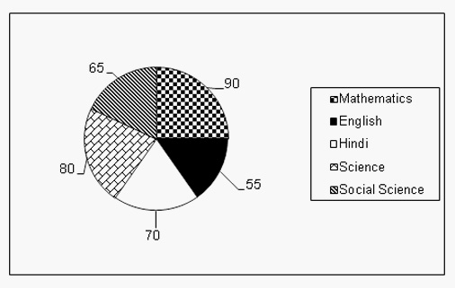

1. How many students like Science subject?

____________________________________________________________________________________

1. Which is the most liked subject?

____________________________________________________________________________________

1. Which is the subject liked by least number of students?

____________________________________________________________________________________

1. What is the difference between the number of students liking Mathematics and Social science?

____________________________________________________________________________________

1. Arrange the given numbers in increasing order.

____________________________________________________________________________________

**DATE TEACHER’S SIGN**

**DATA COLLECTION**

**Objective: To draw bar graph.**

**Answer The Following Questions And Represent The Given Information Through A Bar Graph:**

1. How many balls were sold on all the 6 days?

____________________________________________________________________________________

1. On which day the balls were sold more?

____________________________________________________________________________________

1. On which day less number of balls were sold?

____________________________________________________________________________________

1. How many balls were sold on Saturday than Friday ?

____________________________________________________________________________________

1. Is the number of balls sold on Thursday is thrice the number sold on Friday True/False

____________________________________________________________________________________

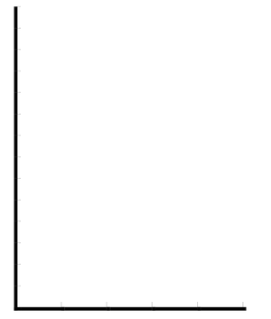

**DATE TEACHER’S SIGN**

**BAR GRAPH**

**Objective: To study the given data and interpret it**

**The Number of loaves of bread baked in a bakery in four different months of a year are given below. Each picture represents 100 loaves.**

**JANUARY :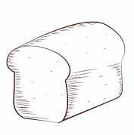 **

**FEBRUARY: **

**MARCH : **

**APRIL : **

**Answer the following questions:**

1. Name the months in which the number of loaves baked was the same?

1. How many loaves were baked in January ?
2. In which month the number of loaves baked was minimum ?
3. What is the number of loaves baked in all the four months?
4. How many loaves were baked in March ?

**DATE TEACHER’S SIGN**