GRADE V
MATHEMATICS
DAILY PRACTICE PAPER
[DPP]
2019-2020

MID TERM
S.NO | DATE | CONTENT | REMARKS | TEACHER  SIGNATURE
1
2
3
4
5
6
7
8
9
10
11
12

4. Parts and wholes
Finding the fraction
Objective: To find the fraction for the shaded part and vice versa.
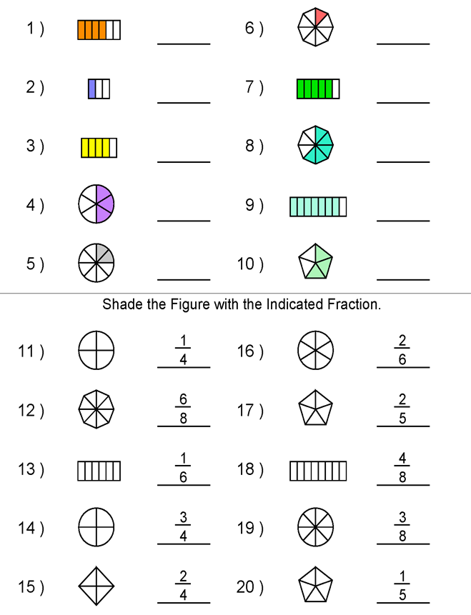
DATE TEACHER’S SIGN

Types of fraction
Objective: To identify the types of fraction.

I. Match the following

1. 1/3, 2/5, 11/13 - mixed numeral
2. 11/9 ,15/13, 20/17 - proper fraction
3. 7/8, 1/8, 2/8 - unit fractions
4. 1/3, 1/4, 1/5 - improper fractions
5. 2 1/3,4 1/7,53/8 - like fractions
6. 4/6,5/6,3/6,2/6 - unlike fractions

II. Write the reciprocal (multiplicative inverse) of the following.

a) 4 _________________

b) 1/5 _________________

c) 34/45 _________________

d) 12/35 _________________

e) 9 _________________

f) 2/4 _________________

g) 55/76 _________________

h) 42/76 _________________

i) 8/34 _________________

j) 12/78 _________________

DATE TEACHER’S SIGN

Equivalent fractions
Objective:To find the equivalent fractions:

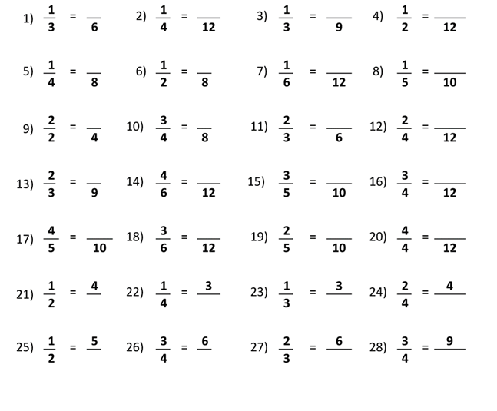

DATE TEACHER’S SIGN

Division fact and fractions
Objective: To convert fractions as division fact and vice versa
I. Write as fractions:

a) 16÷4 = _______________
b) 24÷7 = _______________
c) 94÷ 31 = _______________
d) 63÷ 6 = _______________
e) 96 ÷ 3 = _______________
f) 54 ÷ 5 = _______________
g) 78 ÷ 2 = _______________
II. Write as a division fact:
a) 69/11 = _______________
b) 23/15 = _______________
c) 40/50 = _______________
d) 90/71 = _______________
e) 67/3 = _______________
f) 27/54 = _______________

DATE TEACHER’S SIGN

5.Does it look the same?
Objective: To find and draw the symmetry
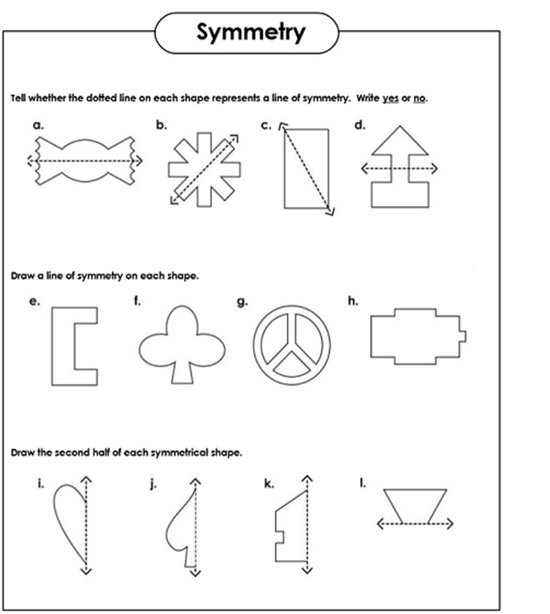
DATE TEACHER’S SIGN

Color me
Objective: To color and find the pattern.

DATE TEACHER’S SIGN

14.Mapping your way
Map study
Objective: To study the map with the help of keys.
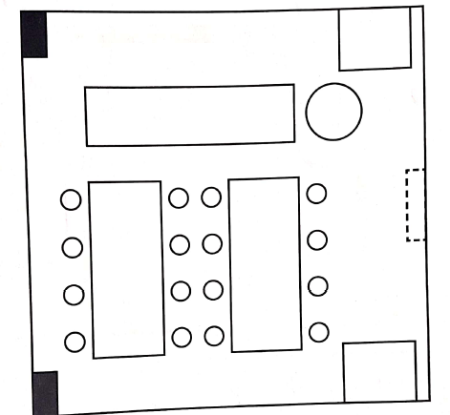
Questions:
- How many students’ stools are there?
____________________________________________________________________________________
- Where are the cupboards: to the right or to the left, as you enter?
____________________________________________________________________________________
- Which is bigger: the student’s stool or the teacher’s chair?
____________________________________________________________________________________
- Can all the students seated facing the teacher see both the windows at the same time?
DATE TEACHER’S SIGN

Directions in maps
Objective: To read the directions in the map

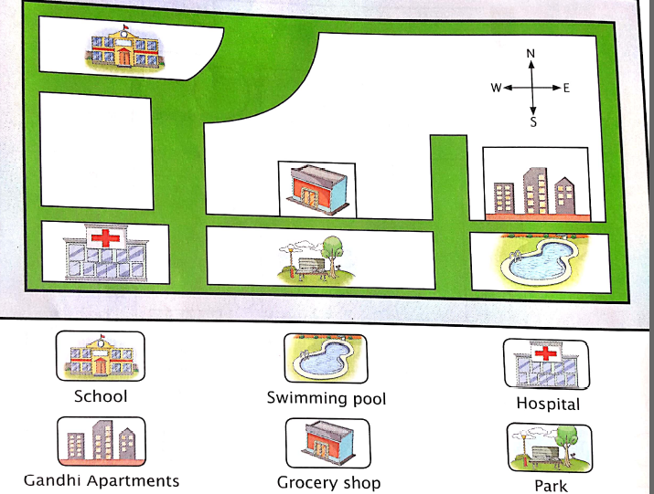
Questions:
- Which building is situated to the north of the park?
____________________________________________________________________________________
- In which direction of the hospital is the park situated?
____________________________________________________________________________________
- Which building is to the south of the school?
___________________________________________________________________________________
- In which direction of the apartments is the grocery shop situated?
____________________________________________________________________________________
- Add more apartments/ houses in the white spaces, and also name the buildings.
____________________________________________________________________________________

DATE TEACHER’S SIGN

Map of a colony
Objective: Able to look at the map and answer the given questions:
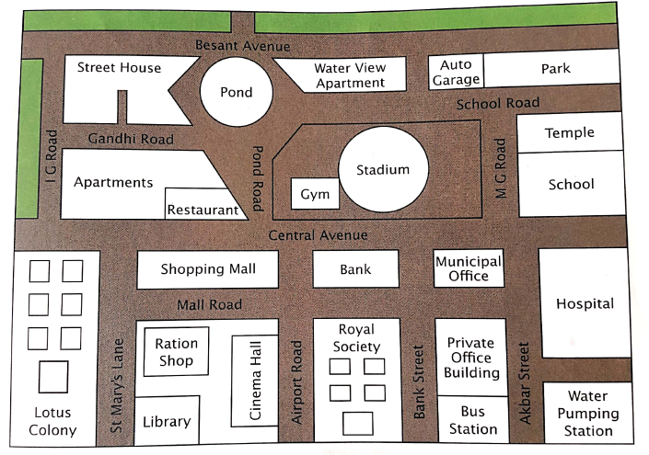
Question:
- What is closer to the library: the school or the park?
____________________________________________________________________________________
- Will a person standing just outside the school gate be able to see the pond?
____________________________________________________________________________________
- A boy living in a house in Besant Avenue has to reach the bus station without having to cross Central Avenue?
____________________________________________________________________________________
- If there is a traffic jam on Airport Road and Central Avenue Junction, how will an ambulance from the hospital reach a house on St Mary’s Lane?
____________________________________________________________________________________
- If there is a traffic jam on Airport Road and Central Avenue Junction, how will an ambulance from the hospital reach a house on St Mary’s Lane?
____________________________________________________________________________________

DATE TEACHER’S SIGN

