GRADE V
MATHEMATICS
DAILY PRACTICE PAPER
[DPP]
2019-2020

POST MID TERM
6. BE MY MULTIPLE I’LL BE YOUR FACTOR
FACTORS
Objective: To find the factors of the given numbers
I. Draw the factor tree for the given numbers.
a. 42 b. 64

c. 50 d. 20

e. 64 f. 120

II. Find the factors for the given numbers:
- 35 b. 21

c.16 d. 13

e. 25 f. 72

DATE TEACHER’S SIGN

PRIME AND COMPOSITE NUMBERS
(Sieve of Eratosthenes)
Objective: To identify the prime and composite numbers:
Follow the given instructions to find the prime and composite numbers between 1 to 100
1 | 2 | 3 | 4 | 5 | 6 | 7 | 8 | 9 | 10
11 | 12 | 13 | 14 | 15 | 16 | 17 | 18 | 19 | 20
21 | 22 | 23 | 24 | 25 | 26 | 27 | 28 | 29 | 30
31 | 32 | 33 | 34 | 35 | 36 | 37 | 38 | 39 | 40
41 | 42 | 43 | 44 | 45 | 46 | 47 | 48 | 49 | 50
51 | 52 | 53 | 54 | 55 | 56 | 57 | 58 | 59 | 60
61 | 62 | 63 | 64 | 65 | 66 | 67 | 68 | 69 | 70
71 | 72 | 73 | 74 | 75 | 76 | 77 | 78 | 79 | 80
81 | 82 | 83 | 84 | 85 | 86 | 87 | 88 | 89 | 90
91 | 92 | 93 | 94 | 95 | 96 | 97 | 98 | 99 | 100

- The first number is 1 but we will ignore it because it is a unique number, neither prime nor composite.
- The next number is 2, which is a prime number. So, we insert a green color around it and color all the numbers divisible by 2 in green .
- The next number is 3, which is also a prime number. We put a blue box around 3 and color all the numbers divisible by 3 in blue color.
- The next number is 4, but that has already been coloured in green in step 2, indicating it is a composite number. So, we move on to the next number, 5. We put an orange box around it, and color the numbers divisible by 5 in orange.
- The next unmarked number is 7.So, we box it in purple, and color all the numbers which are divisible by 7 in purple.
- We have now finished the top row of the square. This means that all the numbers up to 100 that are not prime are colored, and all the prime numbers are either boxed in a particular color or are left blank.

1.Use the grid and answer the questions:
a. List all the prime numbers between 1 and 100.

- Which is the only even prime number ? __________________
- Which is the greatest prime number between 1 and 100? _______________
- 100 is divisible by _________________________________________
- List down the prime numbers between 40 and 60.

- Find the composite numbers between 80 and 100.

__________________________________________________________________________________

- Find whether 24 is a prime or a composite number.

__________________________________________________________________________________
- Find whether 19 is a prime or a composite number.

__________________________________________________________________________________

DATE TEACHER’S SIGN

MULTIPLES AND COMMON MULTIPLES
Objective: To find the multiples and common multiples of the given numbers
- Find the first 5 multiples of the given numbers:
- 20 b. 100

c.9 d. 15

II. Find the first two common multiples of the given numbers:
- 5 and 15

- 4 and 8

- 2 and 6

III. Find the LCM of the given numbers using the number line:
- 2 and 3

- 3 and 6

- 2 and 5

- 5 and 10

DATE TEACHER’S SIGN

7.CAN YOU SEE THE PATTERN?
Continue the Pattern
Objective : To continue the given pattern:
I.Complete the following patterns:

______________ ________________ ______________
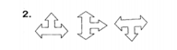 ______________ ________________ ______________
______________ ________________ ______________
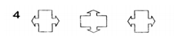 ______________ ________________ ______________
______________ ________________ ______________
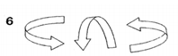 ______________ ________________ ______________
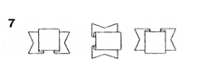 ______________ ________________ ______________

II.Continue the pattern by making a 1/4 turn clockwise.
a. ___________________ _________________________
b.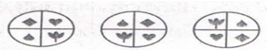___________________ _________________________

c. ___________________ _________________________

d.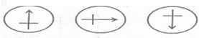 ___________________ _________________________

e. ___________________ _________________________

f. ___________________ _________________________

g. ___________________ _________________________

h. ___________________ _________________________

DATE TEACHER’S SIGN

COMPETENCY ABILITY COMPUTATION
Objective: To think out of box and find the answer:
You will get numbers in each by multiplying the numbers in the next to it.

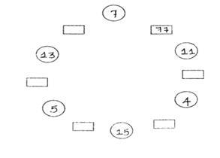

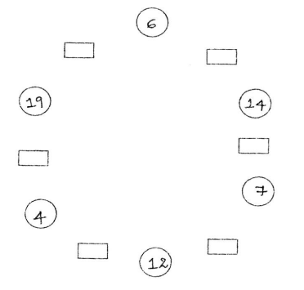

DATE TEACHER’S SIGN

APTITUDE
Objective: To develop the HOTS of the students.
In the magic star write the numbers from 1 to 12 in such that the sum of 4 numbers in a row is
26
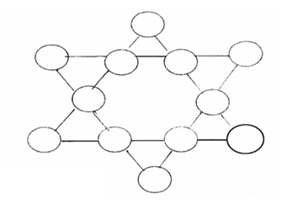

II. Guess and write:
1.What is my secret number?
- It is larger than half of 100.
- It is more than 6 tens and less than 7 tens.
- The tens digit is one more than one’s digit.
- Together the digits have a sum of 11.

DATE TEACHER’S SIGN

BOXES AND SKETCHES

Objective: To find the volume of cubes and cuboids.
- Find the volume of the cubes whose edges are as follows
a) 15 cm b) 12 cm

c) 8 cm d) 10 cm

II. Find the volume of the cuboids whose dimensions are as follows
a) 12 ,8, 10 cm b) 8,4,6 cm

c) A swimming tank is 15 m , 5 m , 10 m in dimension. What is the volume of the tank?

d) A room is 10 m long , 6 m wide and 8 m high. What is the volume of the room?

e) Punit makes a cuboid of length 5 cm , breadth 2 cm and height 3 cm then what is its volume?

DATE TEACHER’S SIGN

FACES , EDGES AND CORNERS
Objective: To know the number of faces , edges and corners of the given shapes.
- Fill in the blanks:-
S.No | Shape | No. of faces | No. of edges | No. of Corners
1 | Cube
2 | Cuboid
3 | Cylinder
4 | Cone

- Join the corners of these figures and write the name of the solid.
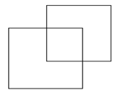

DATE TEACHER’S SIGN

10.TENTHS AND HUNDREDTHS
DECIMAL NUMBERS
Objective: To write the decimal numbers in word form
I. Write the number names for the following decimals:

a) 2.34 - ________________________________________________
b) 50. 123 - ________________________________________________

c) 159.25 - ________________________________________________

d) 234.10 - ________________________________________________

e) 690.358 -________________________________________________

II. Fill in the blanks:

a) Number name of 43.052 is _________
b) forty three point fifty two _________
c) forty three point zero five two _________
d) four point fifty two _________

III.Tick the correct answer:
a) 111 can be written as _____________
1000
i) 0.111 ii) 1.110 iii) 1.111

b) 17$\frac{2}{100}$ can be written as ____________
i) 17.2 ii) 17.02 iii) 1.72

c) 15$\frac{5}{10}$ can be written as _____________
i) 15.5 ii) 15.05 iii) 15.50

DATE TEACHER’S SIGN

DECIMALS AND FRACTIONS
Objective: To convert the given fractions into decimals and vice versa
I Write the following as decimals :
a. $\frac{546}{10}$ - ___________
b. $\frac{3748}{100}$ - ___________
c. $\frac{78}{100}$ - ___________
d. $\frac{156}{100 }$ - ___________
e.$\frac{65}{100}$ - ___________
f.$\frac{9874}{100}$ - ___________
g.$\frac{75}{10 }$ - ___________
II Write the following as fractions :
a) 0.25 - ___________
b) 2.65 - ___________
c) 29.30 - ___________
d) 210.145 - ___________
e) 125.04 - ___________
f) 67.83 - ___________
g)4.675 - ___________

h)34.7 - ___________

DATE TEACHER’S SIGN

ABILITY TO COMPUTE
Objective: To add and subtract decimal numbers:

I) Write these as decimals :

a) 15 m 35 cm = ___________ b) 50m 30cm = ___________
c) 80 paise = ___________ d) 45 ml = ___________
e) 5l 750ml = ___________ f) 12kg 500g = ___________

II) Solve the following:

a) 5.245 + 10 + 315 b) 32.34 + 0.17 + 7.39

c) 348.60 – 78.05 d) 495.34 - 249.53

DATE TEACHER’S SIGN

PROBLEM SOLVING ABILITY
Objective: To multiply and divide the given decimal numbers
I) Shift the decimal appropriately
a) 3.742 x 10 = ____________ b) 3.742 ÷ 10 = ____________
c) 3.742 x 100 = ____________ d) 3.742 ÷ 100 = ____________
e) 3.742 x 1000 = ____________ f) 3.742 ÷ 1000 = ____________
II) Match these:

a)
b)
c)
d)
e)
f)
g)
DATE TEACHER’S SIGN

