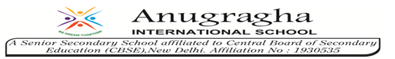

Ref no: 19’/ 17 Date: 19/08/19

Dear Parents,
Olympiad exams are to be held on the following dates.
IGKO[General Knowledge] - 6th Sep
IEO[English] - 15th Oct
NSO[Science] - 11th Nov
NCO[CS] - 28th Nov
IMO[Mathematics] - 5th Dec
Kindly refer the above mentioned time table and prepare your child as per the subjects opted by him/her.
Regards
Principal

