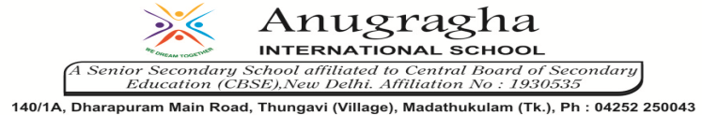

Ref no:19/ '25 Date : 14.11.2019

Dear Parents,
As a first time in the History of School Education Department, Government of Tamil Nadu, the director directs all the parents to turn off all gadgets and spend time with the children on 14th November, 2019 between 7.30 PM to 8.30PM. Why don’t we try to enhance our children’s attitude?

Thank you!

Regards

Principal

