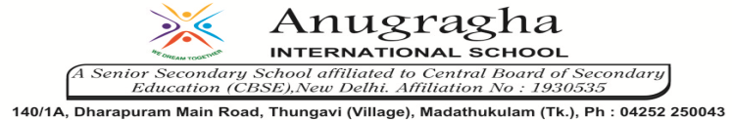

Ref no:19/ '26 Date : 21.11.2019

“Every Tooth in a man’s head is more valuable"
Dear Parents,

- Life without teeth is unimaginable. Healthy teeth are essential to keep us free from numerous diseases and thus maintain good health.
- To bring an understanding about the importance of Dental Health and Hygiene, there is a “Dental Check up Camp” in our school premises on 22.11.2019(Friday).
Thank you!
Regards

Principal

