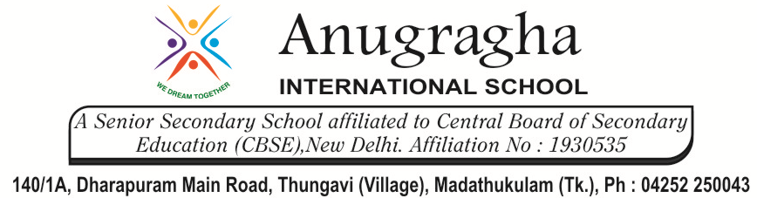

MIDTERM TEST-AUG-2019

KBQ -01
NAME |  | AD.NO
CLASS | VI - | EX.NO
G.D | 13.08.19 | SUB | SCIENCE[CHE]
S.D | 16.08.19 | CH:5 SEPARATION OF SUBSTANCES
Short Answer Type Questions:
1.Mention two reasons why we need to separate substances.
2.What happens to the flour during sieving?
3.Write various methods of separation of components from their mixture.
4.Where is decantation used? Give two examples.
5.Distingusih between Pure substances and Mixture.
Long Answer Type questions:
1.Explain the method that can be used for separating the following mixture.
a)Sand and husk b)Wheat, Sugar and Stalk
c)Water and petrol d)Rice and salt
2.How do farmers use the process of winnowing?
3.Discuss the method of handpicking.
HOTS:
1.Is it possible to separate sugar mixed with wheat flour? If yes, how will you do it?
2.Why does visibility increase after rain?
3.Raghav is given bottle with some substances in it, that is either chalk or sugar. How can he find out which of the two is sugar or chalk, without tasting it?
4. How will you prepare cheese(paneer)?

