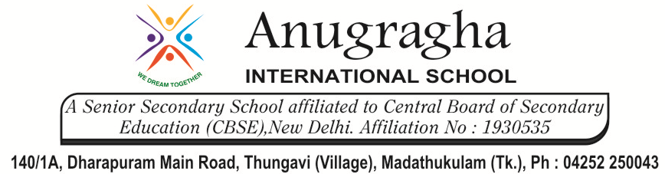

MIDTERM TEST-AUG-2019

KBQ - 01
NAME |  | AD.NO
CLASS | VIII - | EX.NO
G.D | 16.08.19 | SUB | SCIENCE
S.D | 19.08.19 | CH  4:MATERIALS- METALS AND NON-METALS
Short Answer Type Questions:
1.Name a few things that are made of metals
2.Write the chemical reaction that shows rusting of iron.
3.Why aluminum foils are used to wrap food items?
4. Why is phosphorus stored in water?
5.Give two reasons for aluminum being preferred to copper for manufacturing cooking utensils.
Long Answer Type questions:
1.Distinguish between metals and non-metals on the basis of the following properties: hardness, malleability, ductility, heat conduction , conduction of electricity.
2.What happens when
i)dilute sulphuric acid is poured on a copper plate?
ii)iron nails are placed in copper sulphate solution?
Write word equations of the reactions involved.
HOTS:
1.Can you store lemon pickle in an aluminum utensil? Explain
2.A doctor prescribed a tablet to a patient suffering from iron deficiency. The tablet does not look like iron. Explain.
3.An element X burns in air to form an oxide. This oxide neutralizes dilute sulphuric acid to form a salt. Is X a metal or a non-metal.
4.Give reason:
i)Sodium and Potassium are stored in Kerosene.

