POST MIDTERM TEST
CRT-04
NAME : | CLASS: XII – EINSTEIN | SUBJECT: MATHS | DATE:  25.10.19
CH: – Three Dimensional Geometry(lines) |  | MARKS: | 25

1. Find the length and the foot of the perpendicular drawn from the point (2, -1, 5) on the line
$\frac{x-11}{10}$ = $\frac{y+2}{-4}$ = $\frac{z+8}{-11}$. (4)
2. Find the value of $λ$, so that the lines $\frac{1-x}{3}$ = $\frac{7y-14}{2λ}$ = $\frac{5z-10}{11}$ and $\frac{7-7x}{3λ}$ = $\frac{y-5}{1}$ = $\frac{6-z}{5}$ are perpendicular to each other. (4)
3. Find the Cartesian equation of the line which passes through the point (-2, 4, -5) and is parallel to the line $\frac{x+3}{3}$ = $\frac{4-y}{5}$ = $\frac{z+8}{6}$ . (4)
4. Find the point on the line $\frac{x+2}{3}$ = $\frac{y+1}{2}$ = $\frac{z-3}{2}$ at a distance $3 \sqrt{2}$ from the point (1, 2, 3). (4)
5. Find the shortest distance between the following two lines:
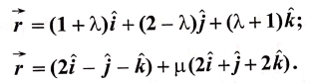 (4)
6. Find the equation of a line passing through the point P(2, -1, 3) aqnd perpendicular to the lines:
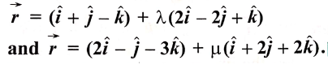 (5)

