POST MIDTERM TEST
CRT-01
NAME : | CLASS: IX - Snowdrop | SUBJECT: MATHS | DATE:  30.10.19
CH: – Circles |  | MARKS: | 25

1. If O is the centre of the circle, then find the value of x in the given figure. (4)
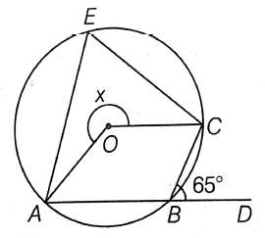
2. A circle has radius $\sqrt{2}$ cm. It is divided into two segments by a chord of length 2 cm. Prove that the angle subtended by the chord at a point in major segment is 45°. (4)
3. In the given figure, AOB is a diameter of the circle and C, D and E are any three points on the semi-circle. Find the value of $∠$ACD + $∠$BED.
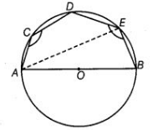 (4)
4. Two chords AB and CD of lengths 5 cm and 11 cm, respectively of a circle are parallel to each other and are on opposite sides of its centre. If the distance between AB and CD is 6 cm, then find the radius of the circle. (4)
5. If circles are drawn taking two sides of a triangle as diameters, then prove that the point of intersection of these circles lie on the third side. (4)
6. A circular park of radius 20 m is situated in a colony. Three boys Ankur, Syed and David are sitting at equal distance on its boundary each having a toy telephone in his hand to talk each other. Find the length of the string of each phone. (4)
7. In the given figure, find the value of x. (1) 