CRT-I-JUL-2019
CLASS | III | SUB |  |  | CS
Les:1 Operating system |  |  | DATE: | MARKS: /20
- Choose the correct option: 4x1=4
- The sign in options:
a)Picture password b) Password c) PIN d) All of them
- It displays all the active applications on the desktop
a)Task view b)Cortana Search box c)File explorer d) None of them
- Which of these is not a software?
a) Windows 10 b) Office 2016 c) CPU d) Word
- This button is used to manage your files and folders.
a) Task View b) File Explorer c) Settings d) Power.
- Write T for the true statement and F for the false one: 4x1=4
- The taskbar is generally located at the bottom of the desktop. ___________________
- When you switch on a computer the lock screen appears. ___________________
- The Start button is present on the right side of the taskbar. ___________________
- A computer is of no use without an operating system. ___________________
- Fill in the blanks: 4x1=4
{Desktop, Icons, Software, Folder}
- The small pictures on the desktop are called _____________________
- A _____________________ is used to store a group of files.
- A _________________ refers to a set of programs that perform some tasks in a computer.
- The screen you see after the sign in screen is called ____________________________
- Answer the following: 2x2 ½ =5
- How does a computer work?

- Give two examples each of computer hardware and software.

- Label the Start button, Start menu and Start screen in the following figure: 3x1=3

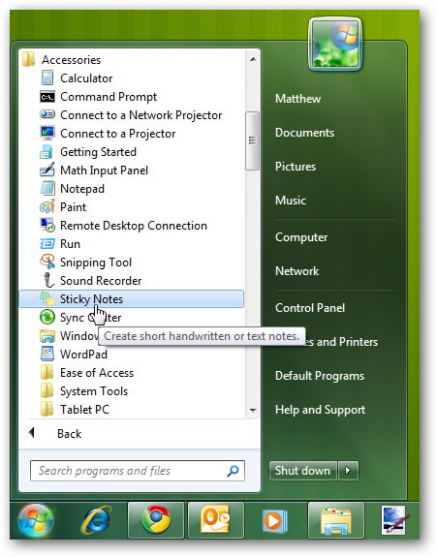

&&&&&& ALL THE BEST &&&&&&

