**IV. Write any five sentences to describe the picture and give suitable title.**

**5x1=5**

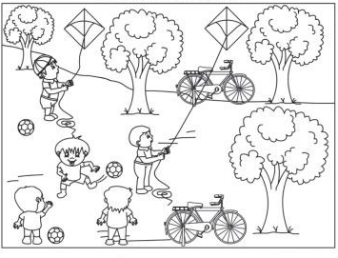

**V. Make two words from the given word: 5x1=5**

1. Friendship
2. Outpatient
3. Sometime
4. Everyday
5. Newspaper

**VI. Answer the following questions(any-3): 3x2=6**

1. Where does the balloon man stand?
2. What does the child like to see the balloon man do?
3. Name three places where the butterfly rested.
4. Why did Sonu let the butterfly go?

|  |  |  |
| --- | --- | --- |
|  | | |
| **POST MIDTERM TEST**  **CRT-01** | | |
| **CLASS: III-** | **SUBJECT: ENG** | **DATE:** |
| **UT:5 (The Balloon Man, The Yellow Butterfly)** | **MARKS: 25** | **TIME: 40 MINS** |

**I. Read the passage carefully and answer the following questions: 5x1=5**

My name is Sam.

I have a black dog.

My dogs name is Maggie.

Maggie loves to play.

She is five years old.

Maggie is my friend!.

**Questions:**

1. What is my name?

2. What do I have?

3. What color is dog?

4. How old is she?

5. Maggie loves to ___________.

**II. Identify the words from the Jumbled letters and write the word:**

**4x ½ =2**

1. c u n l h 3. u l b e
2. w o l b e 4. c r a t

**III. Make the sentences by using the following words: 2x1=2**

1. Wind 2. Market