CRT-I-JUL-2019
CLASS | III | SUB |  |  | EVS
Les:1 Poonam’s Day Out |  |  | DATE: | MARKS: /25
- Answer the following: 5x1=5
- Can fly _______________ , ______________
- Can walk _______________ , ______________
- Can crawl _______________ , ______________
- Have feet _______________ , ______________
- Have tail _______________ , ______________
- Here are some incomplete pictures of Animals complete them and write their names below: 3x2=6
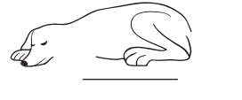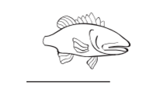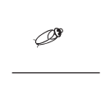
- Find the name in the crossword and put a circle around it: 5x1=5
- Banana is what I love eating
I spend my time jumping and leaping
- On the walls, webs I weave,
Where insects stick and connect leave
- I remain awake the whole night,
And go to sleep in broad daylight
- Crock, Croak is my sound, In water or on land I am found
- I appears after rainfall,
Have no feet so I crawl
- Slow and steady is my peace,
I always win when there is a race.

X | T | Y | A | B | L | S
M | O | N | K | E | Y | P
M | R | Q | N | X | A | I
D | T | F | R | O | G | D
J | O | W | L | E | K | E
L | I | B | C | H | I | R
M | S | N | A | I | L | N
G | E | F | Q | S | W | Y

- Name the animals which can b seen: 5x1=5
1. On the trunk _______________ , ______________
2. On the ground _______________ , ______________
- On the branches _______________ , ______________

- Answer the following questions: 2x2=4
- What is an environment?

- Name any two animals which live on the tree.

&&&&&& ALL THE BEST &&&&&&

