**8. Find the answer: [5]**

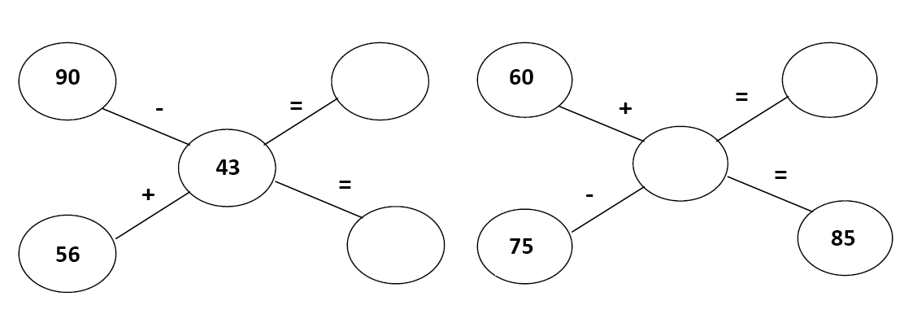

9. Reena noted the electricity meter reading of her house. Last month’s reading was 118 units. This month’s reading is 193 units. How much electricity did she use in one month? **[5]**

This month’s reading _________________

Last month’s reading _________________

|  |  |  |
| --- | --- | --- |
| 100 | 10 | 1 |
| 1 | 9 | 3 |
| 1 | 1 | 8 |
|  |  |  |

She used _________________ units of electricity.

|  |  |  |
| --- | --- | --- |
|  | | |
| **POST MIDTERM TEST**  **CRT-01** | | |
| **CLASS: III-** | **SUBJECT: MAT** | **DATE:** |
| **CH:6. Fun with Give and Take Shopping** | **MARKS: 25** | **TIME: 40 MINS** |

**1. Count to subtract: [2]**

a) 85 -63 b) 84 – 69

**2.** Indu’s pencil is 15 cm long .Jyoti’s pencil is 8 cm long whose pencil is longer? How much longer? **[2]**

**3.** Ajay cooked chapattis in 25 minutes. Then he made daal in 15 minutes. How much time did he take to cook both things? **[2]**

**4. Find the missing numbers: [2]**

a) 100 , 200, 300, __________, ________, 600, ___________.

b) 280 , 260, 240, _________, __________, 180, ___________.

**5. . Fill in the blanks: [1]**

a) 632 - 0 = ............... b) ............... - 0 = 517

**6. Subtract the following: [3]**

a) 17 -3 b) 39-10

**7. Add the following: [3]**

a) 237 + 213 b) 12 +24