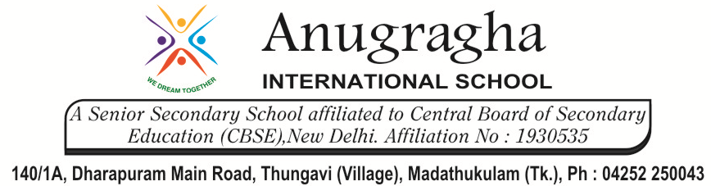

CRT-II-JUN-2019
NAME: |  |  |  | DATE:
CLASS | III | SUB |  |  | ENGLISH
2.Bird Talk, Nina and the Baby sparrows |  |  | MARKS: /25

- Draw a line to match each word to its opposite: 4x1=4
- Happy – wet
- Dry – sad
- Day – Good
- Bad - Night
- Draw a line to match each word to its meanings: 4x1=4
- Present – below
- Under – gift
- Funny - answer
- Reply – foolish
- Write three sentences on birds using the following words: 3x1=3
- Nest –
- Fly –
- Wings -
- Write words that rhyme with the words given below: 4x1=4
1.think –
2.Eat -
3.sing -
4.day -
V. Write the suitable describing words: 4x1=4
[red, beautiful, black, fat]
- A________________ woman
- A _________________ rose.
- A ________________ peacock
- A _______ board .
VI.Answer the following questions: 2x3=6
- Name the two birds in the poem.

- What did Nina find when she came back from the wedding?

&&&&&& ALL THE BEST &&&&&&

