**4. What will the time be? [4]**

a. 1 hour after 10:30 __________________________________

b. 15 minutes after 3:30 __________________________________

c. 10 minutes before 1:20 __________________________________

d. 20 minutes before 5:00 __________________________________

**5. Draw the clocks and show the following time: [3]**

a) 2:30 b) 4:45 c) 11: 15

**6. Fill in the blanks: [5]**

a. 1 hour = _______________minutes.

b. ______________ hand is smaller than the _______________hand.

c. At noon and midnight both hands point to ________________

d. There are __________hours in a day.

e. 1 week = ____________________ days

**7. Write the time with AM or PM. [4]**

a. 2 hours after noon ________

b. 3 hours before mid night ________

c. 6 o’ clock in the evening ________

c. 5 o’ clock in the morning ________

|  |  |  |
| --- | --- | --- |
|  | | |
| **POST MIDTERM TEST**  **CRT-02** | | |
| **CLASS: III-** | **SUBJECT: MAT** | **DATE:** |
| **CH:7. Time goes on** | **MARKS: 25** | **TIME: 40 MINS** |

**1. Draw hands on the clock. [2]**

**7 o’ clock 4 o’ clock**

a)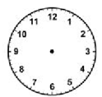 b)

2. **What’s the time on the clock? [3]**

a) 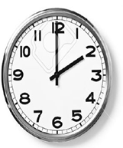b) 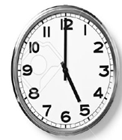 c) 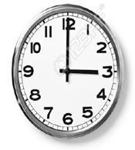

**3. How long does it take? Use the words given below: [4]**

**[Seconds minutes hours days months]**

a. To drink a glass of water __________________

b. For a plant to grow __________________

c. For the sun to rise __________________

d. To blink your eyes __________________