**4. Do as directed and Complete the table: [5]**

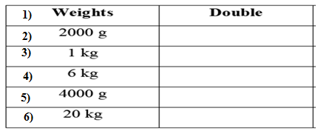

**5. Draw the weights that you will use to weigh the items given in the table: [5]**

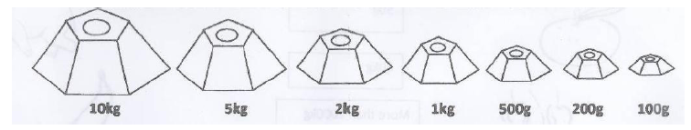

|  |  |
| --- | --- |
| **Items** | **Weights used** |
| 1. 50 kg of wheat |  |
| 1. 9 kg of beans |  |
| 1. 4 kg of tomatoes |  |
| 1. 700 g of rice |  |
| 1. 500 g of sugar |  |

**6. Write the 6th table: [5]**

|  |  |  |
| --- | --- | --- |
|  | | |
| **POST MIDTERM TEST**  **CRT-03** | | |
| **CLASS: III-** | **SUBJECT: MAT** | **DATE:** |
| **CH:8.Who is Heavier?** | **MARKS: 25** | **TIME: 40 MINS** |

**1. Write the objects name that weigh less than ½ kg. [1]**

i)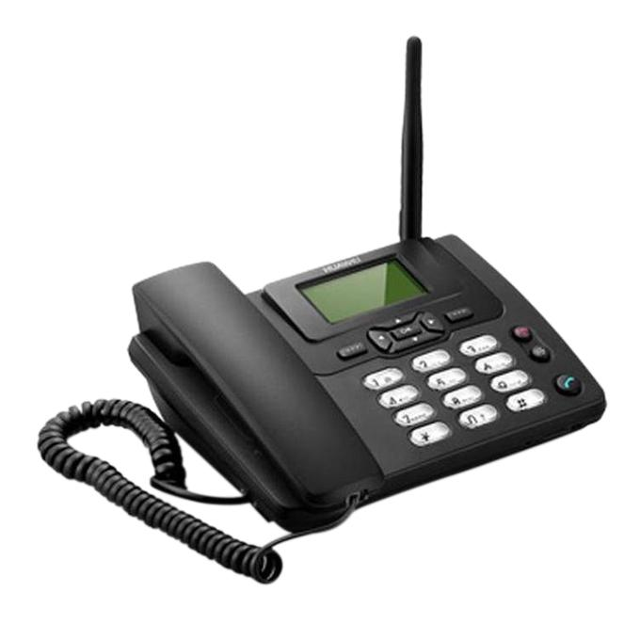 ii)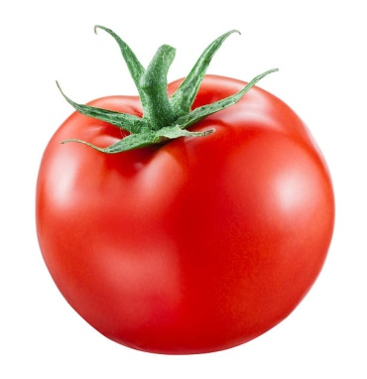 iii) 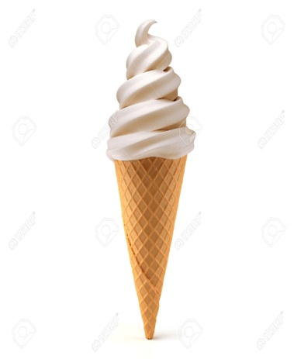

**2. What will you use , g or kg to measure the weight of the following: [6]**

1. A pencil 2. A big watermelon

3. A cake 4. An orange

5. A sack of wheat 6. A spoon of sugar

**3. Observe the given picture and choose the appropriate unit of measurement. [3]**

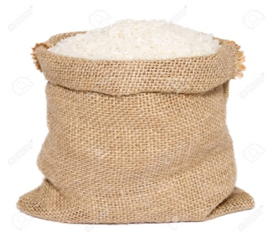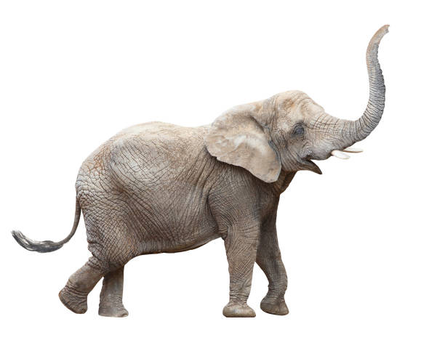

1. The weight of rice is measured in _________ (g/ kg)
2. The weight of a soap is measured in ____________(g/kg)
3. The weight of an elephant is measured in _________(g/ kg)