**4. Complete the following statements: [4]**

1. All numbers that end with 0, 2, 4, 6 and 8 are called _______ numbers.
2. All numbers that end with 1, 3, 5, 7 and 9 are called ________ numbers.
3. The greatest 2 digit odd number is ________________.
4. The smallest 2 digit odd number is ________________.

**5. Some secret messages are given below. Decode these messages and write: [2]**

i) 1g 2o 3o 4d 7m 5o 8r 9n 8i 2n 5g

ii) 11w 2e 5l 8c 6o 3m 0e

**6. Solve the following and write even or odd against each answer: [4]**

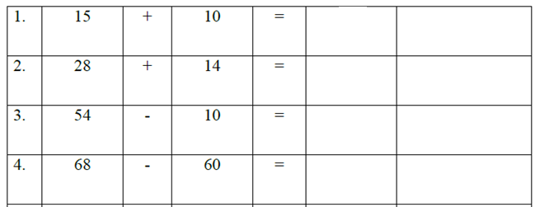

**7. Write the 7th table: [5]**

|  |  |  |
| --- | --- | --- |
|  | | |
| **POST MIDTERM TEST**  **CRT-04** | | |
| **CLASS: III-** | **SUBJECT: MAT** | **DATE:** |
| **CH:10. Play with Patterns** | **MARKS: 25** | **TIME: 40 MINS** |

**1. Choose the correct answer: [4]**

i.Which of the following is an odd number?

a) 734 b) 246 c) 492 d) 599

ii. Which of the following is an even number?

a) 523 b) 135 c) 972 d) 105

iii. If we add 1 to any odd number ,we get _________________

a)0 b)1 c)odd number d)even number

iv.If we add 1 to any even number, we get __________________.

a)0 b)1 c)odd number d)even number

**2. Complete the pattern: [3]**

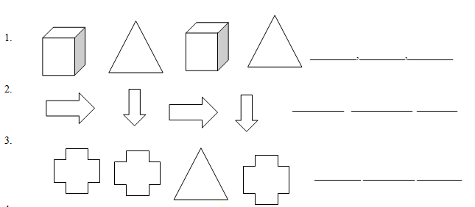

**3. Complete the following number patterns: [3]**

i. 5, 10, 15, 20, _______, _______, _______, _______

ii. 8, 18, 28, 38, _______, _______, _______, _______

iii. 99, 199, 299, 399, _______, _______, _______, _______