**VI. Match the following: 4 x ½ =2**

1. Mangroves - Gum
2. Coconut - Swamps
3. Tape grass - Coastal area
4. Acacia - Underwater plant

**VII. Complete the concept map : 4 x 1=4**

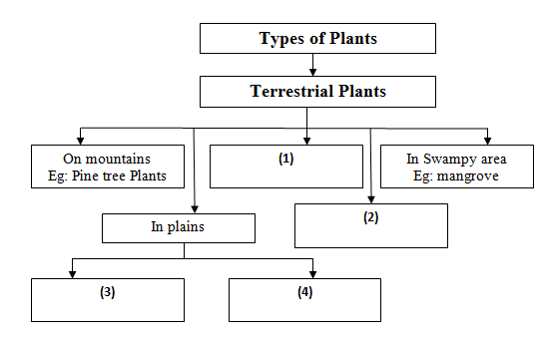

**VIII. Short answer questions: 3x2=6**

1. Why do plants need to adapt?
2. What are aquatic plants?
3. What are terrestrial pants?

**IX. Long answer questions(any-1): 1x5=5**

1. How do desert plants save water?
2. Write a short note on the useful things that we obtain from plants.

|  |  |  |
| --- | --- | --- |
|  | | |
| **POST MIDTERM TEST**  **CRT-01** | | |
| **CLASS: IV-** | **SUBJECT: SCI** | **DATE:** |
| **CH:7. HOW PLANTS SURVIVE** | **MARKS: 25** | **TIME: 40 MINS** |

**I. Choose the correct option: 2x ½ =1**

1. Which one of the following is an example of a non-green plant?

a ) Pitcher plant b) Coral plant

2. Which one of the following is a feature of plants growing in deserts?

a) Needle-like leaves b) Do not have any leaves

**II. Fill in the blanks: 2x1=2**

1. Plants are __________________ to us.

2. Venus flytrap is an ______________ plant.

**III. State True or false: 2x ½ =1**

1. Pine and fir trees grow in plains.

2. Neem is a terrestrial plant.

**IV. Write two examples for each of the following: 2x1=2**

1. Plants that give us medicines 2. Desert plants

**V. Write one word for the following: 2x1=2**

1. Plants that grow on land

2. Plants that grow under the water surface.