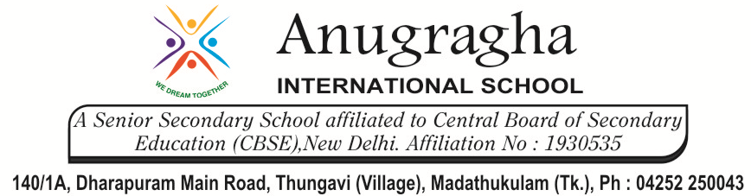

CRT-I-JUL-2019
CLASS | IV | SUB |  |  | SST
1.Types and Elements of Maps |  |  | DATE: | MARKS: /20
- Fill in the blanks: 3x1=3
- The information in maps must be ____________.
- _____________ direction is in between south and east.
- Maps are of ____________________ kinds.

- Write True or False: 2x1=2
- Colours are used in maps to give special information. _________________
- The symbols in maps do not have any meaning. _________________

- Match the following: 5x1=5
- Physical Map a)shows countries, capitals and other cities
- Political Map b) draw an exact and accurate representation of a place.
- Thematic Map c) Work out what the actual size of a place is
- Scale down d)shows mountains, rivers, lakes etc.
- Scale up e)gives information about special topics.
- Short Answer: 2x2=4
- What is a map?

- If a scale in a map say 1cm=150km, what does this mean?

- Long Answer: 1x6=6
- Explain in two sentences how colours and symbols in maps are useful.

&&&&&& ALL THE BEST &&&&&&

