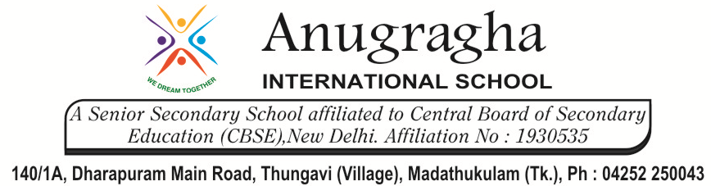

CRT-III-JUN-2019
NAME: |  |  |  | DATE:
CLASS | IV | SUB |  |  | SST
Peoples of India |  |  | MARKS: /20

- Fill in the blanks: 2x1=2
- India’s _________________ density is not the same all over the country.
- __________________ languages are specially mentioned in the Indian constitution.
- Choose the correct answer: 2x1=2
1.Diwali, Eid and Christmas are harvest / religious festivals.
The Indian Constitution says that all / only some Indian are equal.
- Write true or false: 4x1=4
- Most festivals in India are religious festivals. _______________
- There are about 500 languages in India. _______________
- The constitution of India applies to all Indians. _______________
- The staple foods eaten in India are rice, wheat or millets. _______________
- Short Answer: 3x2=6
- Name two parts of India where people are mostly.
- Vegetarian b)non-vegetarian

- What does festivals mean? Name three harvest festivals.

- Give one example of a law that applies to all Indians.

- Long Answer: 2x3=6
- Explain why the constitution unites India.

- Give two reasons why English is one of the languages in India.

&&&&&& ALL THE BEST &&&&&&

