**8.** Find the distance around a rectangular table of length 50 cm and width of 20m.

**Find the boundary of the given figures.**

**9.** a) 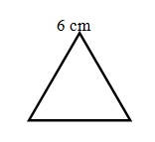 b)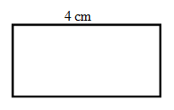

**10.** a)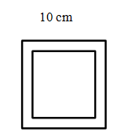 b) 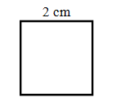

**V. Write 13th table : 5**

|  |  |  |
| --- | --- | --- |
|  | | |
| **POST MIDTERM TEST**  **CRT-04** | | |
| **CLASS: IV-** | **SUBJECT: MAT** | **DATE:** |
| **CH:13. Fields and Fences** | **MARKS: 25** | **TIME: 40 MINS** |

**I. Solve the following: 10x2=20**

**1.** **Find the perimeter of the following squares whose sides are given.**

a. 5 cm b. 10 m

**2. Find the perimeter of rectangle whose length and breadth are given.**

(i) Length = 7 cm ;breadth = 5 cm

(ii) Length = 12 cm ;breadth = 8 cm

**3. Find the boundary around a square field of sides are**

a.13m b. 65 cm.

**4.** Find the length of the barbed wire required to go around 4 times a rectangular field 63m and width of 35 m.

**5.** Arun runs a circular play ground of length 103m and 55cm and Ajay runs a play ground of length 97m and 85cm. What is the difference in distance?

**6.** A hockey field is 91 metres 40 cm long and 55 metres wide. How

long is the boundary of the field?

**7.** A square garden is 200m long. How much wire will be needed for fencing around is 3 times?