MIDTERM TEST
CRT-01
NAME : | CLASS: V- | SUBJECT: ENG | DATE:
CH -3 Po |  | MARKS: | 25
SUBJECT TEACHER’S SIGNATURE |  | PARENT’S SIGNATURE
I. Read the passage and write the answer: 5x1=5
Long ago, there ruled a king named Dashratha in Ayodhya. He was a very kind ruler. He loved hunting very much. Every hunting day he went to a nearby forest. He was also a very good shot. There lived a blind old couple in his kingdom. They had a son, Shravan Kumar. He was a very obedient boy. He always served his old parents. They were very happy with him. They always blessed him.
One day his mother said, "My dear son! You have served us for a long time, now we have only one desire. Now we wish to go on a pilgrimage. But, alas! we cannot go. We are blind and helpless." On hearing this, he said, "Dear mother, please don't worry. I shall do everything to fulfil your desire."

Questions:
- Where did Dashratha rule ?
- In whose kingdom did the blind couple live ?
- Whose son was Shravan Kumar ?
- What was the only desire of the blind couple ?
- What did Dashratha love ?

III.Look at the picture and frame your own sentences: 1x5=5
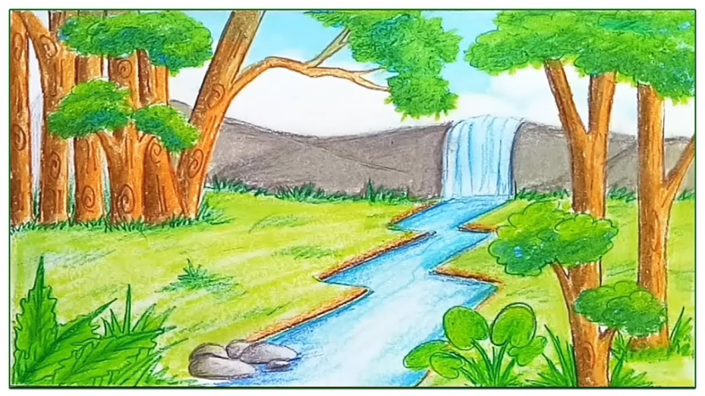
- ______________________________________________________________________________
- ______________________________________________________________________________
- ______________________________________________________________________________
- ______________________________________________________________________________
- ______________________________________________________________________________
IV.Fill in the blanks using one of the words given in brackets: 6x ½ =3

1. Where is the child _________________ parents have come to school?(who/whose/which)
2. The old lady _____________ I met in your house is my neighbor.(whom/ that/ which)
3. I like reading books ____________ have pictures in it.(that/ who / which)
4. The poem__________ you read out, is so lovely.( whose/which/that)
5. I saw many houses ___________ were quite spacious.(which/whose/who)
6. Mathematics, ______________ is my favourite subject, is so interesting.(who/which/that)

V.Rearrange the jumbled sentences: 4x ½ =2

1. was is land the in habited. _____________________________________________
2. alone was not Robinson an island on _____________________________________________
3. was afraid I now _____________________________________________
4. I around me looked. _____________________________________________

VI.Fill in the blanks with correct word: 4x1=4
[and but because so]
- I was very tired ____________ confused.
- I decided to go to the _______________ I went along the water’s edge.
- I was frightened ______________ curious.
- I ran as fast as I could __________________ I was frightened.

VII.Answer the following questions: 3x2=6

1.Who do you think your shadow books like?
_______________________________________________________________________________________________________________________________________________________________.
2. Why did Robinson pray when he saw the footprint?
_______________________________________________________________________________________________________________________________________________________________.
3. What made Robison Crusoe think that the print on the ground was a footprint?
_______________________________________________________________________________________________________________________________________________________________.

