**V. Write atleast five sentences to describe the picture and give suitable title. 5x1=5**

[ colorful, festival, children playing, water balloons, water guns, water, wet clothes, colored powder, happy festival]

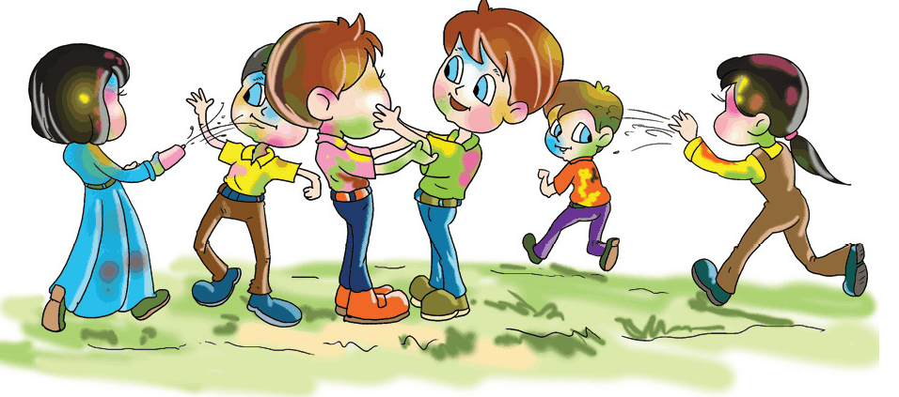

**VI. Complete the following sentences using the correct form of the pronoun given in the brackets. 3x1=3**

1. The girls are playing in the garden. _______________________look very happy.

a)They b)She c)We

2. The boys are making a lot of noise. Please ask ____________to be quiet.

a)they b)them c)him

3. My daughters enjoy watching cartoon films. This CD is for ___________.

a)she b)her c)them

**VII. Answer the following questions: 4x 1 ½ =6**

1. What did the frog do all day.
2. Did you like the frog’s behavior?
3. Why is Rip popular with the children of the village?
4. How is Rip Van Winkle described?

|  |  |  |
| --- | --- | --- |
|  | | |
| **POST MIDTERM TEST**  **CRT-01** | | |
| **CLASS: V-** | **SUBJECT: ENG** | **DATE:** |
| **UT:5 (The Lazy Frog, Rip Van Winkle)** | **MARKS: 25** | **TIME: 40 MINS** |

**I. Read the passage carefully and answer the following questions: 5x1=5**

**Tourists**

Tourists are people who travel for fun. Tourists visit places in the world. Here are Cathy and her family enjoying at the park. Tourists who want to ski or snowboard have to go to mountains. Tourists, who like to surf, swim or fish travel to oceans. Tourists will travel long distances to see interesting dams and bridges. Hot air balloons are beautiful! Tourists like balloon races, football games and car races. Cities sometimes build special places for the tourists. Tourists visit at museums. They also visit zoo and aquariums.

**Questions:**

1. ____________ are people who travel for fun.

2. Where did tourists want to ski and snowboard?

3. Why do the tourists go to the ocean?

4. Which types of races do tourists like the most?

5. Where would you like to go for fun?

**II. Find the opposites of the following words: 2x1 =2**

1. Wake up x 2. Get up x

**III. Write the appropriate word using the clues : 2x1=2**  
1. Away from the right path or direction. ___ s ___ ___ a ___  
2. Any plant that crowds out cultivated plants. w ___ ___ d ___  
**IV.** **Fill in the blanks with a suitable adverb: 2 x1=2**

#### 1. I watch English films....................................

a)once b)always c)occasionally

#### 2. They...................................... go out.

a)rare b)once c)rarely