**V. Complete the concept map : 4x1=4**

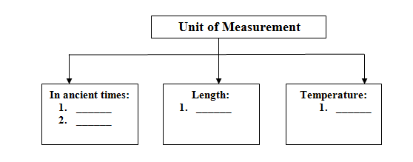

**VI. Short answer questions: 4x2=8**

1. Which unit would you use to measure the length of a pencil?
2. What is a unit?
3. What is length?
4. Why did people in ancient times realize the need for some fixed quantity of measurement?

**VII. Long answer questions(any-1): 1x5=5**

1. Make a list of various units used to measure length, mass, capacity and time.
2. Define temperature. Which instrument is used to measure it? Name the unit in which it is measured.

|  |  |  |
| --- | --- | --- |
|  | | |
| **POST MIDTERM TEST**  **CRT-01** | | |
| **CLASS: V-** | **SUBJECT: SCI** | **DATE:** |
| **CH:8.MEASUREMENT** | **MARKS: 25** | **TIME: 40 MINS** |

**I. Choose the correct option: 2x ½ =1**

1. Which of the following is a unit of capacity?

a ) Metre b) Litre

2. What did people in ancient times use for measurement?

a) Body parts b) Clock

**II. Fill in the blanks: 3x1=3**

1. _____________ is the length of the outstretched arms.

2. 100 centimetres equals 1 ________________.

3. The length between the tip of the middle finger and the elbow is called _________.

**III. State True or false: 2x ½ =1**

1. 60 seconds(s) = 1 minute(min)

2. 100 grams(g) = 1 kilogram (kg).

**IV. Write one word for the following: 3x1=3**

1. A fixed quantity that is used as a standard of measuremnt _______.

2. An instrument used to measure temperature ___________.

3. The measure of how hot or cold an object is _________.