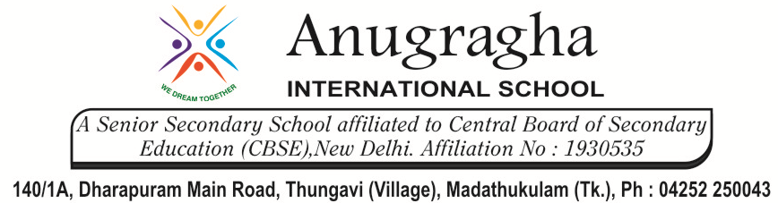

CRT-II-JUN-2019
NAME: |  |  |  | DATE:
CLASS | V | SUB |  |  | CS
Les:2 Objects in word 2016 |  |  | MARKS: /20
- Choose the correct option: 4x1=4
- The wrap Text command is available in the ______________ group of the format tab.
- Arrange b) Wrap c)Alignment d) None of these
- Which of the following Visual effects can be applied to word Art?
- Shadow b) Glow c) Bevel d) All of these
- Which of the following options is available in the Adjust group of the Format tab?
- Corrections b) Crop c) Online Pictures d) None of these
- The term ‘object’ in word 2016 includes
- Word Art b) Pictures c)Text Boxes d) All of these
- Fill in the blanks: 4x1=4
- For gradient fill, use ___________________ in the WordArt styles group.
- ____________ means to remove unwanted edges of a picture.
- The Word Art option is available on the _____________ tab.
- The pictures option is available in the ______________ group of the Insert tab.
- Write T for the true statement and F for the false one: 4x1=4
- The crop Command is available in the size group ________________.
- Text within a text box can be formatted as word Art ___________________
- You can insert shapes in a document _____________________
- Only one text box can be inserted in a word document _________________.
- Give one word for the following: 4x1=4
- The option used to change the direction of Word Art.

- Removing unwanted portions of a picture.

- The graph of the Format tab to control which shape should appear on top.

- The option to change the shape of a text box.

- Answer the following : 2x2=4
- What do you mean by cropping?

- What is the use of the Position command?

&&&&&& ALL THE BEST &&&&&&

