|  |  |  |  |  |  |
| --- | --- | --- | --- | --- | --- |
|  | | | | | |
| **CLASS REVISION TEST-4**  **SET-A**  **SOCIAL SCIENCE[CIV]** | | | | | |
| **EX.NO** |  | **AD.NO** |  | **GRADE** | **X** |
| **DATE** | **16/10/19** | **MARKS** | **50** | **TIME** | **2 Hrs** |
| **Instructions:**   * The question paper comprises of **Three** sections **A, B and C** . * The question paper has 28 questions in all. * All questions are compulsory. * Questions from serial number 1 to 20 are objective type questions. Each question carriers one mark. * Questions from serial number 21 to 25 are 3 marks. Answer of these questions should not exceed 80 words each. * Questions from serial number 26 to 28 are 5 marks. Answer of these questions should not exceed 100 words each. | | | | | |

**SECTION-A**

**20x1=20**

**Fill in the blanks:**

1. Democratic government maybe slow but it is ___________________ Government. (People’s/ Leader’s)

2. Democracies are based on __________________ equality. (Economic/Political) **[1]**

3. Every adult citizen in India has the Right to Vote. This is called ____________.(Universal Adult

Franchise/Universal Suffrages). **[1]**

4. Majority and minority opinions in a democracy are _______________.(Permanent / Temporary) **[1]**

5. __________________ provides a method to resolve conflicts. (Democracy / Dictatorship). **[1]**

6. In the context of assessing democracies, which is the odd one out? Democracies need to ensure: **[1]**

a) free and fair elections b) dignity of individual

c)majority rule d)equal treatment before law.

7. Democracies have successfully eliminated: ____________. **[1]**

a) conflicts among people b)economic inequalities

c)idea of political inequality

d) difference of opinion about how marginalized sections are to be treated.

8. Which of the following statements is true about democracy? **[1]**

a) It is a good form of Government due to lesser corruption.

b) It is a good form of Government since it ensures higher rate of economic growth.

c) It is a good form of Government as it a rule by majority.

d) It is a good form of Government as it respects the freedom and dignity of individuals.

9. Why is democracy better than any other form of Government? **[1]**

I. It improves the quality of decision making.

II. It allows the citizens to do whatever they like.

1. I is true but II is false
2. II is true but I is false.
3. Both I and II are true.
4. Both I and II are false.

10. Which of the following is true with reference to democracy? **[1]**

A. Democracy allows us to correct mistakes.

B. It can address all the socioeconomic and political problems.

a. A is true but B is false.

b. A is false but B is true.

c. Both A and B are true.

d. Both A is true and B is false.

**Tabulate the following with the required details: [10]**

|  |  |  |  |  |
| --- | --- | --- | --- | --- |
| **S.No** | **Regional Party Name** | **State** | **Year of Foundation** | **Symbol** |
| **11** |  | Tamil Nadu | 1972 |  |
| **12** | Telengana Rashtra Samiti |  |  |  |
| **13** |  |  | 1999 |  |
| **14** | Dravida Munnetra Kazhagam | Tamil Nadu |  |  |
| **15** | Telugu Desam Party | Andhra Pradesh |  |  |
| **16** |  | Kerala |  |  |
| **17** | Bharatiya Janata Party(BJP) | National Party |  |  |
| **18** | Bahujan Samaj Party(BSP) | National Party |  |  |
| **19** | Communist Party of India-Marxist(CPI-M) | National Party |  |  |
| **20** | Nationalist Congress Party(NCP) | National Party |  |  |

**SECTION-B**

**Short answer questions: 5x3=15**

21. Why do we need Political Parties? **[3]**

22. Name the six “National Political Parties” in India in a chronological order. **[3]**

23. Categorise these photographs by the functions of Political Parties they illustrate. **[3]**

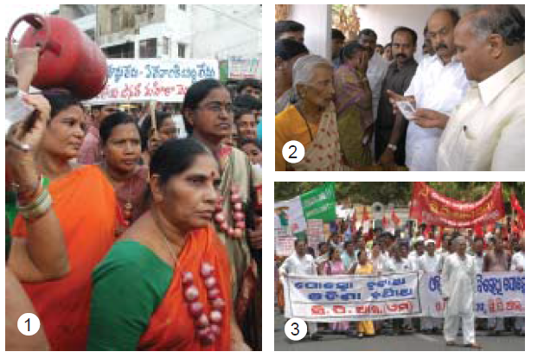

1: Activists of BJP Mahila Morcha demonstrating against hike in prices of onions and LPG in

Visakhapatnam

2: Minister distributes Rs One lakh cheque to the hooch victims family at their houses.

3: Activists of CPI (M), CPI, OGP and JD (S) take out a rally in Bhubaneswar to protest against

POSCO, the Korean steel company for being permitted by the State Government to export iron

ore from Orissa to feed steel plants in China and Korea

24. It is often said that political parties are facing a crisis because they are very unpopular and the citizens are indifferent to political parties. The available evidence shows that this belief is only partly true for India. The evidence, based on a series of large sample surveys conducted over several decades, shows that – Express your own use. **[3]**

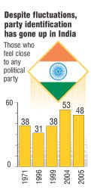h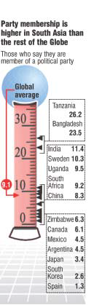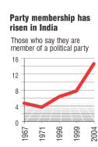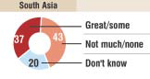

25. Does this suggest that in democracies people consent elections only to make money? But isn’t it true that there are politicians committed to the well-being of the peple? **[3]**



**SECTION-C**

**Long answer questions: 3x5=15**

**26**. **Read the passage below:**

Nannu is a daily wage earner. He lives in Welcome Mazdoor Colony, a slum habitation in East Delhi. He lost his ration card and applied for a duplicate one in January 2004. He made several rounds to the local Food & Civil Supplies office for the next three months. But the clerks and officials would not even look at him, leave alone do his job or bother to tell him the status of his application. Ultimately, he filed an application under the Right to Information Act asking for the daily progress made on his application, names of the officials, who were supposed to act on his application and what action would be taken against these officials for their inaction. Within a week of filing application under the Right to Information Act, he was visited by an inspector from the Food Department, who informed him that the card had been made and he could collect it from the office. When Nannu went to collect his card next day, he was given a very warm treatment by the Food & Supply Officer (FSO), who is the head of a Circle. The FSO offered him tea and requested him to withdraw his application under the Right to Information, since his work had already been done.

**Questions: [5]**

What does Nannu’s example show? What impact did Nannu’s action have on officials? Ask your parents their experiences when they approach government officials to attend to their problems.

**27.Read the following passage and answer the questions given below:**

Muhammad Yunus is a famous economist of Bangladesh. He received several international honours for his efforts to promote economic and social development for the benefit of the poor. He and the Grameen Bank he started jointly,received the Nobel Peace Prize for the 2006. In February 2007, he decided to launch a political party and contest in the parliamentary elections. His objective was to foster proper leadership, good governance and build a new Bangladesh. He felt that only a political party different from the traditional

ones would bring about new political culture. His party would be democratic from the grassroots level. The launching of the new party, called Nagarik Shakti (Citizens’ Power), has caused a stir among the Bangladeshis. While many welcomed his decision, some did not like it. “Now I think Bangladesh will have a chance to choose between good and bad and eventually have a good government,” said Shahedul Islam, a government official. “That government, we hope, would not only keep itself away from corruption but also make fighting corruption and black money a top priority.” But leaders of traditional political parties who dominated the country’s politics for decades were apprehensive. “There was no debate (over him) winning the Nobel, but politics is different – very challenging and often controversial,” said a senior leader of the Bangladesh Nationalist Party. Some others were highly critical. They asked why he was rushing into politics. “Is he being planted in politics by mentors from outside the country,” asked one political observer.

**Questions: [5]**

Do you think Yunus made a right decision to float a new political party?

Do you agree with the statements and fears expressed by various people? How do you want this new party organised to make it different from other parties? If you were the one to begin this political party how would you defend it?

28. “Democracies lead to peaceful and harmonious life among citizens”. Support the statement with examples. **[5]**

**\*\*\*\*\*\*\*\* ALL THE BEST \*\*\*\*\*\*\*\***