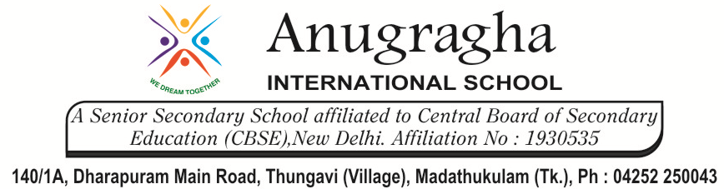
CLASS REVISION TEST-02
MATHEMATICS
EX.NO |  | AD.NO |  | GRADE | IX
DATE | 07.12.2019 | MARKS | 80 | TIME | 3 Hrs
SECTION – A
I. Choose the correct answer:- 10x1=10
1. Constructed externally on the sides AB, AC of $∆$ABC are equilateral triangle ABX and ACY. If P, Q, R are the mid-points of AX, AY and BC respectively, then $∆$PQR is
a. right angle b. equilateral triangle c. isosceles d. None of these
2. ABCD is a square. If P, Q, R and S are points on the sides AB, BC, CD and DA respectively, such that AP = BQ = CR = DS, then the value of $∠$SPQ is equal to
a. 90° b. 70° c.120° d. 60°
3. In the given figure, what will be the value of $∠$CBA?
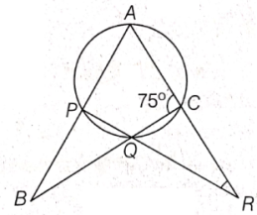
a. 60° b. 75° c. 45° d. 80°
4. In the given figure, O is the centre of the circle and $∠$AOD = 106°, what will be the value of $∠$BCD?
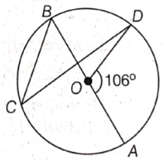
a. 53° b. 43° c. 40° d. 37°
5. Suppose you drop a die at random on the rectangular region shown in the figure below. What is the probability that it will land inside the circle of diameter 2?
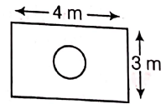
a. $\frac{5π}{12}$ b. $\frac{π}{12}$ c. $\frac{11π}{12}$ d. None of these
6. The percentage increase in the area of a triangle, if each side is quadrupled, is
a. 1500% b. 1200% c. 900% d. 800%
7. Find the probability that the minute hand lies from 5 to 15 min in the wall clock.
a. 1/6 b. 5/6 c. 3/7 d. None of these
8. The mean of 1, 7, 5, 3, 4 and 4 is m. If the observations 3, 2, 4, 2, 3, 3 and p have mean (m – 1) and median q, then the values of p and q is
a. 4 b. 3 c. 2 d. 1
9. The sum of the radii of two spheres is 10 cm and the sum of their volumes is 880 cm³. Then what will be the product of their radii?
a. 1/2 b. 58/3 c. 79/3 d. 26 1/3
10. A ladder, 25 m long is placed against a wall with its foot 7 m from the wall. Now, how far should the foot be drawn out so that the top of the ladder way come down by half the distance the foot is drawn out
a. 24 m b. 12 m c. 8 m d. 15 m

II. Answer in a word:- 10x1=10
11. If angles A, B C and D of the quadrilateral ABCD, taken in order are in the ratio 3 : 7 : 6 : 4, then find the measure of the smallest angle.
12. ABCD is a parallelogram and Q is any point on the side AD. If ar($∆$QBC) = 10 cm², then find
ar ($∆$QAB) + ar ($∆$QDC).
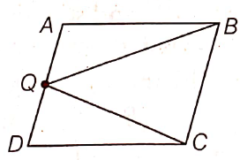
13. If the radius of a cylinder is doubled and height is halved, then find the new volume of the cylinder.
14. In the given figure, if chords AB and CD of the circle intersect each other at right angles, then find x + y.
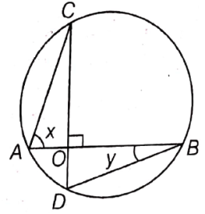
15. In the given figure, A, B and C are three points on a circle such that the angles subtended by the chords AB and AC at the centre O are 80° and 120°, respectively. Determine $∠$BAC.
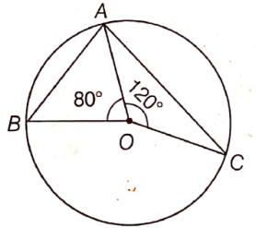
16. Can an angle of 67.5° be constructed?
17. The volume of a cylinder is 448$π$ cm³ and height 7 cm. Find its radius.
18. What is the median of the numbers 4, 4, 5, 7, 6, 7, 7, 12 and 3?
19. A Mathematics book contains 250 pages. A page is selected at random. What is the probability that the number on the page selected is a perfect square?
20. How many spherical balls of diameter 1 cm can be made from an iron ball of diameter 8 cm?
SECTION - B
III. Short answer type questions:- 6x2=12
21. In the given figure, ABCD is a parallelogram with $∠$B = 110°. Find the values of x and y.
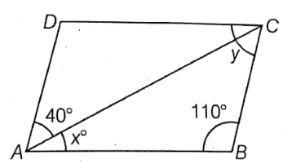
22. Which of the following figures lie on the same base and between the same parallels? In such a case, write the common base and the two parallels.
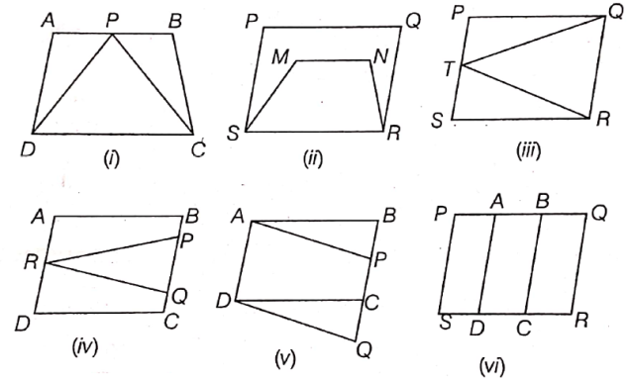
23. In the given figure, the area of parallelogram ABCD is 120 cm², then find the length of BC.
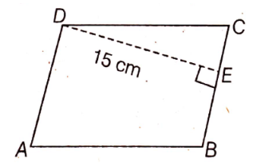
24. In the figure, $∠$ABC = 69° and $∠$ACB = 31°. Find $∠$BDC.
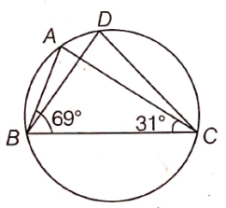
25. If the mean of 6, 8, 9, x and 13 is 10, then find the value of x.
26. The length, breadth and height of a cuboid are in the ratio 6 : 4: 5. If the total surface area of the cuboid is 2368 cm². Find its dimensions.

SECTION – C
IV. Short answer type questions:- 8x3=24
27. In the given figure, ABCD is a parallelogram and $∠$DAB = 60°. If the bisectors AP and BP of angles A and B respectively meets at P on CD. Prove that P is the mid-point of CD.
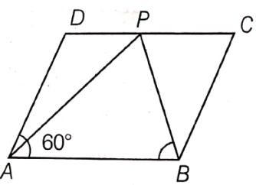
28. ABCD is a trapezium with AB ll DC. A line parallel to AC intersects AB at X and BC at Y. Prove that ar($∆$ADX) = ar($∆$ACY).
29. In a $∆$ABC, E is the mid-point of median AD. Show that ar($∆$BED) = ¼ ar($∆$ABC).
30. Two chords AB and CD of lengths 5 cm and 11 cm respectively of a circle are parallel to each other and are on opposite sides of its centre. If the distance between AB and CD is 6 cm, then find the radius of the circle.
31. The perimeter of a triangle is 50 cm. One side of a triangle is 4 cm longer than the smaller side and the third side is 6 cm less than twice the smaller side. Find the area of the triangle.
32. Probability of getting a blue ball is 2/3, from a bag containing 6 blue and 3 red balls. 12 red balls are added in the bag, then find the probability of getting
i. a blue ball ii. a red ball.
33. Calculate the mean, median and mode for the following data.
23, 25, 28, 25, 16, 23, 17, 22, 25, 25
34. A cylindrical tube opened at both the ends is made of iron sheet which is 2 cm thick. If the outer diameter is 16 cm and its length is 100 cm, then find how many cubic centimetres of iron has been used in making the tube?

SECTION - D
V. Long answer type questions:- 4x6=24
35. Construct a $∆$XYZ, in which $∠$Y = 30°, $∠$Z = 90° and XY + YZ + ZX = 11 cm.
36. Rain water falls on a flat rectangular surface of length 6 m and breadth 4 m is transferred into a cylindrical vessel of internal radius 20 cm. What will be the height of water in the cylindrical vessel of the rain fall in 1 cm. Give your answer to the nearest whole number. [take, $π$ = 3.14]
37. The volume of the two spheres are in the ratio 64 : 27. Find the ratio of their surface areas.

38. The runs scored by two teams A and B on the first 60 balls in a cricket match are given below
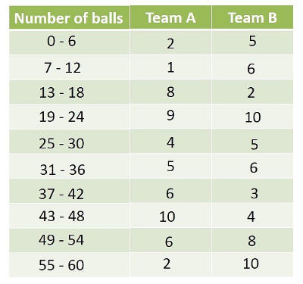
Represent the data of both the teams on the same graph by frequency polygons.
39. Find the mean salary of 60 workers of a factory from the following table.
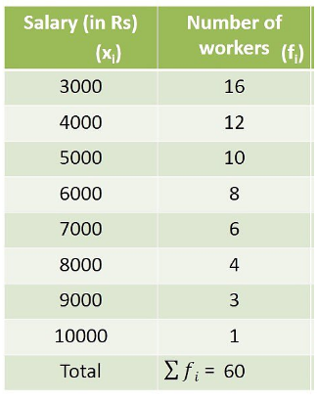
40. Three coins are tossed simultaneously 150 times and it is found that 3 tails appeared 24 times, 2 tails appeared 45 times, 1 tail appeared 72 times and no tail appeared 9 times. If three coins are tossed simultaneously at random. Find the probability of getting
i. 3 tails ii. 2 tails iii. 1 tail iv. 0 tail.

