CLASS REVISION TEST-4
SCIENCE - PHYSICS
EX.NO |  | AD.NO |  | GRADE | X-LAVENDER
DATE | 13/11/19 | MARKS | 80 | TIME | 2 Hrs
SECTION - A
I. Choose the correct answer:- 5x1=5
1. The radius of curvature of concave mirror is 12 cm. Then, the focal length will be
(a) 12 cm (b) 6 cm (c) -24 cm (d) -6cm
2. A man is 6.0 ft tall. What is the smallest size plane mirror he can use to see his entire image?
(a) 3.0 ft (b) 6.0 ft (c) 12 ft (d) 24 ft
3. A spherical mirror and a thin spherical lens have each a focal length of -15 cm. The mirror and the lens are likely to be
(a) both concave (b) both convex
(c) the mirror is concave and the lens is convex
(d) the mirror is convex, but the lens is concave
4. An object is placed 20 cm from the concave mirror of focal length 10 cm, then image is formed at
(a)behind the mirror (b)between the mirror and focus
(c)at focus (d)centre of curvature of mirror
5. The refractive index of dense flint glass is 1.65 and for alcohol, it is 1.36 with respect to air, then the refractive index of the dens flint glass with respect to alcohol is
(a) 1.31 (b) 1.21 (c) 1.11 (d) 1.01
II. Fill in the blanks:- 5x1=5
6. The coloured diaphragm between the cornea and the lens is ____________________.
7. The ability of the eye to focus both near and distant objects, by adjusting its focal length, is called the _______________________.
8. Phenomenon of splitting of white light into its constituent colours is _________________.
9. The middle point of the iris has a hole, which is called _________________________.
10. _________________ is the ability of the eye to adjust its focal length.
III. True or False:- 5x1=5
11. In parallel combination, the reciprocal of equivalent resistance is the sum of the reciprocal of individual resistance.
12. A dentist uses a convex mirror to view the inner parts of a patient’s mouth.
13. The temperature coefficient of resistance of a wire is 0.00125/°C. The resistance of the wire is 1 ohm at 300 K. The resistance will be 2 ohm at 1100 K.
14. Ohm’s law is a relation between the power used in a circuit to the current and the potential difference.
15. The solar spectrum in general is an absorption spectrum.
IV. Assertion and Reason:- 5x1=5
In the following questions, a statement of assertion is followed by a statement of reason. Mark the correct choice as:
a. If both assertion and reason are true and reason is the correct explanation of assertion.
b. If both assertion and reason are true but reason is not the correct explanation of assertion.
c. If assertion is true but reason is false.
d. If both assertion and reason are false.
16. Assertion : Basic difference between an electric line and magnetic line of force is that former is
discontinuous and the later is continuous or endless.
Reason : No electric lines of force exist inside a charged body but magnetic lines do exist
inside a magnet.

17. Assertion : On changing the direction of flow of current through a straight conductor, the
direction of a magnetic field around the conductor is reversed.
Reason : The direction of magnetic field around a conductor can be given in accordance
with left hand thumb rule.
18. Assertion : Magnetic field lines never intersect.
Reason : At a particular point magnetic field has only one direction.

19. Assertion : A compass needle is placed near a current carrying wire. The deflection of the
compass needle decreases when the compass needle is displaced away from the wire.
Reason : Strength of a magnetic field decreases as one moves away from a current carrying
conductor.

20. Assertion : An induced current has a direction such that the magnetic flux that induces the current.
Reason : Above statement is in accordance with conservation of energy.
SECTION - B
V. Answer the following questions:- 10x3=30

21. A student wants to project the image of a candle flame on a screen 60 cm in front of a mirror by
keeping the flame at a distance of 15 cm from its pole.
  - Write the type of mirror he should use.
  - Find the linear magnification of the image produced.
  - What is the distance between the object and its image?
  - Draw a ray diagram to show the image formation in this case.
22. Discuss the position and nature of the image formed by a concave mirror when the object is
moved from infinity towards the pole of the mirror.
23. An object of height 5 cm is placed perpendicular to the principal axis of a concave lens of focal
length 10 cm. If the distance of the object from the optical centre of the lens is 20 cm,
determine the position, nature and size of the image formed using the lens formula.
24. State the cause of dispersion, when white light enters a glass prism. Explain with a diagram.
25. (a) Calculate maximum power of accommodation of a person having normal vision.
(b) A person needs to use glasses for reading newspaper. Identify the defect in her vision and the
type of lens she would need to correct it.
(c) sometimes when we enter into a dark room from bright sunlight we are unable to see objects
clearly. Why?
26. Resistivity of two elements A and B are = 1.62 x 10⁻⁸ $Ω$m and 520 x 10⁻⁸ $Ω$m respectively.
Out of these two, name the element that can be used to make:
a. filament of electric bulb.
b. wires for electrical transmission lines. Justify your answer in each case.
27. State Ohm’s law. Calculate the resistance of a conductor, if the current flowing through it is
0.2 A when the applied potential difference is 0.8 V.
28. Study the following circuit and answer the following questions:
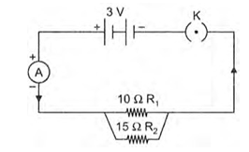
a. State the type of combination of the two resistors in the circuit.
- How much current would flow through: (i) 10 $Ω$ resistor and (ii) 15 $Ω$ resistor?
- What would be the ammeter reading?
29. In our daily life we use two types of electric current whose current-time graphs are given below:
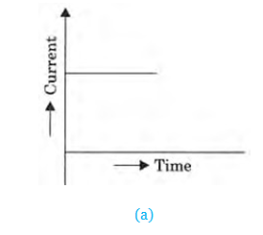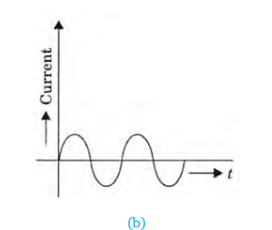
- Name the type of current in two cases.
- Identify any one source for each type of current.
- What is the frequency of current in case (b) in our country?
- On the basis of these graphs list two differences between the two currents.
- Out of the two which one is used in transmitting electric power over long distances and why?
30. (a) Describe an experiment with a diagram to show that force is exerted on a current carrying
conductor when placed perpendicular in a magnetic field.
(b) How will this force change if current in the conductor is increased?
(c) Name a device that uses the above principle.
SECTION - C
VI. Answer the following questions briefly:- 6x5=30
31. A 5 cm tall object is placed perpendicular to the principal axis of a convex lens of focal length 20
cm. The distance of the object from the lens is 30 cm.
Find the: a. position b. nature c. size of the image formed.
32. An object 4 cm high is placed at a distance of 27 cm in front of a convex lens of focal length 18
cm. Find the position, nature and size of the image formed.
33. (a) What is dispersion of white light? What is the cause of such dispersion? Draw a diagram, to
show the dispersion of white light by a glass prism.
(b) A glass prism is able to produce a spectrum when white light passes through it but a glass slab
does not produce any spectrum. Explain why it is so.

34. Three 2 $Ω$ resistors, A, B and C, are connected as shown in figure. Each of them dissipates
energy and can withstand a maximum power of 18 $Ω$ without melting. Find the maximum
current that can flow through the three resistors.
35. Calculate the resistance of an electric bulb which allows a 10 A current when connected to a 220
V power source.
36. Two coils C1 and C2 are wrapped around a non- conducting cylinder. Coil C1 is connected to a
battery and key and C2 with galvanometer G. On pressing the key (K), current starts flowing in
the coil C1 State your observation in the galvanometer.
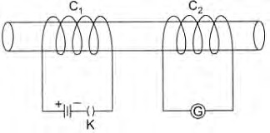
a. When key K is pressed on.
b. When current in the coil C1 is switched off.
c. When the current is passed continuously through coil C1.
d. Name and state the phenomenon responsible for the above observation. Write the name of
the rule that is used to determine the direction of current produced in the phenomena.

