CLASS REVISION TEST-01
PHYSICS
EX.NO |  | AD.NO |  | GRADE | XII
DATE | 23/11/19 | MARKS | 80 | TIME | 3 Hrs

I. Choose the correct answer:- 10x1=10
1. A body has a positive charge of 8x10⁻¹⁹ C. It has
a)an excess of 5 electrons b)a deficiency of 5 electrons
c)an excess of 8 electrons d) a deficiency of 8 electrons.
2. A dipole placed in a uniform field with its dipole moment parallel to the filed , experiences:
a)only a net force b) only a torque
c)both d)neither
3. The nucleus of hydrogen atom is a sphere of radius 10⁻¹⁵ m. The electric field at the surface of the nucleus is:
a) 14.1 x 10⁴ Vm⁻¹ b) 14.1 x 10¹⁰ Vm⁻¹
c) 14.1 x 10¹⁹ Vm⁻¹ d) 14.1 x 10²⁰ Vm⁻¹
4. Electric field intensity E at a point P (see figure) at a perpendicular distance r from an infinitely long linear charge X-X having linear charge density $λ$ is given by:
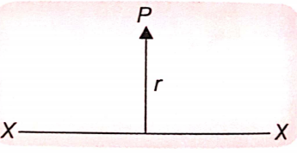
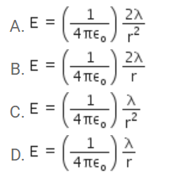
5. The electric filed inside a hollow charged sphere is zero. The potential V will vary with distance r from the centre of the sphere as:
a)V∝ r b) V $∝$ 1/r c) V $∝$ 1/r² d) does not depend on r.
6. When a test-charge is brought from infinity along the perpendicular are bisector of an electric dipole, then the work done is:
a) positive b) negative c)zero d) none
7. A hollow metal sphere fixed on an insulating stand is charged positively. The electric potential inside the sphere is:
a) Zero b) everywhere same as on the surface
c) higher than that on the surface d) lower than that on the surface
8. The factor which do not affect the capacitance of a capacitor is
a) Shape of the plates b) distance between the plates
c) potential difference between the plates d) nature of medium between the plates
9. The equivalent capacitance between points A and B in the given figure would be:
a) 2.5 $μ$ F b) 15$μ$ F
c) 2.4$μ$ F d) none
10. Two small sphere placed first in air and then in a medium of dielectric constant K at the same distance apart are charged to the same potential. The ratio of the electrical forces between the spheres in the two cases is
a) K:1 b) 1:K
c) 1:K² d) K² : 1
II. Answer in a word:- 10x1=10
11. The charge on a conductor is -1.6C. How many electrons are in excess on it than normal state?
OR
A conductor has 2.4 x 10⁻¹⁸ C of positive charge. How many electrons are in excess or short?
12. A charged oil drop weighing 1.6 x10⁻¹⁵ N is found to remain suspended in a uniform electric field of intensity 2 x10³ N C⁻¹. Find the charge on the drop.
13. Maximum torque acting on an electric dipole of moment 3x10⁻²⁹ Gm in a uniform electric field E is 6 x10⁻²⁵ Nm. Find E.
14. The unit of electrostatic field E is volt/metre. Obtain the unit of electric flux.
15. A large hollow metallic sphere has a positive charge of 35.4 $μ$ C at its centre. Find how much electric flux emanates from the sphere.
16. If Coulomb’s law involved 1/r³ dependence (instead of 1 /r³), would Gauss’ law still valid?
17. What will be the nature of electric potential at a place where the electric filed is zero?
18. State how the following quantities depend upon r:
a)Electric filed and potential due to a point-charge,
b) Potential at a distance r form the centre of a charged metallic sphere(r< radius of the sphere).
19. What is the dielectric constant of metal? Give reason.
20. Can there be a potential difference between two close conductors of the same volume carrying equal positive charges?

III. Answer the following questions:- 7x2=14
21. A polythene piece rubbed with wool is found to have a negative charge 3.2 x 10⁻⁷ C. Estimate the number of electrons transferred (from which to which?). Is there any transfer of mass from wool to polythene?
OR
Two electric charges q and 2 q are at a distance ‘a’ apart from each other in air. A third charge Q is to be placed along the same line in such way that the net force acting at q and also at 2 q is zero. Calculate the position of charge Q in terms of q and a.
22. Explain the stamen ‘ Relative permittivity of water is 81.’
OR
When we draw lines of force for two equal positive charges, the neutral point is found at the mid-point of the line joining the charges. If the two charges are unequal, then?
23. A point-charge is placed at the centre of closed Gaussian spherical surface. How is electric flux $∅$_{E} through the surface affected when
a)The sphere is replaced by a cylinder of the same or different volume?
b)the charge is shifted from the centre to some other place inside the sphere?
c)a second charge is paled inside to sphere?
d) the charge is replaced by an electric dipole?
24. A cylinder is immersed in a uniform electric filed E with its axis parallel to the field. Show that the electric flux through the cylinder is zero.
25.
26.
27. Two charges conducting spheres of radii a and b are connected to each other by a wire. Find the ratio of electric fields at the surfaces of the spheres.
IV Answer the following questions in brief:- 10x5=50
28. A charge q is divided into two parts such that they repel earth other with a maximum force when placed at a certain distance apart. How has the charge been divided?
OR
Explain the meaning of the statement “electric charge of a body is quantized”. Why can we ignore quantization of electric charge when dealing with large charges?
29. Define electric flux and electric flux density. What is meant by negative flux? Explain with diagram. Write SI unit and dimensions of electric flux.
30. State Gauss’ law in electrostatics. Apply it to show that, for a uniformly –charged spherical shell, the field inside the shell vanishes, whereas outside it the field is as if all the charges were concentrated at the centre.
31. The charges –q and +q of a dipole are located at points (0,0, -a) and (0,0,a). How much work is done in (-7,0,0,) along the X-axis? Does the answer change if the path of the test-charge is not along X-axis?
OR
What is an equipotential surface? Draw the same for a point-charge. Show that electric field is always. Directed perpendicular to an equipotential surface.
OR
Derive an expression for the electric potential at a point in the end-on potential of an electric dipole.
32. Can a charge of 1 coulomb be given to a metallic sphere of radius 1 cm?
OR
Derive an expression for the total work done in rotating an electric dipole through an angle $θ$ in a uniform electric filed.
33. Derive an expression for the energy stored in a capacitor of capacitance C, charged to a potential V.
34. Three capacitors of capacitances C₁,C₂,C₃ are connected (i) a sphere, (ii) in parallel. Derive expressions for the equivalent capacitance for each of these combinations.
35. Define electric flux, write its SI unit. Explain area as a vector quantity and release it to the electric flux passing through an area A of a Gaussian surface.
OR
Write properties of Gaussian surface and obtain an expression for intensity of electric filed due to an infinite line charge.
36. An electron is circulating around the nucleus of a hydrogen atom in a circular orbit of radius
5.3 x 10⁻¹¹m. be the electric potential energy due to a helium nucleus at the same radius?
OR
(i)Calculate the work required to assemble each of the systems of charges (Which is same as the electrostatic potential energy of the system) shown in fig (a) and (b)
(ii) A charge Q₀ is brought from infinity to the centre of the square , the four charges being held fixed as its corners. How much extra work is need to do this?
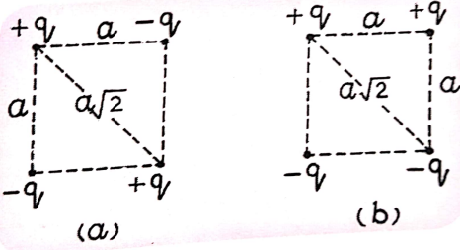
37. A parallel-plate capacitor has plates each of area A and separation d. Two dielectrics of dielectric constants K₁ and K₂ are filled between the plated in two arrangements as shown. Find out the capacitance of the capacitor in each of the arrangements (a) and (b)

