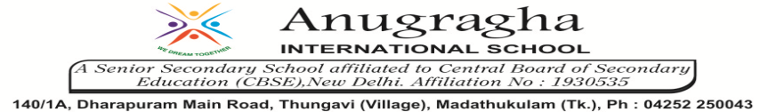

ANNUAL EXAMINATION-FEB-2020

KBQ - 05
NAME |  |  |  | AD.NO
CLASS | VII- |  |  | EX.NO
G.D | 14.02.2020 | S.D | 17.02.2020 | SUB | SST
TOPIC: CH:9 THE MAKING REGIONAL CULTURES

Short Answer Type Questions:

1.Why did minstrels proclaim the achievements of heroes?
2.Why were temples built in Bengal?
3.What are regional cultures?
4.How did Cheras help in evolution of Malayalam?
5.What were the great achievements of Malyalam literature?
6.How did Rajputs and women emerge with heroic traditions?

Long Answer Type questions:
1. What are the important architectural features of the temples of Bengal?
2.What developments took place in Bengal in 16th century?

3.How did the traditional of Kathak emerge?
4.How did fish become a popular food in Bengal?
5.How were Rajputs special for Rajasthan?
6.How were miniatures part of traditions?

