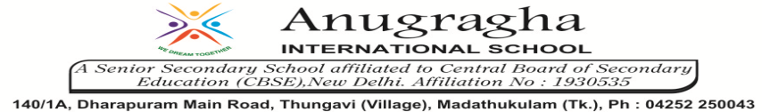

ANNUAL EXAMINATION-JAN-2020

KBQ - 01
NAME | «NAME_OF_THE_STUDENT» |  |  | AD.NO | «ADMNO»
CLASS | VI-«SECTION» |  |  | EX.NO | «EXNO»
G.D |  | S.D |  | SUB | SCI
TOPIC: CH:10.MOTION AND MEASUREMENT OF DISTANCES
Short Answer Type Questions:
1. Why can a space or a footstep not be used as a standard unit of length?
2. How can a measured length be expressed?
3. State two precautions to be observed while measuring length with the help of a metre scale.
4. What is meant by periodic motion?
5. How can we determine whether a motion is fast or slow?
Long Answer Type questions:
1. How can you measure the length of a curved line?
2. Why do we need standard unit for measurement?
3. Explain how the eye should be placed in correct position for taking measurements.

HOTS:
1. The distance between Radha’s home and her school is 3250m. Express this distance in km.
2. Why could you not use an elastic measuring tape to measure distance? What would be some of the problems you would meet in telling someone about a distance you measured with an elastic tape?
3. How are motions of a wheel of a moving bicycle and a mark on the blade of a moving electric fan different? Explain.
4. Three students measured the length of a corridor and reported their measurements. The value of their measurements were different. What could be the reason for difference in their measurements?
5. While travelling in a train, it appears that the trees near the track are moving whereas co-passengers appear to be stationary. Explain the reason.

