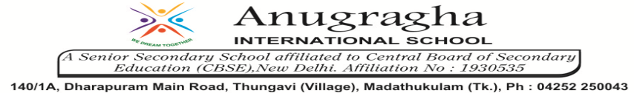

ANNUAL EXAMINATION-FEB-2020

KBQ - 04
NAME | «NAME_OF_THE_STUDENT» |  |  | AD.NO | «ADMNO»
CLASS | VIII-«SECTION» |  |  | EX.NO | «EXNO»
G.D | 26.02.2020 | S.D | 29.02.2020 | SUB | SCI
TOPIC: CH:18 POLLUTION OF AIR AND WATER

Short Answer Type Questions:
1.Mention the various causes of air pollution.
2.What are the causes of indoor air pollution? How to prevent or minimize it?
3.Explain Ganga Action Plan.
4.How are industries are responsible for water pollution?
5.Write some effects of global warming.

Long Answer Type questions:
1.What is greenhouse effect? State its significance for us.
2.How does acid rain affect soil and plants?
3.How does air get polluted? Explain.

HOTS:
1.At an individual level, how can you help to reduce air pollution?
2.Clear, transparent water is always fit for drinking. Comment.
3.State why a car parked in the sunshine with its windows closed is found much more hot inside than outside?
4.Burning of fossil fuels causes pollution. Comment.
5.Burning dry leaves cause air pollution? How can it be avoided?
6. “Hot water can also be a pollutant” Explain why?

