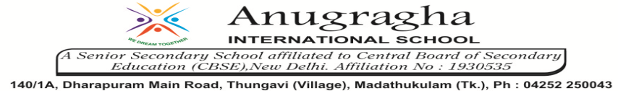

ANNUAL EXAMINATION-FEB-2020

KBQ - 06
NAME | «NAME_OF_THE_STUDENT» |  |  | AD.NO | «ADMNO»
CLASS | VIII-«SECTION» |  |  | EX.NO | «EXNO»
G.D | 14.02.2020 | S.D | 17.02.2020 | SUB | SCI
TOPIC: CH:10 REACHING THE AGE OF ADOLESCENCE

Short Answer Type Questions:
1.Write the factors on which the height of a person depends.
2.What are the functions performed by testes in human beings?
3.What do you mean by balanced diet?
4.What is menstruation? Explain.
5.What do you mean by health? What are the factors which help to keep a good health?

Long Answer Type questions:
1. Explain how the reproduction function is initiated by hormones at puberty.

2.Name the diseases or side effects caused by deficiency of following hormones?
a)Thyroxine b)Insulin c)Adrenaline d)Growth hormone.
3.Write a short note on nutritional needs of the adolescents.

HOTS:
1.Boys and girls have different development in their voice during puberty. Describe the changes.
2.Adolescence is a period of change in a person’s way of thinking. Justify.
3.When does a child gain maximum height?
4.Why is the presence of iodine in water required for the proper growth of tadpoles?
5.Why some young people get acne and pimples on the face during puberty?

