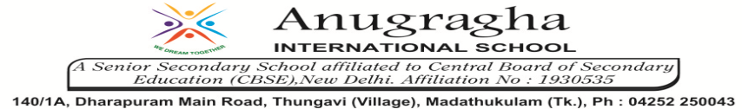

ANNUAL EXAMINATION-JAN-2020

KBQ - 01
NAME | «NAME_OF_THE_STUDENT» |  |  | AD.NO | «ADMNO»
CLASS | VII-«SECTION» |  |  | EX.NO | «EXNO»
G.D |  | S.D |  | SUB | SCI
TOPIC: CH:9.SOIL

Short Answer Type Questions:
1.How is clayey soil useful for crops?
2.Explain how soil is formed?
3.List the difference between clayey soil and sandy soil.
4.What are the various components of soil?
5.What do you understand by soil texture?

Long Answer Type questions:
1.Explain how soil pollution and soil erosion could be prevented?
2.Describe loamy soil. Mention the plants that grow well in loamy soil.
3.What are chemical fertilizers? Write their harmful effects.

HOTS:
1.Why on a hot summer day the soil seems to shimmer?
2.Soil is very important for the living beings?Justify.
3.Why should plastics and polythene be banned?
4.Raman always advises his neighbours to plant more trees?Why? List any two values shown by him.
5.Cotton requires soil which drains water easily. Which soil according to you will be ideal for growing cotton?

