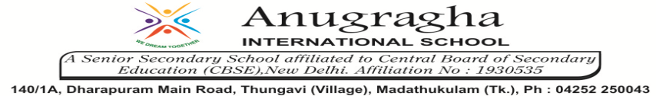

ANNUAL EXAMINATION-JAN-2020

KBQ - 02
NAME | «NAME_OF_THE_STUDENT» |  |  | AD.NO | «ADMNO»
CLASS | VIII-«SECTION» |  |  | EX.NO | «EXNO»
G.D | 30.01.2020 | S.D | 03.02.2020 | SUB | SCI
TOPIC: CH:15.SOME NATURAL PHENOMENA

Short Answer Type Questions:
1. Suggest three measures to protect ourselves from lightning.
2.What are lighting conductors? How is it used?
What steps should be taken if someone becomes a victim of lightning?
3.What is the relation between an electric charge and an electric current?
4.What is earthing? Why is it important?
5.What are fault zones?

Long Answer Type questions:
1.Explain the mechanism of earthquake?
2.What is a seismograph? How does it work?
3.What is the reason behind the lightning that we see in the sky during rainy season?

HOTS:
1.Explain why a charged balloon is repelled by another charged balloon whereas an uncharged balloon is attracted by another charged balloon.
2.Explain why a charged body loses its charge if we touch it with our hand.
3.Sometimes a crackling sound is heard while taking off sweater during winters.
4.Suppose you are outside your from and earthquake strikes. What precautions would you take to protect yourself?
5.The weather department has predicated that a thunderstorm is likely to occur on a certain day. Suppose you have to go out on that day. Would you carry an umbrella? Explain.

