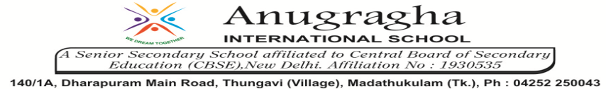

ANNUAL EXAMINATION-FEB-2020

KBQ - 03
NAME | «NAME_OF_THE_STUDENT» |  |  | AD.NO | «ADMNO»
CLASS | VIII-«SECTION» |  |  | EX.NO | «EXNO»
G.D | 15.02.2020 | S.D | 18.02.2020 | SUB | SCI
TOPIC: CH:17 STARS AND THE SOLAR SYSTEM

Short Answer Type Questions:
1.What do you know about the phases of moon? Why do phases of the moon occur?
2.What is Pole star? How do you locate the position of polar star?
3.Define satellite. Name the natural satellite of the Earth.
4.Write the difference between revolution and rotation.
5.What is waxing and vaning of moon?

Long Answer Type questions:
1.What are constellation? Explain some natural constellations.
2.What are planets? Explain them.
3.Write a note on the concept of a light year. How does this unit compare with the other measures of distance?

HOTS:
1.Do all the stars in the sky move? Explain.
2.Why can we not hear any sound on the moon?
3.Why does the moon change its shape everyday?
4.Why are meteors commonly shooting areas?
5.Why does the tail of a comet always point away from Sun?

