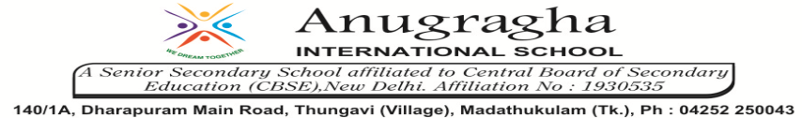

ANNUAL EXAMINATION-JAN-2020

KBQ – 04
NAME | «NAME_OF_THE_STUDENT» |  |  | AD.NO | «ADMNO»
CLASS | VII-«SECTION» |  |  | EX.NO | «EXNO»
G.D | 22.01.2020 | S.D | 25.01.2020 | SUB | SCI
TOPIC: CH:11. TRANSPORTATION IN ANIMALS AND PLANTS

Short Answer Type Questions:
1.Why is transport of materials necessary in a plant or in an animal? Explain.
2.What are the components of blood?
3.What is the difference between arteries and veins?
4.What does circulatory system consist of? What is the function of each part?
5.Why is blood needed by all parts of a body?
6. What are stomata? Give two functions of stomata.

Long Answer Type questions:
1.Describe the function of the heart.
2.Explain what do you understand by the heartbeat.
3.Explain the composition of blood.
4. Describe xylem and phloem.

HOTS:
1.What will happen if there are no platelets in the blood?
2.Boojho’s uncle was hospitalized and put on dialysis after a severe infection in both of his kidneys?
a)What is dialysis?
b)When does it become necessary to take such a treatment?
3.Where can you feel the pulse?
4.Does transpiration serve any useful function in the plants? Explain.
5.Why should sports persons and athletes drink more water?

