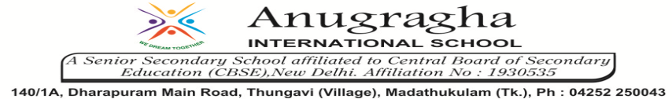

ANNUAL EXAMINATION-FEB-2020

KBQ - 03
NAME | «NAME_OF_THE_STUDENT» |  |  | AD.NO | «ADMNO»
CLASS | VII-«SECTION» |  |  | EX.NO | «EXNO»
G.D | 18.02.2020 | S.D | 22.02.2020 | SUB | SCI
TOPIC: CH:16.WATER:A PRECIOUS RESOURCE

Short Answer Type Questions:
1.What do you mean by ‘depletion of water table’?
2.What do you mean by “Water Crisis”?
3.Explain how groundwater is recharged?
4.Write three ways by which we can conserve water.
5.Why is water so important for us?

Long Answer Type questions:
1.What do you mean by ‘Water Scarcity”?What are its effect?
2.Describe the water cycle.
3.What do you mean by rainwater harvesting? What are its advantages?
4.What do you mean by ‘Water management’? What are the steps involved in it?

HOTS:
1.Water is very precious for all living beings. What will happen in future if we do not save water now?
2.My sister is in habit of keeping the tap open while brushing her teeth. She loves to bathe under the shower. According to me her way of handling the most precious source of water is absolutely wrong.
a)Do you agree with me or not?
b)What changes in the above situation can be done to conserve water?
3.Why do plants die in summer, if they are not watered?
4.Give reasons:
a)Water the plants before sunrise or after sunset.
b)Drip irrigation helps in conserving water.
5.There are ten tubewalls in a lane of fifty houses. What could be the long term impact on the water table?

