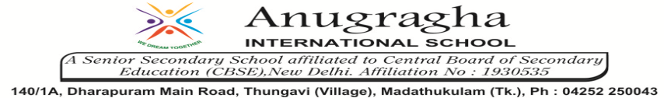

ANNUAL EXAMINATION-JAN-2020

KBQ - 01
NAME | «NAME_OF_THE_STUDENT» |  |  | AD.NO | «ADMNO»
CLASS | VIII-«SECTION» |  |  | EX.NO | «EXNO»
G.D |  | S.D |  | SUB | SCI
TOPIC: CH:14. CHEMICAL EFFECTS OF ELECTRIC CURRENT

Answer Type Questions:
1.What is LED? Why is it used in place of a bulb in the tester?
2.When do you need magnetic compass to test the conduction of electricity?
3.What is a tester?
4.Explain the mechanism of glowing of bulb in liquid.
5.Explain the advantages of electroplating.

Long Answer Type questions:
1.Write a note to describe the usefulness of electroplating?
2.Give the advantages and disadvantages of LED and CFLs.
3.What are the chemical effects of electric current? Explain with an example.

HOTS:
1.The ordinary water can conduct electricity while distilled water does not. Explain why?
2.Except chromium plating on several other metals what other metals are used for plating. Give few examples.
3.There are some situations in which even though liquid is conducting, bulb may not glow. Give reasons.
4.Explain why a bulb glows on passing current.
5.Is it safe for the electrician to carry out electrical repairs outdoors during heavy down pour? Explain.

